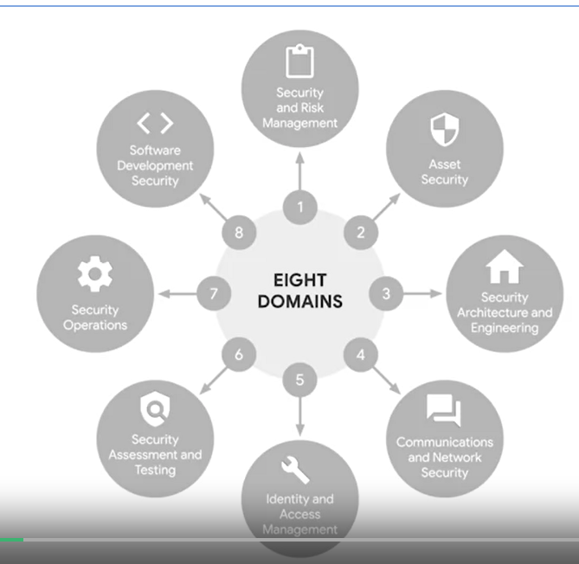

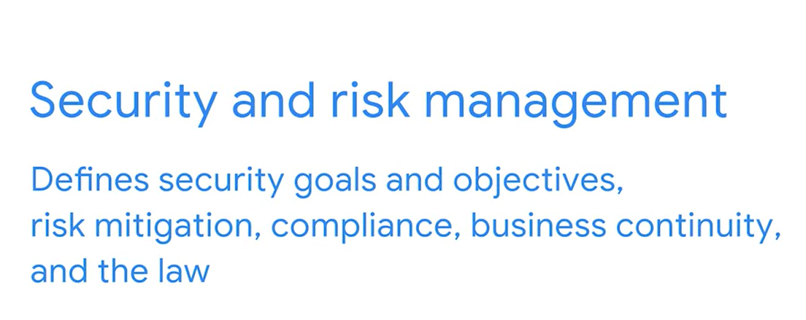

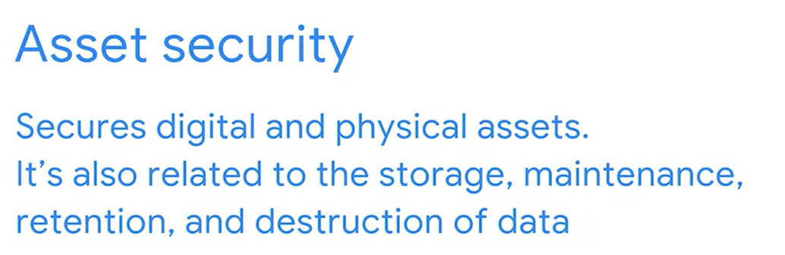

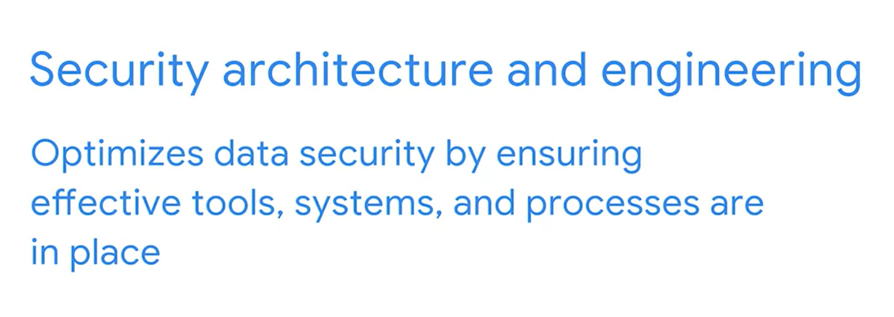

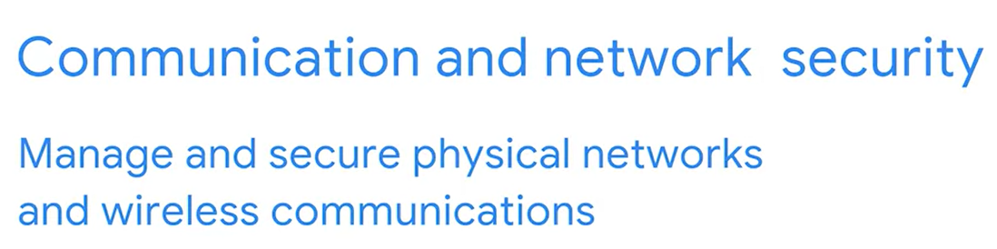

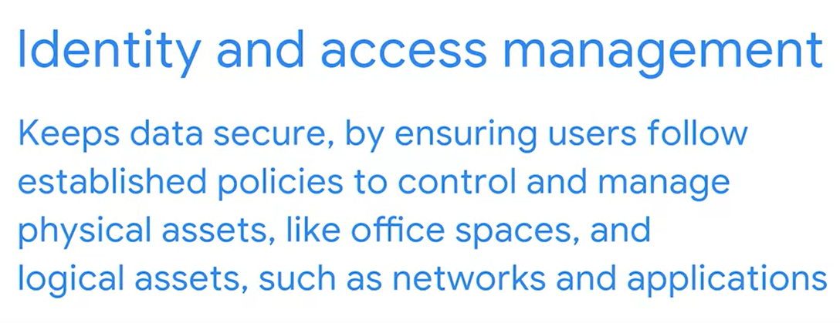

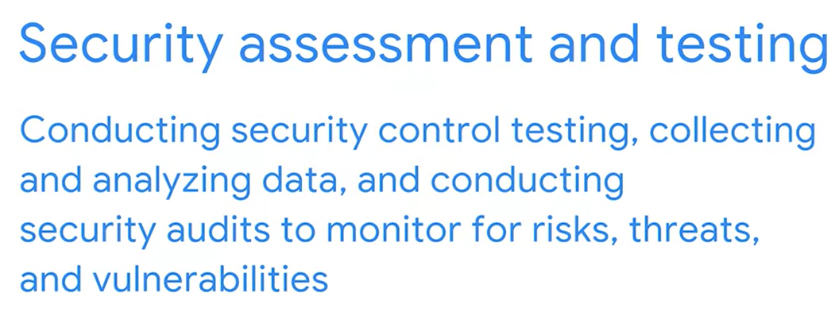

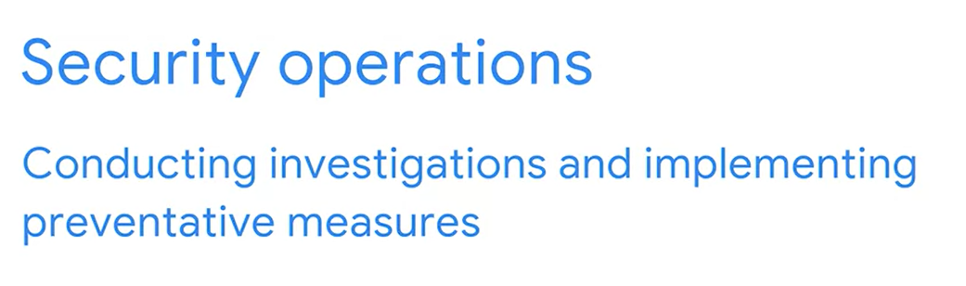

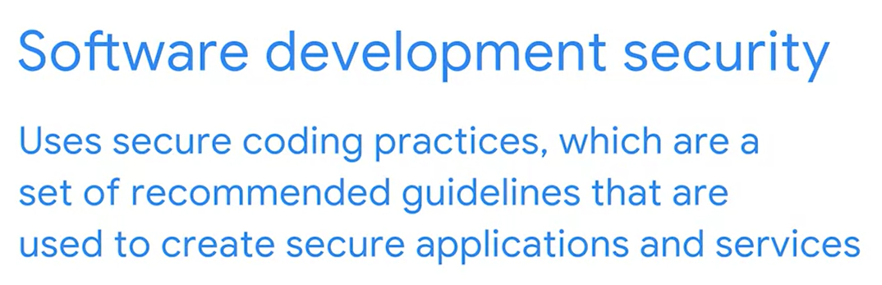

## Domain one: Security and risk management

All organizations must develop their security posture. Security posture is an organization’s ability to manage its defense of critical assets and data and react to change. Elements of the security and risk management domain that impact an organization's security posture include:

* Security goals and objectives
* Risk mitigation processes
* Compliance
* Business continuity plans
* Legal regulations
* Professional and organizational ethics

Information security, or InfoSec, is also related to this domain and refers to a set of processes established to secure information. An organization may use playbooks and implement training as a part of their security and risk management program, based on their needs and perceived risk. There are many InfoSec design processes, such as:

* Incident response
* Vulnerability management
* Application security
* Cloud security
* Infrastructure security

As an example, a security team may need to alter how personally identifiable information (PII) is treated in order to adhere to the European Union's General Data Protection Regulation (GDPR).

## Domain two: Asset security

Asset security involves managing the cybersecurity processes of organizational assets, including the storage, maintenance, retention, and destruction of physical and virtual data. Because the loss or theft of assets can expose an organization and increase the level of risk, keeping track of assets and the data they hold is essential. Conducting a security impact analysis, establishing a recovery plan, and managing data exposure will depend on the level of risk associated with each asset. Security analysts may need to store, maintain, and retain data by creating backups to ensure they are able to restore the environment if a security incident places the organization’s data at risk.

## Domain three: Security architecture and engineering

This domain focuses on managing data security. Ensuring effective tools, systems, and processes are in place helps protect an organization’s assets and data. Security architects and engineers create these processes.

One important aspect of this domain is the concept of shared responsibility. Shared responsibility means all individuals involved take an active role in lowering risk during the design of a security system. Additional design principles related to this domain, which are discussed later in the program, include:

* Threat modeling
* Least privilege
* Defense in depth
* Fail securely
* Separation of duties
* Keep it simple
* Zero trust
* Trust but verify

An example of managing data is the use of a security information and event management (SIEM) tool to monitor for flags related to unusual login or user activity that could indicate a threat actor is attempting to access private data.

## Domain four: Communication and network security

This domain focuses on managing and securing physical networks and wireless communications. This includes on-site, remote, and cloud communications.

Organizations with remote, hybrid, and on-site work environments must ensure data remains secure, but managing external connections to make certain that remote workers are securely accessing an organization’s networks is a challenge. Designing network security controls—such as restricted network access—can help protect users and ensure an organization’s network remains secure when employees travel or work outside of the main office.

## Domain five: Identity and access management

The identity and access management (IAM) domain focuses on keeping data secure. It does this by ensuring user identities are trusted and authenticated and that access to physical and logical assets is authorized. This helps prevent unauthorized users, while allowing authorized users to perform their tasks.

Essentially, IAM uses what is referred to as the principle of least privilege, which is the concept of granting only the minimal access and authorization required to complete a task. As an example, a cybersecurity analyst might be asked to ensure that customer service representatives can only view the private data of a customer, such as their phone number, while working to resolve the customer's issue; then remove access when the customer's issue is resolved.

## Domain six: Security assessment and testing

The security assessment and testing domain focuses on identifying and mitigating risks, threats, and vulnerabilities. Security assessments help organizations determine whether their internal systems are secure or at risk. Organizations might employ penetration testers, often referred to as “pen testers,” to find vulnerabilities that could be exploited by a threat actor.

This domain suggests that organizations conduct security control testing, as well as collect and analyze data. Additionally, it emphasizes the importance of conducting security audits to monitor for and reduce the probability of a data breach. To contribute to these types of tasks, cybersecurity professionals may be tasked with auditing user permissions to validate that users have the correct levels of access to internal systems.

## Domain seven: Security operations

The security operations domain focuses on the investigation of a potential data breach and the implementation of preventative measures after a security incident has occurred. This includes using strategies, processes, and tools such as:

* Training and awareness
* Reporting and documentation
* Intrusion detection and prevention
* SIEM tools
* Log management
* Incident management
* Playbooks
* Post-breach forensics
* Reflecting on lessons learned

The cybersecurity professionals involved in this domain work as a team to manage, prevent, and investigate threats, risks, and vulnerabilities. These individuals are trained to handle active attacks, such as large amounts of data being accessed from an organization's internal network, outside of normal working hours. Once a threat is identified, the team works diligently to keep private data and information safe from threat actors.

## Domain eight: Software development security

The software development security domain is focused on using secure programming practices and guidelines to create secure applications. Having secure applications helps deliver secure and reliable services, which helps protect organizations and their users.

Security must be incorporated into each element of the software development life cycle, from design and development to testing and release. To achieve security, the software development process must have security in mind at each step. Security cannot be an afterthought.

Performing application security tests can help ensure vulnerabilities are identified and mitigated accordingly. Having a system in place to test the programming conventions, software executables, and security measures embedded in the software is necessary. Having quality assurance and pen tester professionals ensure the software has met security and performance standards is also an essential part of the software development process. For example, an entry-level analyst working for a pharmaceutical company might be asked to make sure encryption is properly configured for a new medical device that will store private patient data.

# Glossary terms from module 1

## ****Terms and definitions from Course 2, Module 1****

**Assess:** The fifth step of the NIST RMF that means to determine if established controls are implemented correctly

**Authorize:** The sixth step of the NIST RMF that refers to being accountable for the security and privacy risks that may exist in an organization

**Business continuity:** An organization's ability to maintain their everyday productivity by establishing risk disaster recovery plans

**Categorize:** The second step of the NIST RMF that is used to develop risk management processes and tasks

**External threat:** Anything outside the organization that has the potential to harm organizational assets

**Implement:** The fourth step of the NIST RMF that means to implement security and privacy plans for an organization

**Internal threat:** A current or former employee, external vendor, or trusted partner who poses a security risk

**Monitor**: The seventh step of the NIST RMF that means be aware of how systems are operating

**Prepare:** The first step of the NIST RMF related to activities that are necessary to manage security and privacy risks before a breach occurs

**Ransomware:** A malicious attack where threat actors encrypt an organization’s data and demand payment to restore access

**Risk:** Anything that can impact the confidentiality, integrity, or availability of an asset

**Risk mitigation:** The process of having the right procedures and rules in place to quickly reduce the impact of a risk like a breach

**Security posture:** An organization’s ability to manage its defense of critical assets and data and react to change

**Select**: The third step of the NIST RMF that means to choose, customize, and capture documentation of the controls that protect an organization

**Shared responsibility:** The idea that all individuals within an organization take an active role in lowering risk and maintaining both physical and virtual security

**Social engineering:** A manipulation technique that exploits human error to gain private information, access, or valuables

**Vulnerability:** A weakness that can be exploited by a threat

# The relationship between frameworks and controls

Previously, you learned how organizations use security frameworks and controls to protect against threats, risks, and vulnerabilities. This included discussions about the National Institute of Standards and Technology’s (NIST’s) Risk Management Framework (RMF) and Cybersecurity Framework (CSF), as well as the confidentiality, integrity, and availability (CIA) triad. In this reading, you will further explore security frameworks and controls and how they are used together to help mitigate organizational risk.

## Frameworks and controls

**Security frameworks** are guidelines used for building plans to help mitigate risk and threats to data and privacy. Frameworks support organizations’ ability to adhere to compliance laws and regulations. For example, the healthcare industry uses frameworks to comply with the United States’ Health Insurance Portability and Accountability Act (HIPAA), which requires that medical professionals keep patient information safe.

**Security controls** are safeguards designed to reduce specific security risks. Security controls are the measures organizations use to lower risk and threats to data and privacy. For example, a control that can be used alongside frameworks to ensure a hospital remains compliant with HIPAA is requiring that patients use multi-factor authentication (MFA) to access their medical records. Using a measure like MFA to validate someone’s identity is one way to help mitigate potential risks and threats to private data.

## Specific frameworks and controls

There are many different frameworks and controls that organizations can use to remain compliant with regulations and achieve their security goals. Frameworks covered in this reading are the Cyber Threat Framework (CTF) and the International Organization for Standardization/International Electrotechnical Commission (ISO/IEC) 27001. Several common security controls, used alongside these types of frameworks, are also explained.

### **Cyber Threat Framework (CTF)**

According to the Office of the Director of National Intelligence, the CTF was developed by the U.S. government to provide “a common language for describing and communicating information about cyber threat activity.” By providing a common language to communicate information about threat activity, the CTF helps cybersecurity professionals analyze and share information more efficiently. This allows organizations to improve their response to the constantly evolving cybersecurity landscape and threat actors' many tactics and techniques.

### **International Organization for Standardization/International Electrotechnical Commission (ISO/IEC) 27001**

An internationally recognized and used framework is ISO/IEC 27001. The ISO 27000 family of standards enables organizations of all sectors and sizes to manage the security of assets, such as financial information, intellectual property, employee data, and information entrusted to third parties. This framework outlines requirements for an information security management system, best practices, and controls that support an organization’s ability to manage risks. Although the ISO/IEC 27001 framework does not require the use of specific controls, it does provide a collection of controls that organizations can use to improve their security posture.

### **Controls**

Controls are used alongside frameworks to reduce the possibility and impact of a security threat, risk, or vulnerability. Controls can be physical, technical, and administrative and are typically used to prevent, detect, or correct security issues.

Examples of physical controls:

* Gates, fences, and locks
* Security guards
* Closed-circuit television (CCTV), surveillance cameras, and motion detectors
* Access cards or badges to enter office spaces

Examples of technical controls:

* Firewalls
* MFA
* Antivirus software

Examples of administrative controls:

* Separation of duties
* Authorization
* Asset classification

To learn more about controls, particularly those used to protect health-related assets from a variety of threat types, review the U.S. Department of Health and Human Services’ [Physical Access Control presentation](https://www.hhs.gov/sites/default/files/physical-access-control.pdf)

.

## Key takeaways

Cybersecurity frameworks and controls are used together to establish an organization’s security posture. They also support an organization’s ability to meet security goals and comply with laws and regulations. Although these frameworks and controls are typically voluntary, organizations are strongly encouraged to implement and use them to help ensure the safety of critical assets.

# Use the CIA triad to protect organizations

Previously, you were introduced to the confidentiality, integrity, and availability (CIA) triad and how it helps organizations consider and mitigate risk. In this reading, you will learn how cybersecurity analysts use the CIA triad in the workplace.

## The CIA triad for analysts

The **CIA triad** is a model that helps inform how organizations consider risk when setting up systems and security policies. It is made up of three elements that cybersecurity analysts and organizations work toward upholding: confidentiality, integrity, and availability. Maintaining an acceptable level of risk and ensuring systems and policies are designed with these elements in mind helps establish a successful **security posture**, which refers to an organization’s ability to manage its defense of critical assets and data and react to change.

### **Confidentiality**

**Confidentiality** is the idea that only authorized users can access specific assets or data. In an organization, confidentiality can be enhanced through the implementation of design principles, such as the principle of least privilege. The principle of least privilege limits users' access to only the information they need to complete work-related tasks. Limiting access is one way of maintaining the confidentiality and security of private data.

### **Integrity**

**Integrity** is the idea that the data is verifiably correct, authentic, and reliable. Having protocols in place to verify the authenticity of data is essential. One way to verify data integrity is through [cryptography](https://www.nist.gov/cryptography#:~:text=Cryptography%20uses%20mathematical%20techniques%20to,that%20drives%20research%20and%20innovation.)

, which is used to transform data so unauthorized parties cannot read or tamper with it (NIST, 2022). Another example of how an organization might implement integrity is by enabling encryption, which is the process of converting data from a readable format to an encoded format. Encryption can be used to prevent access and ensure data, such as messages on an organization's internal chat platform, cannot be tampered with.

### **Availability**

**Availability** is the idea that data is accessible to those who are authorized to use it. When a system adheres to both availability and confidentiality principles, data can be used when needed. In the workplace, this could mean that the organization allows remote employees to access its internal network to perform their jobs. It’s worth noting that access to data on the internal network is still limited, depending on what type of access employees need to do their jobs. If, for example, an employee works in the organization’s accounting department, they might need access to corporate accounts but not data related to ongoing development projects.

## Key takeaways

The CIA triad is essential for establishing an organization’s security posture. Knowing what it is and how it’s applied can help you better understand how security teams work to protect organizations and the people they serve.

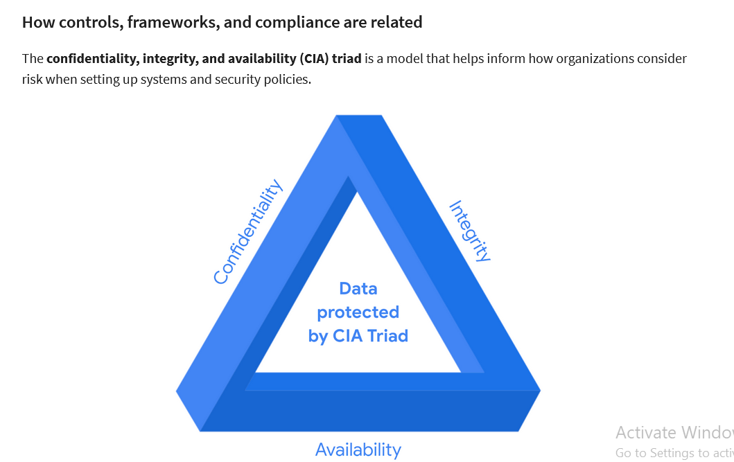

**Terms and definitions from Course 1, Module 3**

**Asset:** An item perceived as having value to an organization

**Availability:** The idea that data is accessible to those who are authorized to access it

**Compliance:** The process of adhering to internal standards and external regulations

**Confidentiality:** The idea that only authorized users can access specific assets or data

**Confidentiality, integrity, availability (CIA) triad:** A model that helps inform how organizations consider risk when setting up systems and security policies

**Hacktivist:** A person who uses hacking to achieve a political goal

**Health Insurance Portability and Accountability Act (HIPAA):** A U.S. federal law established to protect patients' health information

**Integrity:** The idea that the data is correct, authentic, and reliable

**National Institute of Standards and Technology (NIST) Cyber Security Framework (CSF):** A voluntary framework that consists of standards, guidelines, and best practices to manage cybersecurity risk

**Privacy protection:** The act of safeguarding personal information from unauthorized use

**Protected health information (PHI):** Information that relates to the past, present, or future physical or mental health or condition of an individual

**Security architecture:** A type of security design composed of multiple components, such as tools and processes, that are used to protect an organization from risks and external threats

**Security controls:** Safeguards designed to reduce specific security risks

**Security ethics:** Guidelines for making appropriate decisions as a security professional

**Security frameworks:** Guidelines used for building plans to help mitigate risk and threats to data and privacy

**Security governance:** Practices that help support, define, and direct security efforts of an organization

**Sensitive personally identifiable information (SPII):** A specific type of PII that falls under stricter handling guidelines

**Security information and event management (SIEM) tools**

A **SIEM tool** is an application that collects and analyzes log data to monitor critical activities in an organization. A **log** is a record of events that occur within an organization’s systems. Depending on the amount of data you’re working with, it could take hours or days to filter through log data on your own. SIEM tools reduce the amount of data an analyst must review by providing alerts for specific types of threats, risks, and vulnerabilities.

SIEM tools provide a series of dashboardsthat visually organize data into categories, allowing users to select the data they wish to analyze. Different SIEM toolshave different dashboard types that display the information you have access to.

SIEM tools also come with different hosting options, including on-premise and cloud. Organizations may choose one hosting option over another based on a security team member’s expertise. For example, because a cloud-hosted version tends to be easier to set up, use, and maintain than an on-premise version, a less experienced security team may choose this option for their organization.

## ****Terms and definitions from Course 1, Module 4****

**Antivirus software:** A software program used to prevent, detect, and eliminate malware and viruses

**Database:** An organized collection of information or data

**Data point:** A specific piece of information

**Intrusion detection system (IDS):** An application that monitors system activity and alerts on possible intrusions

**Linux:** An open-source operating system

**Log:** A record of events that occur within an organization’s systems

**Network protocol analyzer (packet sniffer):** A tool designed to capture and analyze data traffic within a network

**Order of volatility:** A sequence outlining the order of data that must be preserved from first to last

**Programming:** A process that can be used to create a specific set of instructions for a computer to execute tasks

**Protecting and preserving evidence:** The process of properly working with fragile and volatile digital evidence

**Security information and event management (SIEM)**: An application that collects and analyzes log data to monitor critical activities in an organization

**SQL (Structured Query Language):** A query language used to create, interact with, and request information from a database

# More about OWASP security principles

Previously, you learned that cybersecurity analysts help keep data safe and reduce risk for an organization by using a variety of security frameworks, controls, and security principles. In this reading, you will learn about more Open Web Application Security Project, recently renamed Open Worldwide Application Security Project® (OWASP), security principles and how entry-level analysts use them.

## Security principles

In the workplace, security principles are embedded in your daily tasks. Whether you are analyzing logs, monitoring a security information and event management (SIEM) dashboard, or using a [vulnerability scanner](https://csrc.nist.gov/glossary/term/vulnerability_scanner)

, you will use these principles in some way.

Previously, you were introduced to several OWASP security principles. These included:

* **Minimize attack surface area**: Attack surface refers to all the potential vulnerabilities a threat actor could exploit.
* **Principle of least privilege**: Users have the least amount of access required to perform their everyday tasks.
* **Defense in depth**: Organizations should have varying security controls that mitigate risks and threats.
* **Separation of duties**: Critical actions should rely on multiple people, each of whom follow the principle of least privilege.
* **Keep security simple**: Avoid unnecessarily complicated solutions. Complexity makes security difficult.
* **Fix security issues correctly**: When security incidents occur, identify the root cause, contain the impact, identify vulnerabilities, and conduct tests to ensure that remediation is successful.

# **More about security audits**

Previously, you were introduced to how to plan and complete an internal security audit. In this reading, you will learn more about security audits, including the goals and objectives of audits.

## Security audits

A **security audit** is a review of an organization's security controls, policies, and procedures against a set of expectations. Audits are independent reviews that evaluate whether an organization is meeting internal and external criteria. Internal criteria include outlined policies, procedures, and best practices. External criteria include regulatory compliance, laws, and federal regulations.

Additionally, a security audit can be used to assess an organization's established security controls. As a reminder, **security controls** are safeguards designed to reduce specific security risks.

Audits help ensure that security checks are made (i.e., daily monitoring of security information and event management dashboards), to identify threats, risks, and vulnerabilities. This helps maintain an organization’s security posture. And, if there are security issues, a remediation process must be in place.

## Goals and objectives of an audit

The goal of an audit is to ensure an organization's information technology (IT) practices are meeting industry and organizational standards. The objective is to identify and address areas of remediation and growth. Audits provide direction and clarity by identifying what the current failures are and developing a plan to correct them.

Security audits must be performed to safeguard data and avoid penalties and fines from governmental agencies. The frequency of audits is dependent on local laws and federal compliance regulations.

## Factors that affect audits

Factors that determine the types of audits an organization implements include:

* Industry type
* Organization size
* Ties to the applicable government regulations
* A business’s geographical location
* A business decision to adhere to a specific regulatory compliance

To review common compliance regulations that different organizations need to adhere to, refer to [the reading about controls, frameworks, and compliance](https://www.coursera.org/learn/foundations-of-cybersecurity/supplement/xu4pr/controls-frameworks-and-compliance)

.

## The role of frameworks and controls in audits

Along with compliance, it’s important to mention the role of frameworks and controls in security audits. Frameworks such as the National Institute of Standards and Technology Cybersecurity Framework (NIST CSF) and the international standard for information security (ISO 27000) series are designed to help organizations prepare for regulatory compliance security audits. By adhering to these and other relevant frameworks, organizations can save time when conducting external and internal audits. Additionally, frameworks, when used alongside controls, can support organizations’ ability to align with regulatory compliance requirements and standards.

There are three main categories of controls to review during an audit, which are administrative and/or managerial, technical, and physical controls. To learn more about specific controls related to each category, click the following link and select “Use Template.”

**CSF typically stands for "Cybersecurity Framework**." It is a voluntary framework developed by the National Institute of Standards and Technology (NIST) to provide organizations with standards, guidelines, and best practices to manage and improve their cybersecurity posture. The CSF helps organizations assess and improve their ability to prevent, detect, respond to, and recover from cybersecurity threats and incidents. It consists of a set of core functions: Identify, Protect, Detect, Respond, and Recover, which provide a structured approach to managing cybersecurity risk.

1. Identify:
   * The Identify function involves understanding the cybersecurity risks to an organization's systems, assets, data, and capabilities.
   * This includes identifying the resources that need to be protected, understanding the potential threats and vulnerabilities, and determining the potential impact of a cybersecurity incident on the organization's business objectives.
   * Key activities under this function include asset management, risk assessment, and understanding of roles and responsibilities.
2. Protect:
   * The Protect function focuses on implementing safeguards to mitigate the cybersecurity risks identified in the Identify function.
   * This involves implementing security controls and measures to protect the confidentiality, integrity, and availability of critical assets and data.
   * Examples of protective measures include access controls, encryption, secure configurations, and security awareness training for employees.
3. Detect:
   * The Detect function involves developing and implementing capabilities to identify cybersecurity threats and incidents promptly.
   * This includes continuous monitoring, anomaly detection, and incident detection techniques to identify unauthorized access, malicious activity, or security breaches.
   * The goal is to detect cybersecurity events in a timely manner to minimize the impact and facilitate effective response and recovery efforts.
4. Respond:
   * The Respond function focuses on developing and implementing response procedures to effectively respond to cybersecurity incidents.
   * This includes establishing response plans, defining roles and responsibilities, and coordinating response activities to contain and mitigate the impact of incidents.
   * Response activities may include incident analysis, containment, eradication, recovery, and communication with stakeholders.
5. Recover:
   * The Recover function involves developing and implementing strategies to restore capabilities and services affected by cybersecurity incidents.
   * This includes restoring data, systems, and operations to normal functionality, as well as implementing measures to prevent similar incidents in the future.
   * Recovery activities may include data backups, system restoration, resilience planning, and lessons learned to improve future response and recovery efforts.

## Audit checklist

It’s necessary to create an audit checklist before conducting an audit. A checklist is generally made up of the following areas of focus:

**Identify the scope of the audit**

* The audit should:
  + List assets that will be assessed (e.g., firewalls are configured correctly, PII is secure, physical assets are locked, etc.)
  + Note how the audit will help the organization achieve its desired goals
  + Indicate how often an audit should be performed
  + Include an evaluation of organizational policies, protocols, and procedures to make sure they are working as intended and being implemented by employees

**Complete a risk assessment**

* A risk assessment is used to evaluate identified organizational risks related to budget, controls, internal processes, and external standards (i.e., regulations).

**Conduct the audit**

* When conducting an internal audit, you will assess the security of the identified assets listed in the audit scope.

**Create a mitigation plan**

* A mitigation plan is a strategy established to lower the level of risk and potential costs, penalties, or other issues that can negatively affect the organization’s security posture.

**Communicate results to stakeholders**

* The end result of this process is providing a detailed report of findings, suggested improvements needed to lower the organization's level of risk, and compliance regulations and standards the organization needs to adhere to.

## Key takeaways

In this reading you learned more about security audits, including what they are; why they’re conducted; and the role of frameworks, controls, and compliance in audits.

Although there is much more to learn about security audits, this introduction is meant to support your ability to complete an audit of your own for a self-reflection portfolio activity later in this course.

# Control categories

## Control categories

Controls within cybersecurity are grouped into three main categories:

* Administrative/Managerial controls
* Technical controls
* Physical controls

**Administrative/Managerial controls** address the human component of cybersecurity. These controls include policies and procedures that define how an organization manages data and clearly defines employee responsibilities, including their role in protecting the organization. While administrative controls are typically policy based, the enforcement of those policies may require the use of technical or physical controls.

**Technical controls** consist of solutions such as firewalls, intrusion detection systems (IDS), intrusion prevention systems (IPS), antivirus (AV) products, encryption, etc. Technical controls can be used in a number of ways to meet organizational goals and objectives.

**Physical controls** include door locks, cabinet locks, surveillance cameras, badge readers, etc. They are used to limit physical access to physical assets by unauthorized personnel.

## Control types

Control types include, but are not limited to:

1. Preventative
2. Corrective
3. Detective
4. Deterrent

These controls work together to provide defense in depth and protect assets. **Preventative controls** are designed to prevent an incident from occurring in the first place. **Corrective controls** are used to restore an asset after an incident. **Detective controls** are implemented to determine whether an incident has occurred or is in progress. **Deterrent controls** are designed to discourage attacks.

Review the following charts for specific details about each type of control and its purpose.

| **Administrative Controls** | | |
| --- | --- | --- |
| **Control Name** | **Control Type** | **Control Purpose** |
| Least Privilege | Preventative | Reduce risk and overall impact of malicious insider or compromised accounts |
| Disaster recovery plans | Corrective | Provide business continuity |
| Password policies | Preventative | Reduce likelihood of account compromise through brute force or dictionary attack techniques |
| Access control policies | Preventative | Bolster confidentiality and integrity by defining which groups can access or modify data |
| Account management policies | Preventative | Managing account lifecycle, reducing attack surface, and limiting overall impact from disgruntled former employees and default account usage |
| Separation of duties | Preventative | Reduce risk and overall impact of malicious insider or compromised accounts |

|  |  |  |
| --- | --- | --- |
| **Technical Controls** | | |
| **Control Name** | **Control Type** | **Control Purpose** |
| Firewall | Preventative | To filter unwanted or malicious traffic from entering the network |
| IDS/IPS | Detective | To detect and prevent anomalous traffic that matches a signature or rule |
| Encryption | Deterrent | Provide confidentiality to sensitive information |
| Backups | Corrective | Restore/recover from an event |
| Password management | Preventative | Reduce password fatigue |
| Antivirus (AV) software | Corrective | Detect and quarantine known threats |
| Manual monitoring, maintenance, and intervention | Preventative | Necessary to identify and manage threats, risks, or vulnerabilities to out-of-date systems |

|  |  |  |
| --- | --- | --- |
| **Physical Controls** | | |
| **Control Name** | **Control Type** | **Control Purpose** |
| Time-controlled safe | Deterrent | Reduce attack surface and overall impact from physical threats |
| Adequate lighting | Deterrent | Deter threats by limiting “hiding” places |
| Closed-circuit television (CCTV) | Preventative/Detective | Closed circuit television is both a preventative and detective control because it’s presence can reduce risk of certain types of events from occurring, and can be used after an event to inform on event conditions |
| Locking cabinets (for network gear) | Preventative | Bolster integrity by preventing unauthorized personnel and other individuals from physically accessing or modifying network infrastructure gear |
| Signage indicating alarm service provider | Deterrent | Deter certain types of threats by making the likelihood of a successful attack seem low |
| Locks | Deterrent/Preventative | Bolster integrity by deterring and preventing unauthorized personnel, individuals from physically accessing assets |
| Fire detection and prevention (fire alarm, sprinkler system, etc.) | Detective/Preventative | Detect fire in physical location and prevent damage to physical assets such as inventory, servers, etc. |

# Glossary terms from module 2

## ****Terms and definitions from Course 2, Module 2****

**Asset:** An item perceived as having value to an organization

**Attack vectors:** The pathways attackers use to penetrate security defenses

**Authentication:** The process of verifying who someone is

**Authorization:** The concept of granting access to specific resources in a system

**Availability:** The idea that data is accessible to those who are authorized to access it

**Biometrics:** The unique physical characteristics that can be used to verify a person’s identity

**Confidentiality:** The idea that only authorized users can access specific assets or data

**Confidentiality, integrity, availability (CIA) triad:** A model that helps inform how organizations consider risk when setting up systems and security policies

**Detect:** A NIST core function related to identifying potential security incidents and improving monitoring capabilities to increase the speed and efficiency of detections

**Encryption:** The process of converting data from a readable format to an encoded format

**Identify**: A NIST core function related to management of cybersecurity risk and its effect on an organization’s people and assets

**Integrity:** The idea that the data is correct, authentic, and reliable

**National Institute of Standards and Technology (NIST) Cybersecurity Framework (CSF):** A voluntary framework that consists of standards, guidelines, and best practices to manage cybersecurity risk

**National Institute of Standards and Technology (NIST) Special Publication (S.P.) 800-53:** A unified framework for protecting the security of information systems within the U.S. federal government

**Open Web Application Security Project/Open Worldwide Application Security Project (OWASP):** A non-profit organization focused on improving software security

**Protect:** A NIST core function used to protect an organization through the implementation of policies, procedures, training, and tools that help mitigate cybersecurity threats

**Recover:** A NIST core function related to returning affected systems back to normal operation

**Respond:** A NIST core function related to making sure that the proper procedures are used to contain, neutralize, and analyze security incidents, and implement improvements to the security process

**Risk:** Anything that can impact the confidentiality, integrity, or availability of an asset

**Security audit:** A review of an organization's security controls, policies, and procedures against a set of expectations

**Security controls:** Safeguards designed to reduce specific security risks

**Security frameworks:** Guidelines used for building plans to help mitigate risk and threats to data and privacy

**Security posture:** An organization’s ability to manage its defense of critical assets and data and react to change

**Threat:** Any circumstance or event that can negatively impact assets

## Current SIEM solutions

A **SIEM** tool is an application that collects and analyzes log data to monitor critical activities in an organization. SIEM tools offer real-time monitoring and tracking of security event logs. The data is then used to conduct a thorough analysis of any potential security threat, risk, or vulnerability identified. SIEM tools have many dashboard options. Each dashboard option helps cybersecurity team members manage and monitor organizational data. However, currently, SIEM tools require human interaction for analysis of security events.

## Splunk

Splunk offers different SIEM tool options: Splunk® Enterprise and Splunk® Cloud. Both allow you to review an organization's data on dashboards. This helps security professionals manage an organization's internal infrastructure by collecting, searching, monitoring, and analyzing log data from multiple sources to obtain full visibility into an organization’s everyday operations.

Review the following Splunk dashboards and their purposes:

### **Security posture dashboard**

The security posture dashboard is designed for security operations centers (SOCs). It displays the last 24 hours of an organization’s notable security-related events and trends and allows security professionals to determine if security infrastructure and policies are performing as designed. Security analysts can use this dashboard to monitor and investigate potential threats in real time, such as suspicious network activity originating from a specific IP address.

### **Executive summary dashboard**

The executive summary dashboard analyzes and monitors the overall health of the organization over time. This helps security teams improve security measures that reduce risk. Security analysts might use this dashboard to provide high-level insights to stakeholders, such as generating a summary of security incidents and trends over a specific period of time.

### **Incident review dashboard**

The incident review dashboard allows analysts to identify suspicious patterns that can occur in the event of an incident. It assists by highlighting higher risk items that need immediate review by an analyst. This dashboard can be very helpful because it provides a visual timeline of the events leading up to an incident.

### **Risk analysis dashboard**

The risk analysis dashboard helps analysts identify risk for each risk object (e.g., a specific user, a computer, or an IP address). It shows changes in risk-related activity or behavior, such as a user logging in outside of normal working hours or unusually high network traffic from a specific computer. A security analyst might use this dashboard to analyze the potential impact of vulnerabilities in critical assets, which helps analysts prioritize their risk mitigation efforts.

## Chronicle

Chronicle is a cloud-native SIEM tool from Google that retains, analyzes, and searches log data to identify potential security threats, risks, and vulnerabilities. Chronicle allows you to collect and analyze log data according to:

* A specific asset
* A domain name
* A user
* An IP address

Chronicle provides multiple dashboards that help analysts monitor an organization’s logs, create filters and alerts, and track suspicious domain names.

Review the following Chronicle dashboards and their purposes:

### **Enterprise insights dashboard**

The enterprise insights dashboard highlights recent alerts. It identifies suspicious domain names in logs, known as indicators of compromise (IOCs). Each result is labeled with a confidence score to indicate the likelihood of a threat. It also provides a severity level that indicates the significance of each threat to the organization. A security analyst might use this dashboard to monitor login or data access attempts related to a critical asset—like an application or system—from unusual locations or devices.

### **Data ingestion and health** **dashboard**

The data ingestion and health dashboard shows the number of event logs, log sources, and success rates of data being processed into Chronicle. A security analyst might use this dashboard to ensure that log sources are correctly configured and that logs are received without error. This helps ensure that log related issues are addressed so that the security team has access to the log data they need.

### **IOC** **matches** **dashboard**

The IOC matches dashboard indicates the top threats, risks, and vulnerabilities to the organization. Security professionals use this dashboard to observe domain names, IP addresses, and device IOCs over time in order to identify trends. This information is then used to direct the security team’s focus to the highest priority threats. For example, security analysts can use this dashboard to search for additional activity associated with an alert, such as a suspicious user login from an unusual geographic location.

### **Main** **dashboard**

The main dashboard displays a high-level summary of information related to the organization’s data ingestion, alerting, and event activity over time. Security professionals can use this dashboard to access a timeline of security events—such as a spike in failed login attempts— to identify threat trends across log sources, devices, IP addresses, and physical locations.

### **Rule detections** **dashboard**

The rule detections dashboard provides statistics related to incidents with the highest occurrences, severities, and detections over time. Security analysts can use this dashboard to access a list of all the alerts triggered by a specific detection rule, such as a rule designed to alert whenever a user opens a known malicious attachment from an email. Analysts then use those statistics to help manage recurring incidents and establish mitigation tactics to reduce an organization's level of risk.

### **User sign in overview** **dashboard**

The user sign in overview dashboard provides information about user access behavior across the organization. Security analysts can use this dashboard to access a list of all user sign-in events to identify unusual user activity, such as a user signing in from multiple locations at the same time. This information is then used to help mitigate threats, risks, and vulnerabilities to user accounts and the organization’s applications.

## Terms and definitions from Course 2, Module 3

**Chronicle:** A cloud-native tool designed to retain, analyze, and search data

**Incident response:** An organization’s quick attempt to identify an attack, contain the damage, and correct the effects of a security breach

**Log:** A record of events that occur within an organization’s systems

**Metrics:** Key technical attributes such as response time, availability, and failure rate, which are used to assess the performance of a software application

**Operating system (OS):** The interface between computer hardware and the user

**Playbook:** A manual that provides details about any operational action

**Security information and event management (SIEM):** An application that collects and analyzes log data to monitor critical activities in an organization

**Security orchestration, automation, and response (SOAR):** A collection of applications, tools, and workflows that use automation to respond to security events

**SIEM tools:** A software platform that collects, analyzes, and correlates security data from various sources across your IT infrastructure that helps identify and respond to security threats in real-time, investigate security incidents, and comply with security regulations

**Splunk Cloud:** A cloud-hosted tool used to collect, search, and monitor log data

**Splunk Enterprise:** A self-hosted tool used to retain, analyze, and search an organization's log data to provide security information and alerts in real-time

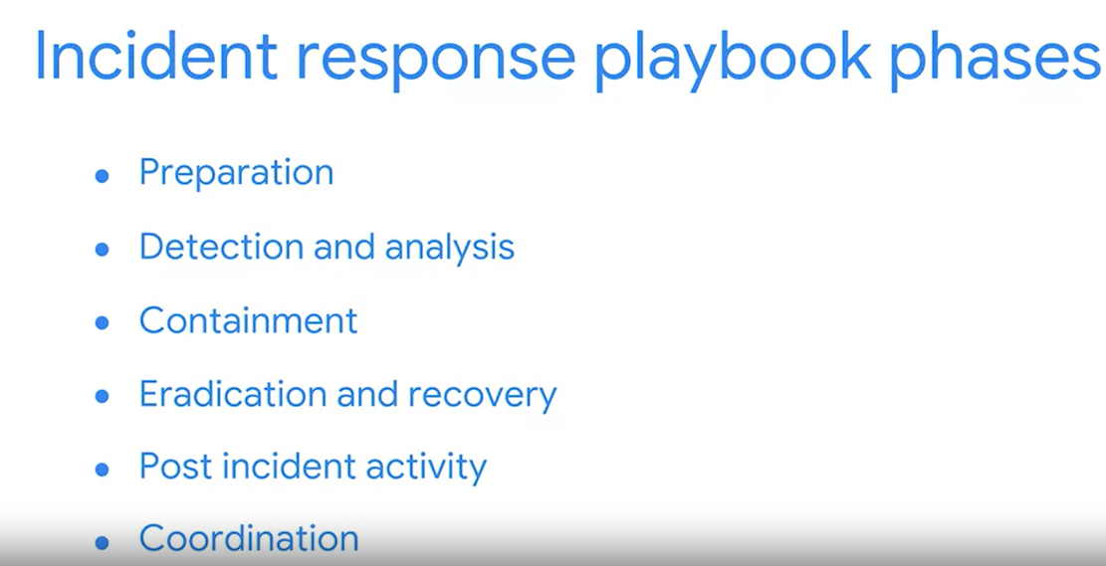

### **Incident and vulnerability response playbooks**

Incident and vulnerability response playbooks are commonly used by entry-level cybersecurity professionals. They are developed based on the goals outlined in an organization’s business continuity plan. A business continuity plan is an established path forward allowing a business to recover and continue to operate as normal, despite a disruption like a security breach.

These two types of playbooks are similar in that they both contain predefined and up-to-date lists of steps to perform when responding to an incident. Following these steps is necessary to ensure that you, as a security professional, are adhering to legal and organizational standards and protocols. These playbooks also help minimize errors and ensure that important actions are performed within a specific timeframe.

When an incident, threat, or vulnerability occurs or is identified, the level of risk to the organization depends on the potential damage to its assets. A basic formula for determining the level of risk is that risk equals the likelihood of a threat. For this reason, a sense of urgency is essential. Following the steps outlined in playbooks is also important if any forensic task is being carried out. Mishandling data can easily compromise forensic data, rendering it unusable.

## Playbooks and SOAR tools

Playbooks are also used with SOAR tools. SOAR tools are similar to SIEM tools in that they are used for threat monitoring. SOAR is a piece of software used to automate repetitive tasks generated by tools such as a SIEM or managed detection and response (MDR). For example, if a user attempts to log into their computer too many times with the wrong password, a SOAR would automatically block their account to stop a possible intrusion. Then, analysts would refer to a playbook to take steps to resolve the issue.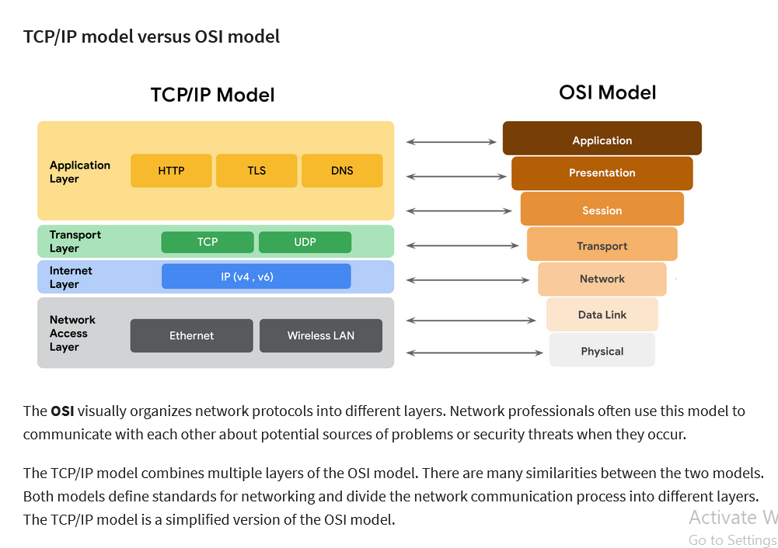

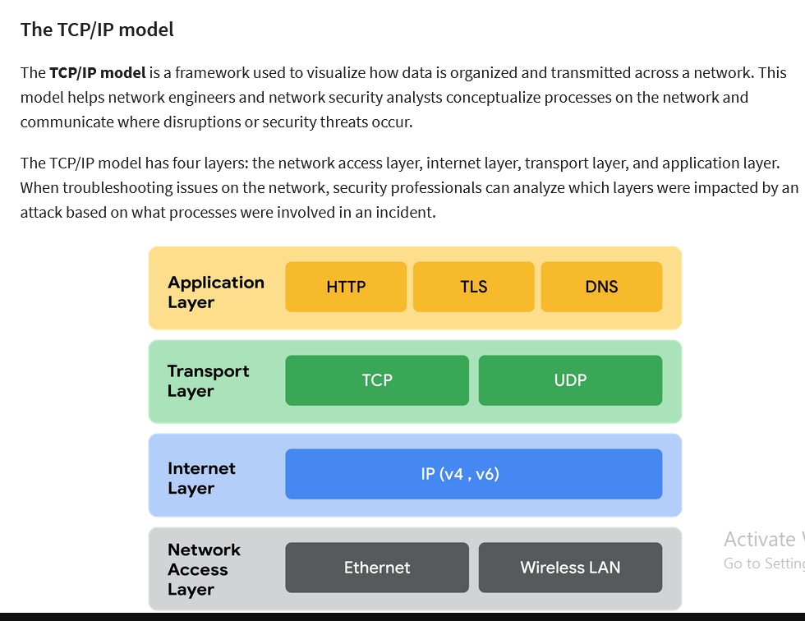

As a security professional, it's important that you understand the TCP/IP model because it describes the functions of various network protocols. The TCP/IP model is based on the TCP/IP protocols suite that includes all network protocols that support the main TCP/IP protocol. To reiterate from previous lessons, a network protocol, also known as an internet protocol, is a set of standards used for routing and addressing data packets as they travel between devices on a network. In this reading, you will learn which network protocols operate on which communication layers of the TCP/IP model. The two most common models available are the TCP/IP and the OSI model. These models are a representative guideline of how hosts communicate across a network. The examples provided in this course will follow the TCP/IP model.

## The TCP/IP model

The **TCP/IP model** is a framework used to visualize how data is organized and transmitted across a network. This model helps network engineers and network security analysts conceptualize processes on the network and communicate where disruptions or security threats occur.

The TCP/IP model has four layers: the network access layer, internet layer, transport layer, and application layer. When troubleshooting issues on the network, security professionals can analyze which layers were impacted by an attack based on what processes were involved in an incident.

## Network access layer

The network access layer, sometimes called the data link layer, deals with the creation of data packets and their transmission across a network. This layer corresponds to the physical hardware involved in network transmission. Hubs, modems, cables, and wiring are all considered part of this layer. The address resolution protocol (ARP) is part of the network access layer. Since MAC addresses are used to identify hosts on the same physical network, ARP is needed to map IP addresses to MAC addresses for local network communication.

## Internet layer

The internet layer, sometimes referred to as the network layer, is responsible for ensuring the delivery to the destination host, which potentially resides on a different network. It ensures IP addresses are attached to data packets to indicate the location of the sender and receiver. The internet layer also determines which protocol is responsible for delivering the data packets and ensures the delivery to the destination host. Here are some of the common protocols that operate at the internet layer:

* **Internet Protocol (IP)**. IP sends the data packets to the correct destination and relies on the Transmission Control Protocol/User Datagram Protocol (TCP/UDP) to deliver them to the corresponding service. IP packets allow communication between two networks. They are routed from the sending network to the receiving network. TCP in particular retransmits any data that is lost or corrupt.
* **Internet Control Message Protocol (ICMP)**. The ICMP shares error information and status updates of data packets. This is useful for detecting and troubleshooting network errors. The ICMP reports information about packets that were dropped or that disappeared in transit, issues with network connectivity, and packets redirected to other routers.

## Transport layer

The transport layer is responsible for delivering data between two systems or networks and includes protocols to control the flow of traffic across a network. TCP and UDP are the two transport protocols that occur at this layer.

### Transmission Control Protocol

The **Transmission Control Protocol (TCP)** is an internet communication protocol that allows two devices to form a connection and stream data. It ensures that data is reliably transmitted to the destination service. TCP contains the port number of the intended destination service, which resides in the TCP header of a TCP/IP packet.

### User Datagram Protocol

The **User Datagram Protocol (UDP)** is a connectionless protocol that does not establish a connection between devices before transmissions. It is used by applications that are not concerned with the reliability of the transmission. Data sent over UDP is not tracked as extensively as data sent using TCP. Because UDP does not establish network connections, it is used mostly for performance sensitive applications that operate in real time, such as video streaming.

## Application layer

The application layer in the TCP/IP model is similar to the application, presentation, and session layers of the OSI model. The application layer is responsible for making network requests or responding to requests. This layer defines which internet services and applications any user can access. Protocols in the application layer determine how the data packets will interact with receiving devices. Some common protocols used on this layer are:

* Hypertext transfer protocol (HTTP)
* Simple mail transfer protocol (SMTP)
* Secure shell (SSH)
* File transfer protocol (FTP)
* Domain name system (DNS)

Application layer protocols rely on underlying layers to transfer the data across the network.

## OSI MODEL Layer 7: Application layer

The application layer includes processes that directly involve the everyday user. This layer includes all of the networking protocols that software applications use to connect a user to the internet. This characteristic is the identifying feature of the application layer—user connection to the internet via applications and requests.

An example of a type of communication that happens at the application layer is using a web browser. The internet browser uses HTTP or HTTPS to send and receive information from the website server. The email application uses simple mail transfer protocol (SMTP) to send and receive email information. Also, web browsers use the domain name system (DNS) protocol to translate website domain names into IP addresses which identify the web server that hosts the information for the website.

## Layer 6: Presentation layer

Functions at the presentation layer involve data translation and encryption for the network. This layer adds to and replaces data with formats that can be understood by applications (layer 7) on both sending and receiving systems. Formats at the user end may be different from those of the receiving system. Processes at the presentation layer require the use of a standardized format.

Some formatting functions that occur at layer 6 include encryption, compression, and confirmation that the character code set can be interpreted on the receiving system. One example of encryption that takes place at this layer is SSL, which encrypts data between web servers and browsers as part of websites with HTTPS.

## Layer 5: Session layer

A session describes when a connection is established between two devices. An open session allows the devices to communicate with each other. Session layer protocols keep the session open while data is being transferred and terminate the session once the transmission is complete.

The session layer is also responsible for activities such as authentication, reconnection, and setting checkpoints during a data transfer. If a session is interrupted, checkpoints ensure that the transmission picks up at the last session checkpoint when the connection resumes. Sessions include a request and response between applications. Functions in the session layer respond to requests for service from processes in the presentation layer (layer 6) and send requests for services to the transport layer (layer 4).

## Layer 4: Transport layer

The transport layer is responsible for delivering data between devices. This layer also handles the speed of data transfer, flow of the transfer, and breaking data down into smaller segments to make them easier to transport. Segmentation is the process of dividing up a large data transmission into smaller pieces that can be processed by the receiving system. These segments need to be reassembled at their destination so they can be processed at the session layer (layer 5). The speed and rate of the transmission also has to match the connection speed of the destination system. TCP and UDP are transport layer protocols.

## Layer 3: Network layer

The network layer oversees receiving the frames from the data link layer (layer 2) and delivers them to the intended destination. The intended destination can be found based on the address that resides in the frame of the data packets. Data packets allow communication between two networks. These packets include IP addresses that tell routers where to send them. They are routed from the sending network to the receiving network.

## Layer 2: Data link layer

The data link layer organizes sending and receiving data packets within a single network. The data link layer is home to switches on the local network and network interface cards on local devices.

Protocols like network control protocol (NCP), high-level data link control (HDLC), and synchronous data link control protocol (SDLC) are used at the data link layer.

## Layer 1: Physical layer

As the name suggests, the physical layer corresponds to the physical hardware involved in network transmission. Hubs, modems, and the cables and wiring that connect them are all considered part of the physical layer. To travel across an ethernet or coaxial cable, a data packet needs to be translated into a stream of 0s and 1s. The stream of 0s and 1s are sent across the physical wiring and cables, received, and then passed on to higher levels of the OSI model.

## Key takeaways

Both the TCP/IP and OSI models are conceptual models that help network professionals design network processes and protocols with regards to data transmission between two or more systems. The OSI model contains seven communication layers. Network and security professionals use the OSI model to communicate with each other about potential sources of problems or security threats when they occur.  Network engineers and network security analysts use the TCP/IP and OSI models to conceptualize network processes and communicate the location of disruptions or threats.

## Terms and definitions from Course 3, Module 1

**Bandwidth:** The maximum data transmission capacity over a network, measured by bits per second

**Cloud computing:** The practice of using remote servers, application, and network services that are hosted on the internet instead of on local physical devices

**Cloud network:** A collection of servers or computers that stores resources and data in remote data centers that can be accessed via the internet

**Data packet:** A basic unit of information that travels from one device to another within a network

**Hub:** A network device that broadcasts information to every device on the network

**Internet Protocol (IP):** A set of standards used for routing and addressing data packets as they travel between devices on a network

**Internet Protocol (IP) address:** A unique string of characters that identifies the location of a device on the internet

**Local Area Network (LAN):** A network that spans small areas like an office building, a school, or a home

**Media Access Control (MAC) address:** A unique alphanumeric identifier that is assigned to each physical device on a network

**Modem:** A device that connects your router to the internet and brings internet access to the LAN

**Network:** A group of connected devices

**Open systems interconnection (OSI) model:** A standardized concept that describes the seven layers computers use to communicate and send data over the network

**Packet sniffing:** The practice of capturing and inspecting data packets across a network

**Port:** A software-based location that organizes the sending and receiving of data between devices on a network

**Router:** A network device that connects multiple networks together

**Speed:** The rate at which a device sends and receives data, measured by bits per second

**Switch:** A device that makes connections between specific devices on a network by sending and receiving data between them

**TCP/IP model:** A framework used to visualize how data is organized and transmitted across a network

**Transmission Control Protocol (TCP):** An internet communication protocol that allows two devices to form a connection and stream data

**User Datagram Protocol (UDP):** A connectionless protocol that does not establish a connection between devices before transmissions

**Wide Area Network (WAN):** A network that spans a large geographic area like a city, state, or country

## Three categories of network protocols

Network protocols can be divided into three main categories: communication protocols, management protocols, and security protocols. There are dozens of different network protocols, but you don’t need to memorize all of them for an entry-level security analyst role. However, it’s important for you to know the ones listed in this reading.

### **Communication protocols**

Communication protocols govern the exchange of information in network transmission. They dictate how the data is transmitted between devices and the timing of the communication. They also include methods to recover data lost in transit. Here are a few of them.

* **Transmission Control Protocol (TCP)** is an internet communication protocol that allows two devices to form a connection and stream data. TCP uses a three-way handshake process. First, the device sends a synchronize (SYN) request to a server. Then the server responds with a SYN/ACK packet to acknowledge receipt of the device's request. Once the server receives the final ACK packet from the device, a TCP connection is established. In the TCP/IP model, TCP occurs at the transport layer.
* **User Datagram Protocol (UDP)** is a connectionless protocol that does not establish a connection between devices before a transmission. This makes it less reliable than TCP. But it also means that it works well for transmissions that need to get to their destination quickly. For example, one use of UDP is for sending DNS requests to local DNS servers. In the TCP/IP model, UDP occurs at the transport layer.
* **Hypertext Transfer Protocol (HTTP)** is an application layer protocol that provides a method of communication between clients and website servers. HTTP uses port 80. HTTP is considered insecure, so it is being replaced on most websites by a secure version, called HTTPS that uses encryption from SSL/TLS for communication. However, there are still many websites that use the insecure HTTP protocol. In the TCP/IP model, HTTP occurs at the application layer.
* **Domain Name System (DNS)** is a protocol that translates internet domain names into IP addresses. When a client computer wishes to access a website domain using their internet browser, a query is sent to a dedicated DNS server. The DNS server then looks up the IP address that corresponds to the website domain. DNS normally uses UDP on port 53. However, if the DNS reply to a request is large, it will switch to using the TCP protocol. In the TCP/IP model, DNS occurs at the application layer.

### **Management Protocols**

The next category of network protocols is management protocols. Management protocols are used for monitoring and managing activity on a network. They include protocols for error reporting and optimizing performance on the network.

* **Simple Network Management Protocol (SNMP)** is a network protocol used for monitoring and managing devices on a network. SNMP can reset a password on a network device or change its baseline configuration. It can also send requests to network devices for a report on how much of the network’s bandwidth is being used up. In the TCP/IP model, SNMP occurs at the application layer.
* **Internet Control Message Protocol (ICMP)** is an internet protocol used by devices to tell each other about data transmission errors across the network. ICMP is used by a receiving device to send a report to the sending device about the data transmission. ICMP is commonly used as a quick way to troubleshoot network connectivity and latency by issuing the “ping” command on a Linux operating system. In the TCP/IP model, ICMP occurs at the internet layer.

### **Security Protocols**

Security protocols are network protocols that ensure that data is sent and received securely across a network. Security protocols use encryption algorithms to protect data in transit. Below are some common security protocols.

* **Hypertext Transfer Protocol Secure (HTTPS)** is a network protocol that provides a secure method of communication between clients and website servers. HTTPS is a secure version of HTTP that uses secure sockets layer/transport layer security (SSL/TLS) encryption on all transmissions so that malicious actors cannot read the information contained. HTTPS uses port 443. In the TCP/IP model, HTTPS occurs at the application layer.
* **Secure File Transfer Protocol (SFTP)** is a secure protocol used to transfer files from one device to another over a network. SFTP uses secure shell (SSH), typically through TCP port 22. SSH uses Advanced Encryption Standard (AES) and other types of encryption to ensure that unintended recipients cannot intercept the transmissions. In the TCP/IP model, SFTP occurs at the application layer. SFTP is used often with cloud storage. Every time a user uploads or downloads a file from cloud storage, the file is transferred using the SFTP protocol.

**Note:** The encryption protocols mentioned do not conceal the source or destination IP address of network traffic. This means a malicious actor can still learn some basic information about the network traffic if they intercept it.

## Dynamic Host Configuration Protocol

Dynamic Host Configuration Protocol (DHCP) is in the management family of network protocols. DHCP is an application layer protocol used on a network to configure devices. It works with the router to assign a unique IP address to each device and provide the addresses of the appropriate DNS server and default gateway for each device. DHCP servers operate on UDP port 67 while DHCP clients operate on UDP port 68.

## Address Resolution Protocol

By now, you are familiar with IP and MAC addresses. You’ve learned that each device on a network has a public IP address, a private IP address, and a MAC address that identify it on the network. A device’s IP address may change over time, but its MAC address is permanent because it is unique to a device's network interface card. The MAC address is used to communicate with devices within the same network, but sometimes, the MAC address is unknown. This is why the Address Resolution Protocol (ARP) is needed. ARP is mainly a network access layer protocol in the TCP/IP model used to translate the IP addresses that are found in data packets into the MAC address of the hardware device.

Each device on the network performs ARP and keeps track of matching IP and MAC addresses in an ARP cache. ARP does not have a specific port number since it is a layer 2 protocol and port numbers are associated with the layer 7 application layer.

## Telnet

Telnet is an application layer protocol that is used to connect with a remote system. Telnet sends all information in clear text. It uses command line prompts to control another device similar to secure shell (SSH), but Telnet is not as secure as SSH. Telnet can be used to connect to local or remote devices and uses TCP port 23.

## Secure shell

Secure shell protocol (SSH) is used to create a secure connection with a remote system. This application layer protocol provides an alternative for secure authentication and encrypted communication. SSH operates over the TCP port 22 and is a replacement for less secure protocols, such as Telnet.

## Post office protocol

Post office protocol (POP) is an application layer (layer 4 of the TCP/IP model) protocol used to manage and retrieve email from a mail server. POP3 is the most commonly used version of POP. Many organizations have a dedicated mail server on the network that handles incoming and outgoing mail for users on the network. User devices will send requests to the remote mail server and download email messages locally. If you have ever refreshed your email application and had new emails populate in your inbox, you are experiencing POP and internet message access protocol (IMAP) in action. Unencrypted, plaintext authentication uses TCP/UDP port 110 and encrypted emails use Secure Sockets Layer/Transport Layer Security (SSL/TLS) over TCP/UDP port 995.  When using POP, mail has to finish downloading on a local device before it can be read. After downloading, the mail may or may not be deleted from the mail server, so it does not guarantee that a user can sync the same email across multiple devices.

## Internet Message Access Protocol (IMAP)

IMAP is used for incoming email. It downloads the headers of emails and the message content. The content also remains on the email server, which allows users to access their email from multiple devices. IMAP uses TCP port 143 for unencrypted email and TCP port 993 over the TLS protocol. Using IMAP allows users to partially read email before it is finished downloading. Since the mail is kept on the mail server, it allows a user to sync emails across multiple devices.

## Simple Mail Transfer Protocol

Simple Mail Transfer Protocol (SMTP) is used to transmit and route email from the sender to the recipient’s address. SMTP works with Message Transfer Agent (MTA) software, which searches DNS servers to resolve email addresses to IP addresses, to ensure emails reach their intended destination. SMTP uses TCP/UDP port 25 for unencrypted emails and TCP/UDP port 587 using TLS for encrypted emails. The TCP port 25 is often used by high-volume spam. SMTP helps to filter out spam by regulating how many emails a source can send at a time.

## Protocols and port numbers

Remember that port numbers are used by network devices to determine what should be done with the information contained in each data packet once they reach their destination. Firewalls can filter out unwanted traffic based on port numbers. For example, an organization may configure a firewall to only allow access to TCP port 995 (POP3) by IP addresses belonging to the organization.

As a security analyst, you will need to know about many of the protocols and port numbers mentioned in this course. They may be used to determine your technical knowledge in interviews, so it’s a good idea to memorize them. You will also learn about new protocols on the job in a security position.

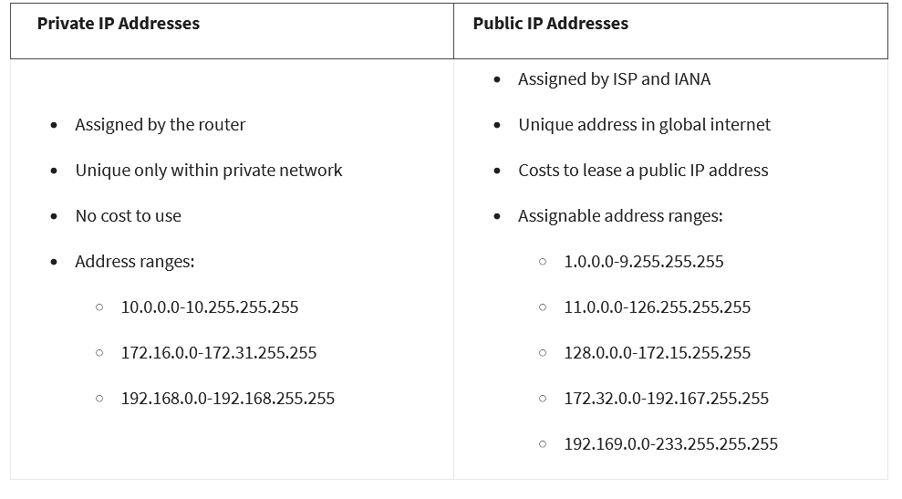

## ****Network security tools and practices****

### **Firewalls**

Previously, you learned that firewalls are network virtual appliances (NVAs) or hardware devices that inspect and can filter network traffic before it’s permitted to enter the private network. Traditional firewalls are configured with rules that tell it what types of data packets are allowed based on the port number and IP address of the data packet.

There are two main categories of firewalls.

* **Stateless:** A class of firewall that operates based on predefined rules and does not keep track of information from data packets
* **Stateful:** A class of firewall that keeps track of information passing through it and proactively filters out threats. Unlike stateless firewalls, which require rules to be configured in two directions, a stateful firewall only requires a rule in one direction. This is because it uses a "state table" to track connections, so it can match return traffic to an existing session

Next generation firewalls (NGFWs) are the most technologically advanced firewall protection. They exceed the security offered by stateful firewalls because they include deep packet inspection (a kind of packet sniffing that examines data packets and takes actions if threats exist) and intrusion prevention features that detect security threats and notify firewall administrators. NGFWs can inspect traffic at the application layer of the TCP/IP model and are typically application aware. Unlike traditional firewalls that block traffic based on IP address and ports, NGFWs rules can be configured to block or allow traffic based on the application. Some NGFWs have additional features like Malware Sandboxing, Network Anti-Virus, and URL and DNS Filtering.

### **Proxy servers**

A proxy server is another way to add security to your private network. Proxy servers utilize network address translation (NAT) to serve as a barrier between clients on the network and external threats. Forward proxies handle queries from internal clients when they access resources external to the network. Reverse proxies function opposite of forward proxies; they handle requests from external systems to services on the internal network. Some proxy servers can also be configured with rules, like a firewall.  For example, you can create filters to block websites identified as containing malware.

### **Virtual Private Networks (VPN)**

A VPN is a service that encrypts data in transit and disguises your IP address. VPNs use a process called encapsulation. Encapsulation wraps your unencrypted data in an encrypted data packet, which allows your data to be sent across the public network while remaining anonymous. Enterprises and other organizations use VPNs to help protect communications from users’ devices to corporate resources. Some of these resources include servers or virtual machines that host business applications. Individuals also use VPNs to increase personal privacy. VPNs protect user privacy by concealing personal information, including IP addresses, from external servers. A reputable VPN also minimizes its own access to user internet activity by using strong encryption and other security measures. Organizations are increasingly using a combination of VPN and SD-WAN capabilities to secure their networks. A software-defined wide area network (SD-WAN) is a virtual WAN service that allows organizations to securely connect users to applications across multiple locations and over large geographical distances.

## Terms and definitions from Course 3, Module 2

**Address Resolution Protocol (ARP):** A network protocol used to determine the MAC address of the next router or device on the path

**Cloud-based firewalls:** Software firewalls that are hosted by the cloud service provider

**Controlled zone:** A subnet that protects the internal network from the uncontrolled zone

**Domain Name System (DNS):** A networking protocol that translates internet domain names into IP addresses

**Encapsulation:** A process performed by a VPN service that protects your data by wrapping sensitive data in other data packets

**Firewall:** A network security device that monitors traffic to or from your network

**Forward proxy server:** A server that regulates and restricts a person’s access to the internet

**Hypertext Transfer Protocol (HTTP):** An application layer protocol that provides a method of communication between clients and website servers

**Hypertext Transfer Protocol Secure (HTTPS):** A network protocol that provides a secure method of communication between clients and servers

**IEEE 802.11 (Wi-Fi):** A set of standards that define communication for wireless LANs

**Network protocols:** A set of rules used by two or more devices on a network to describe the order of delivery of data and the structure of data

**Network segmentation:** A security technique that divides the network into segments

**Port filtering:** Afirewall function that blocks or allows certain port numbers to limit unwanted communication

**Proxy server:** A server that fulfills the requests of its clients by forwarding them to other servers

**Reverse proxy server:** A server that regulates and restricts the internet's access to an internal server

**Secure File Transfer Protocol (SFTP):** A secure protocol used to transfer files from one device to another over a network

**Secure shell (SSH):** A security protocol used to create a shell with a remote system

**Security zone:** A segment of a company’s network that protects the internal network from the internet

**Simple Network Management Protocol (SNMP):** A network protocol used for monitoring and managing devices on a network

**Stateful:** A class of firewall that keeps track of information passing through it and proactively filters out threats

**Stateless:** A class of firewall that operates based on predefined rules and does not keep track of information from data packets

**Subnetting:** The subdivision of a network into logical groups called subnets

**Transmission Control Protocol (TCP):** An internet communication protocol that allows two devices to form a connection and stream data

**Uncontrolled zone:** The portion of the network outside the organization

**Virtual private network (VPN):** A network security service that changes your public IP address and masks your virtual location so that you can keep your data private when you are using a public network like the internet

**Wi-Fi Protected Access (WPA):** A wireless security protocol for devices to connect to the internet

## Terms and definitions from Course 3, Module 3

**Active packet sniffing:** A type of attack where data packets are manipulated in transit

**Botnet:** A collection of computers infected by malware that are under the control of a single threat actor, known as the “bot-herder"

**Denial of service (DoS) attack:** An attack that targets a network or server and floods it with network traffic

**Distributed denial of service (DDoS) attack:** A type of denial of service attack that uses multiple devices or servers located in different locations to flood the target network with unwanted traffic

**Internet Control Message Protocol (ICMP):** An internet protocol used by devices to tell each other about data transmission errors across the network

**Internet Control Message Protocol (ICMP) flood:** A type of DoS attack performed by an attacker repeatedly sending ICMP request packets to a network server

**IP spoofing:** A network attack performed when an attacker changes the source IP of a data packet to impersonate an authorized system and gain access to a network

**On-path attack:** An attack where a malicious actor places themselves in the middle of an authorized connection and intercepts or alters the data in transit

**Packet sniffing:** The practice of capturing and inspecting data packets across a network

**Passive packet sniffing:** A type of attack where a malicious actor connects to a network hub and looks at all traffic on the network

**Ping of death:** A type of DoS attack caused when a hacker pings a system by sending it an oversized ICMP packet that is bigger than 64KB

**Replay attack:** A network attack performed when a malicious actor intercepts a data packet in transit and delays it or repeats it at another time

**Smurf attack:** A network attack performed when an attacker sniffs an authorized user’s IP address and floods it with ICMP packets

**Synchronize (SYN) flood attack:** A type of DoS attack that simulates a TCP/IP connection and floods a server with SYN packets

## Intrusion Detection System

An **intrusion detection system** (IDS) is an application that monitors system activity and alerts on possible intrusions. An IDS alerts administrators based on the signature of malicious traffic.

The IDS is configured to detect known attacks. IDS systems often sniff data packets as they move across the network and analyze them for the characteristics of known attacks. Some IDS systems review not only for signatures of known attacks, but also for anomalies that could be the sign of malicious activity. When the IDS discovers an anomaly, it sends an alert to the network administrator who can then investigate further.

The limitations to IDS systems are that they can only scan for known attacks or obvious anomalies. New and sophisticated attacks might not be caught. The other limitation is that the IDS doesn’t actually stop the incoming traffic if it detects something awry. It’s up to the network administrator to catch the malicious activity before it does anything damaging to the network

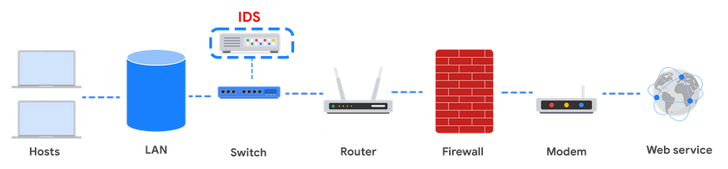

**Intrusion Prevention System**

An **intrusion prevention system (IPS)** is an application that monitors system activity for intrusive activity and takes action to stop the activity. It offers even more protection than an IDS because it actively stops anomalies when they are detected, unlike the IDS that simply reports the anomaly to a network administrator.

An IPS searches for signatures of known attacks and data anomalies. An IPS reports the anomaly to security analysts and blocks a specific sender or drops network packets that seem suspect.

The IPS (like an IDS) sits behind the firewall in the network architecture. This offers a high level of security because risky data streams are disrupted before they even reach sensitive parts of the network. However, one potential limitation is that it is inline: If it breaks, the connection between the private network and the internet breaks. Another limitation of IPS is the possibility of false positives, which can result in legitimate traffic getting dropped.

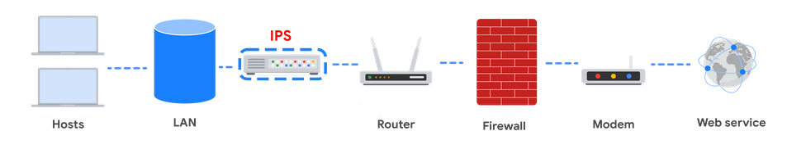

## Security Information and Event Management

A **security information and event management system (SIEM)** is an application that collects and analyzes log data to monitor critical activities in an organization. SIEM tools work in real time to report suspicious activity in a centralized dashboard. SIEM tools additionally analyze network log data sourced from IDSs, IPSs, firewalls, VPNs, proxies, and DNS logs. SIEM tools are a way to aggregate security event data so that it all appears in one place for security analysts to analyze. This is referred to as a single pane of glass.

Below, you can review an example of a dashboard from Google Cloud’s SIEM tool, Chronicle. **Chronicle** is a cloud-native tool designed to retain, analyze, and search data.

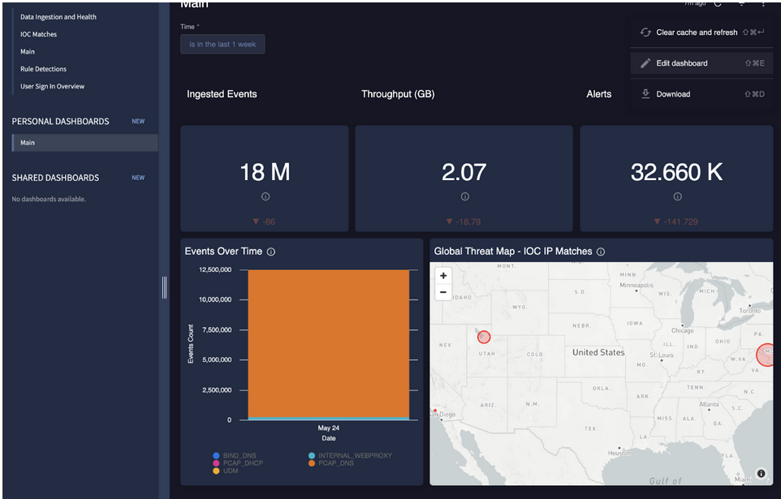

**Splunk** is another common SIEM tool. Splunk offers different SIEM tool options: Splunk Enterprise and Splunk Cloud. Both options include detailed dashboards which help security professionals to review and analyze an organization's data. There are also other similar SIEM tools available, and it's important for security professionals to research the different tools to determine which one is most beneficial to the organization.

A SIEM tool doesn’t replace the expertise of security analysts, or of the network- and system-hardening activities covered in this course, but they’re used in combination with other security methods. Security analysts often work in a Security Operations Center (SOC) where they can monitor the activity across the network. They can then use their expertise and experience to determine how to respond to the information on the dashboard and decide when the events meet the criteria to be escalated to oversight.

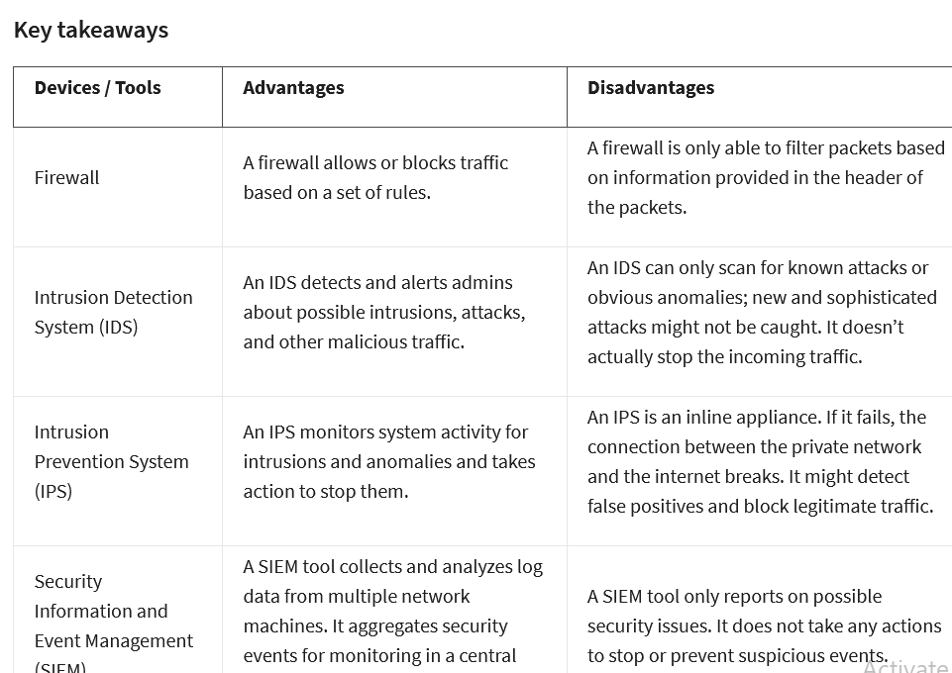

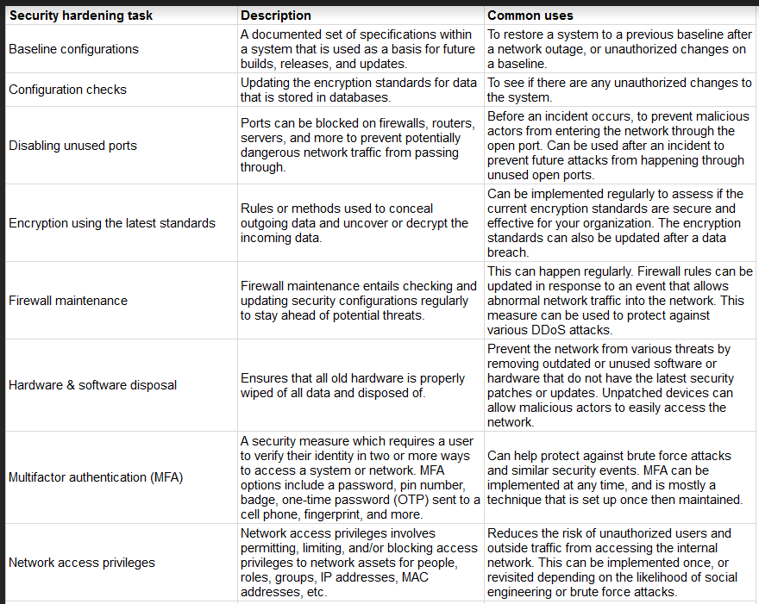

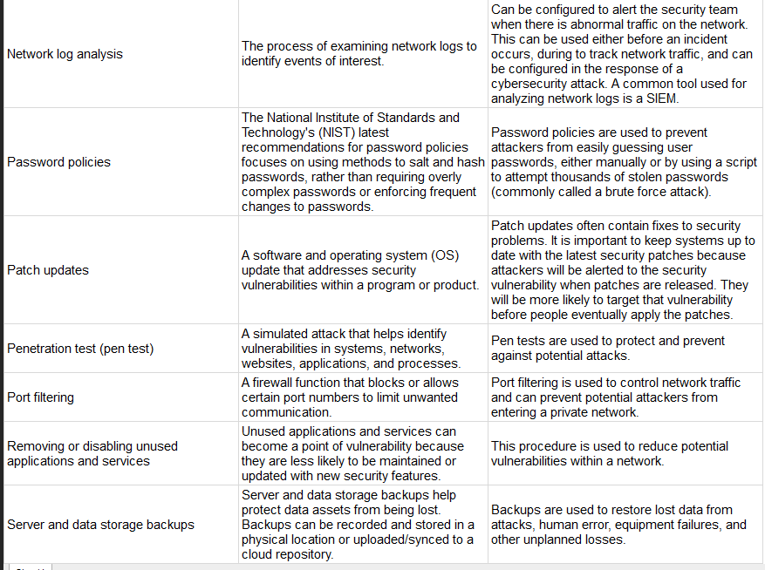

# Cryptography and cloud security

Earlier in this course, you were introduced to the concepts of the shared responsibility model and identity and access management (IAM). Similar to on-premise networks, cloud networks also need to be secured through a mixture of security hardening practices and cryptography.

This reading will address common cloud security hardening practices, what to consider when implementing cloud security measures, and the fundamentals of cryptography. Since cloud infrastructure is becoming increasingly common, it’s important to understand how cloud networks operate and how to secure them.

## Cloud security hardening

There are various techniques and tools that can be used to secure cloud network infrastructure and resources. Some common cloud security hardening techniques include incorporating IAM, hypervisors, baselining, cryptography, and cryptographic erasure.

### Identity access management (IAM)

**Identity access management (IAM)** is a collection of processes and technologies that helps organizations manage digital identities in their environment. This service also authorizes how users can leverage different cloud resources.

### Hypervisors

A **hypervisor** abstracts the host’s hardware from the operating software environment. There are two types of hypervisors. Type one hypervisors run on the hardware of the host computer. An example of a type one hypervisor is VMware®'s ESXi. Type two hypervisors operate on the software of the host computer. An example of a type two hypervisor is VirtualBox. Cloud service providers (CSPs) commonly use type one hypervisors. CSPs are responsible for managing the hypervisor and other virtualization components. The CSP ensures that cloud resources and cloud environments are available, and it provides regular patches and updates. Vulnerabilities in hypervisors or misconfigurations can lead to virtual machine escapes (VM escapes). A VM escape is an exploit where a malicious actor gains access to the primary hypervisor, potentially the host computer and other VMs. As a CSP customer, you will rarely deal with hypervisors directly.

### Baselining

Baselining for cloud networks and operations cover how the cloud environment is configured and set up. A baseline is a fixed reference point. This reference point can be used to compare changes made to a cloud environment. Proper configuration and setup can greatly improve the security and performance of a cloud environment. Examples of establishing a baseline in a cloud environment include: restricting access to the admin portal of the cloud environment, enabling password management, enabling file encryption, and enabling threat detection services for SQL databases.

## Cryptography in the cloud

Cryptography can be applied to secure data that is processed and stored in a cloud environment. Cryptography uses encryption and secure key management systems to provide data integrity and confidentiality. Cryptographic encryption is one of the key ways to secure sensitive data and information in the cloud.

Encryption is the process of scrambling information into ciphertext, which is not readable to anyone without the encryption key. Encryption primarily originated from manually encoding messages and information using an algorithm to convert any given letter or number to a new value. Modern encryption relies on the secrecy of a key, rather than the secrecy of an algorithm. Cryptography is an important tool that helps secure cloud networks and data at rest to prevent unauthorized access. You’ll learn more about cryptography in-depth in an upcoming course.

## Cryptographic erasure

Cryptographic erasure is a method of erasing the encryption key for the encrypted data. When destroying data in the cloud, more traditional methods of data destruction are not as effective. Crypto-shredding is a newer technique where the cryptographic keys used for decrypting the data are destroyed. This makes the data undecipherable and prevents anyone from decrypting the data. When crypto-shredding, all copies of the key need to be destroyed so no one has any opportunity to access the data in the future.

## Key Management

Modern encryption relies on keeping the encryption keys secure. Below are the measures you can take to further protect your data when using cloud applications:

* Trusted platform module (TPM). TPM is a computer chip that can securely store passwords, certificates, and encryption keys.
* Cloud hardware security module (CloudHSM). CloudHSM is a computing device that provides secure storage for cryptographic keys and processes cryptographic operations, such as encryption and decryption.

Organizations and customers do not have access to the cloud service provider (CSP) directly, but they can request audits and security reports by contacting the CSP. Customers typically do not have access to the specific encryption keys that CSPs use to encrypt the customers’ data. However, almost all CSPs allow customers to provide their own encryption keys, depending on the service the customer is accessing. In turn, the customer is responsible for their encryption keys and ensuring the keys remain confidential. The CSP is limited in how they can help the customer if the customer’s keys are compromised or destroyed. One key benefit of the shared responsibility model is that the customer is not entirely responsible for maintenance of the cryptographic infrastructure. Organizations can assess and monitor the risk involved with allowing the CSP to manage the infrastructure by reviewing a CSPs audit and security controls. For federal contractors, FEDRAMP provides a list of verified CSPs.

## Key takeaways

Cloud security hardening is a critical component to consider when assessing the security of various public cloud environments and improving the security within your organization. Identity access management (IAM), correctly configuring a baseline for the cloud environment, securing hypervisors, cryptography, and cryptographic erasure are all methods to use to further secure cloud infrastructure.

## ****Terms and definitions from Course 3, Module 4****

**Baseline configuration (baseline image):** A documented set of specifications within a system that is used as a basis for future builds, releases, and updates

**Hardware:** The physical components of a computer

**Multi-factor authentication (MFA):** A security measure which requires a user to verify their identity in two or more ways to access a system or network

**Network log analysis:** The process of examining network logs to identify events of interest

**Operating system (OS):** The interface between computer hardware and the user

**Patch update:** A software and operating system update that addresses security vulnerabilities within a program or product

**Penetration testing (pen test):** A simulated attack that helps identify vulnerabilities in systems, networks, websites, applications, and processes

**Security hardening:** The process of strengthening a system to reduce its vulnerabilities and attack surface

**Security information and event management (SIEM):** An application that collects and analyzes log data to monitor critical activities for an organization

**World-writable file:** A file that can be altered by anyone in the world

# Understand risks, threats, and vulnerabilities

When security events occur, you’ll need to work in close coordination with others to address the problem. Doing so quickly requires clear communication between you and your team to get the job done.

Previously, you learned about three foundational security terms:

* **Risk**: Anything that can impact the confidentiality, integrity, or availability of an asset
* **Threat**: Any circumstance or event that can negatively impact assets
* **Vulnerability**: A weakness that can be exploited by a threat

These words tend to be used interchangeably in everyday life. But in security, they are used to describe very specific concepts when responding to and planning for security events. In this reading, you’ll identify what each term represents and how they are related.

## Security risk

Security plans are all about how an organization defines risk. However, this definition can vary widely by organization. As you may recall, a **risk** is anything that can impact the confidentiality, integrity, or availability of an asset. Since organizations have particular assets that they value, they tend to differ in how they interpret and approach risk.

One way to interpret risk is to consider the potential effects that negative events can have on a business. Another way to present this idea is with this calculation:

**Likelihood x Impact = Risk**

For example, you risk being late when you drive a car to work. This negative event is more likely to happen if you get a flat tire along the way. And the impact could be serious, like losing your job. All these factors influence how you approach commuting to work every day. The same is true for how businesses handle security risks.

In general, we calculate risk in this field to help:

* Prevent costly and disruptive events
* Identify improvements that can be made to systems and processes
* Determine which risks can be tolerated
* Prioritize the critical assets that require attention

The business impact of a negative event will always depend on the asset and the situation. Your primary focus as a security professional will be to focus on the likelihood side of the equation by dealing with certain factors that increase the odds of a problem.

## Risk factors

As you’ll discover throughout this course, there are two broad risk factors that you’ll be concerned with in the field:

* Threats
* Vulnerabilities

The risk of an asset being harmed or damaged depends greatly on whether a threat takes advantage of vulnerabilities.

Let’s apply this to the risk of being late to work. A threat would be a nail puncturing your tire, since tires are vulnerable to running over sharp objects. In terms of security planning, you would want to reduce the likelihood of this risk by driving on a clean road.

### **Categories of threat**

**Threats** are circumstances or events that can negatively impact assets. There are many different types of threats. However, they are commonly categorized as two types: intentional and unintentional.

For example, an intentional threat might be a malicious hacker who gains access to sensitive information by targeting a misconfigured application. An unintentional threat might be an employee who holds the door open for an unknown person and grants them access to a restricted area. Either one can cause an event that must be responded to.

### **Categories of vulnerability**

**Vulnerabilities** are weaknesses that can be exploited by threats. There’s a wide range of vulnerabilities, but they can be grouped into two categories: technical and human.

For example, a technical vulnerability can be misconfigured software that might give an unauthorized person access to important data. A human vulnerability can be a forgetful employee who loses their access card in a parking lot. Either one can lead to risk.

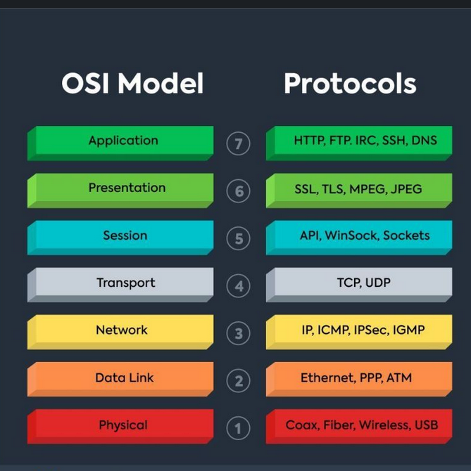

## Common asset classifications

Asset classification helps organizations implement an effective risk management strategy. It also helps them prioritize security resources, reduce IT costs, and stay in compliance with legal regulations.

The most common classification scheme is: restricted, confidential, internal-only, and public.

* **Restricted** is the highest level. This category is reserved for incredibly sensitive assets,  like need-to-know information.
* **Confidential** refers to assets whose disclosure may lead to a significant negative impact on an organization.
* **Internal-only** describes assets that are available to employees and business partners.
* **Public** is the lowest level of classification. These assets have no negative consequences to the organization if they’re released.

How this scheme is applied depends greatly on the characteristics of an asset. It might surprise you to learn that identifying an asset’s owner is sometimes the most complicated characteristic to determine.

**Note:** Although many organizations adopt this classification scheme, there can be variability at the highest levels. For example, government organizations label their most sensitive assets as confidential instead of restricted.

## Soaring into the cloud

Starting an online business used to be a complicated and costly process. In years past, companies had to build and maintain their own internal solutions to operate in the digital marketplace. Now, it’s much easier for anyone to participate because of the cloud.

The availability of cloud technologies has drastically changed how businesses operate online. These new tools allow companies to scale and adapt quickly while also lowering their costs. Despite these benefits, the shift to cloud-based services has also introduced a range of new cybersecurity challenges that put assets at risk.

## Cloud-based services

The term cloud-based services refers to a variety of on demand or web-based business solutions. Depending on a company’s needs and budget, services can range from website hosting, to application development environments, to entire back-end infrastructure.

There are three main categories of cloud-based services:

* Software as a service (SaaS)
* Platform as a service (PaaS)
* Infrastructure as a service (IaaS)

### **Software as a service (SaaS)**

SaaS refers to front-end applications that users access via a web browser. The service providers host, manage, and maintain all of the back-end systems for those applications. Common examples of SaaS services include applications like Gmail™ email service, Slack, and Zoom software.

### **Platform as a service (PaaS)**

PaaS refers to back-end application development tools that clients can access online. Developers use these resources to write code and build, manage, and deploy their own apps. Meanwhile, the cloud service providers host and maintain the back-end hardware and software that the apps use to operate. Some examples of PaaS services include Google App Engine™ platform, Heroku®, and VMware Cloud Foundry.

### **Infrastructure as a service (IaaS)**

IaaS customers are given remote access to a range of back-end systems that are hosted by the cloud service provider. This includes data processing servers, storage, networking resources, and more. Resources are commonly licensed as needed, making it a cost-effective alternative to buying and maintaining on premises.

Cloud-based services allow companies to connect with their customers, employees, and business partners over the internet. Some of the largest organizations in the world offer cloud-based services:

* Google Cloud Platform
* Microsoft Azure

## Cloud security

Shifting applications and infrastructure over to the cloud can make it easier to operate an online business. It can also complicate keeping data private and safe. Cloud security is a growing subfield of cybersecurity that specifically focuses on the protection of data, applications, and infrastructure in the cloud.

In a traditional model, organizations had their entire IT infrastructure on premises. Protecting those systems was entirely up to the internal security team in that environment. These responsibilities are not so clearly defined when part or all of an operational environment is in the cloud.

For example, a PaaS client pays to access the resources they need to build their applications. So, it is reasonable to expect them to be responsible for securing the apps they build. On the other hand, the responsibility for maintaining the security of the servers they are accessing should belong to the cloud service provider because there are other clients using the same systems.

In cloud security, this concept is known as the shared responsibility model. Clients are commonly responsible for securing anything that is directly within their control:

* Identity and access management
* Resource configuration
* Data handling

**Note:** The amount of responsibility that is delegated to a service provider varies depending on the service being used: SaaS, PaaS, and IaaS.

## Cloud security challenges

All service providers do their best to deliver secure products to their customers. Much of their success depends on preventing breaches and how well they can protect sensitive information. However, since data is stored in the cloud and accessed over the internet, several challenges arise:

* **Misconfiguration** is one of the biggest concerns. Customers of cloud-based services are responsible for configuring their own security environment. Oftentimes, they use out-of-the-box configurations that fail to address their specific security objectives.
* **Cloud-native breaches** are more likely to occur due to misconfigured services.
* **Monitoring access might be difficult** depending onthe client and level of service.
* **Meeting regulatory standards** is also a concern, particularly in industries that are required by law to follow specific requirements such as HIPAA, PCI DSS, and GDPR.

Many other challenges exist besides these. As more businesses adopt cloud-based services, there’s a growing need for cloud security professionals to meet a growing number of risks. Burning Glass, a leading labor market analytics firm, ranks cloud security among the most in-demand skills in cybersecurity.

## Key takeaways

So much of the global marketplace has shifted to cloud-based services. Cloud technology is still new, resulting in the emergence of new security models and a range of security challenges. And it’s likely that other concerns might arise as more businesses become reliant on the cloud. Being familiar with the cloud and the different services that are available is an important step towards supporting any organizations efforts to protect information online.

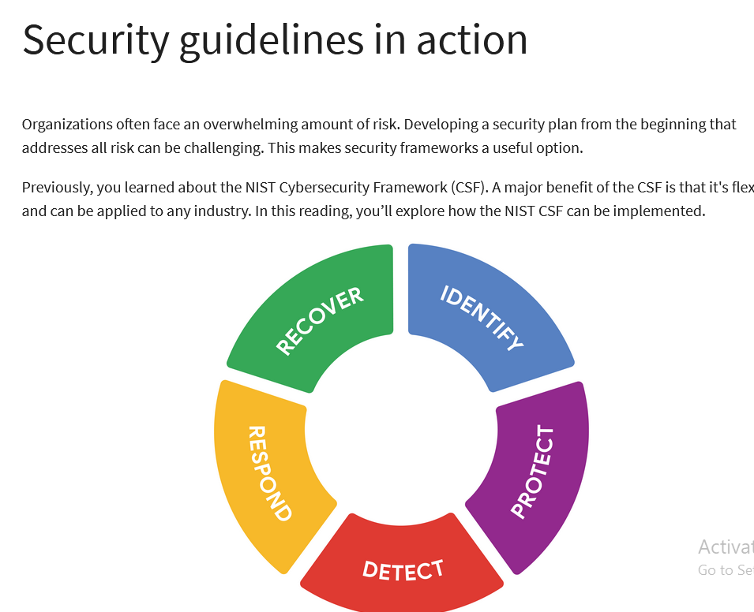

## Origins of the framework

Originally released in 2014, NIST developed the Cybersecurity Framework to protect critical infrastructure in the United States. NIST was selected to develop the CSF because they are an unbiased source of scientific data and practices. NIST eventually adapted the CSF to fit the needs of businesses in the public and private sector. Their goal was to make the framework more flexible, making it easier to adopt for small businesses or anyone else that might lack the resources to develop their own security plans.

## Components of the CSF

As you might recall, the framework consists of three main components: the core, tiers, and profiles. In the following sections, you'll learn more about each of these CSF components.

### **Core**

The CSF core is a set of desired cybersecurity outcomes that help organizations customize their security plan. It consists of five functions, or parts: Identify, Protect, Detect, Respond, and Recover. These functions are commonly used as an informative reference to help organizations identify their most important assets and protect those assets with appropriate safeguards. The CSF core is also used to understand ways to detect attacks and develop response and recovery plans should an attack happen.

### **Tiers**

The CSF tiers are a way of measuring the sophistication of an organization's cybersecurity program. CSF tiers are measured on a scale of 1 to 4. Tier 1 is the lowest score, indicating that a limited set of security controls have been implemented. Overall, CSF tiers are used to assess an organization's security posture and identify areas for improvement.

### **Profiles**

The CSF profiles are pre-made templates of the NIST CSF that are developed by a team of industry experts. CSF profiles are tailored to address the specific risks of an organization or industry. They are used to help organizations develop a baseline for their cybersecurity plans, or as a way of comparing their current cybersecurity posture to a specific industry standard.

**Note:** The core, tiers, and profiles were each designed to help any business improve their security operations. Although there are only three components, the entire framework consists of a complex system of subcategories and processes.

## Implementing the CSF

As you might recall, compliance is an important concept in security. **Compliance** is the process of adhering to internal standards and external regulations. In other words, compliance is a way of measuring how well an organization is protecting their assets. The **NIST Cybersecurity Framework (CSF)** is a voluntary framework that consists of standards, guidelines, and best practices to manage cybersecurity risk. Organizations may choose to use the CSF to achieve compliance with a variety of regulations.

**Note:** Regulations are rules that must be followed, while frameworks are resources you can choose to use.

Since its creation, many businesses have used the NIST CSF. However, CSF can be a challenge to implement due to its high level of detail. It can also be tough to find where the framework fits in. For example, some businesses have established security plans, making it unclear how CSF can benefit them. Alternatively, some businesses might be in the early stages of building their plans and need a place to start.

In any scenario, the U.S. Cybersecurity and Infrastructure Security Agency (CISA) provides detailed guidance that any organization can use to implement the CSF. This is a quick overview and summary of their recommendations:

* **Create a current profile** of the security operations and outline the specific needs of your business.
* **Perform a risk assessment** to identify which of your current operations are meeting business and regulatory standards.
* **Analyze and prioritize existing gaps** in security operations that place the businesses assets at risk.
* **Implement a plan of action** to achieve your organization’s goals and objectives.

**Pro tip:** Always consider current risk, threat, and vulnerability trends when using the NIST CSF.

You can learn more about implementing the CSF in [this report by CISA that outlines how the framework was applied in the commercial facilities sector](https://www.cisa.gov/sites/default/files/publications/Commercial_Facilities_Sector_Cybersecurity_Framework_Implementation_Guidance_FINAL_508.pdf)

.

## Industries embracing the CSF

The NIST CSF has continued to evolve since its introduction in 2014. Its design is influenced by the standards and best practices of some of the largest companies in the world.

A benefit of the framework is that it aligns with the security practices of many organizations across the global economy. It also helps with regulatory compliance that might be shared by business partners.

## ****Terms and definitions from Course 5,**** Module ****1****

**Asset:** An item perceived as having value to an organization

**Asset classification:** The practice of labeling assets based on sensitivity and importance to an organization

**Asset inventory:** A catalog of assets that need to be protected

**Asset management:** The process of tracking assets and the risks that affect them

**Compliance:** The process of adhering to internal standards and external regulations

**Data:** Information that is translated, processed, or stored by a computer

**Data at rest:** Data not currently being accessed

**Data in transit:** Data traveling from one point to another

**Data in use:** Data being accessed by one or more users

**Information security (InfoSec):** The practice of keeping data in all states away from unauthorized users

**National Institute of Standards and Technology (NIST) Cybersecurity Framework (CSF):** A voluntary framework that consists of standards, guidelines, and best practices to manage cybersecurity risk

**Policy:** A set of rules that reduce risk and protect information

**Procedures:** Step-by-step instructions to perform a specific security task

**Regulations:** Rules set by a government or other authority to control the way something is done

**Risk**: Anything that can impact confidentiality, integrity, or availability of an asset

**Standards:** References that inform how to set policies

**Threat:** Any circumstance or event that can negatively impact assets

**Vulnerability:** A weakness that can be exploited by a threat

# Principle of least privilege

Security controls are essential to keeping sensitive data private and safe. One of the most common controls is the principle of least privilege, also referred to as PoLP or least privilege. The **principle of least privilege** is a security concept in which a user is only granted the minimum level of access and authorization required to complete a task or function.

Least privilege is a fundamental security control that supports the confidentiality, integrity, and availability (CIA) triad of information. In this reading, you'll learn how the principle of least privilege reduces risk, how it's commonly implemented, and why it should be routinely audited.

## Limiting access reduces risk

Every business needs to plan for the risk of data theft, misuse, or abuse. Implementing the principle of least privilege can greatly reduce the risk of costly incidents like data breaches by:

* Limiting access to sensitive information
* Reducing the chances of accidental data modification, tampering, or loss
* Supporting system monitoring and administration

Least privilege greatly reduces the likelihood of a successful attack by connecting specific resources to specific users and placing limits on what they can do. It's an important security control that should be applied to any asset. Clearly defining who or what your users are is usually the first step of implementing least privilege effectively.

**Note:** Least privilege is closely related to another fundamental security principle, the separation of duties—a security concept that divides tasks and responsibilities among different users to prevent giving a single user complete control over critical business functions. You'll learn more about separation of duties in a different reading about identity and access management.

## Determining access and authorization

To implement least privilege, access and authorization must be determined first. There are two questions to ask to do so:

* Who is the user?
* How much access do they need to a specific resource?

Determining who the user is usually straightforward. A user can refer to a person, like a customer, an employee, or a vendor. It can also refer to a device or software that's connected to your business network. In general, every user should have their own account. Accounts are typically stored and managed within an organization's directory service.

These are the most common types of user accounts:

* **Guest accounts** are provided to external users who need to access an internal network, like customers, clients, contractors, or business partners.
* **User accounts** are assigned to staff based on their job duties.
* **Service accounts** are granted to applications or software that needs to interact with other software on the network.
* **Privileged accounts** have elevated permissions or administrative access.

It's best practice to determine a baseline access level for each account type before implementing least privilege. However, the appropriate access level can change from one moment to the next. For example, a customer support representative should only have access to your information while they are helping you. Your data should then become inaccessible when the support agent starts working with another customer and they are no longer actively assisting you. Least privilege can only reduce risk if user accounts are routinely and consistently monitored.

**Pro tip:** Passwords play an important role when implementing the principle of least privilege. Even if user accounts are assigned appropriately, an insecure password can compromise your systems.

## Auditing account privileges

Setting up the right user accounts and assigning them the appropriate privileges is a helpful first step. Periodically auditing those accounts is a key part of keeping your company’s systems secure.

There are three common approaches to auditing user accounts:

* Usage audits
* Privilege audits
* Account change audits

As a security professional, you might be involved with any of these processes.

### **Usage audits**

When conducting a usage audit, the security team will review which resources each account is accessing and what the user is doing with the resource. Usage audits can help determine whether users are acting in accordance with an organization’s security policies. They can also help identify whether a user has permissions that can be revoked because they are no longer being used.

### **Privilege audits**

Users tend to accumulate more access privileges than they need over time, an issue known as privilege creep. This might occur if an employee receives a promotion or switches teams and their job duties change. Privilege audits assess whether a user's role is in alignment with the resources they have access to.

### **Account change audits**

Account directory services keep records and logs associated with each user. Changes to an account are usually saved and can be used to audit the directory for suspicious activity, like multiple attempts to change an account password. Performing account change audits helps to ensure that all account changes are made by authorized users.

**Note:** Most directory services can be configured to alert system administrators of suspicious activity.

## Key takeaways

The principle of least privilege is a security control that can reduce the risk of unauthorized access to sensitive information and resources. Setting up and configuring user accounts with the right levels of access and authorization is an important step toward implementing least privilege. Auditing user accounts and revoking unnecessary access rights is an important practice that helps to maintain the confidentiality, integrity, and availability of information.

# The data lifecycle

Organizations of all sizes handle a large amount of data that must be kept private. You learned that data can be vulnerable whether it is at rest, in use, or in transit. Regardless of the state it is in, information should be kept private by limiting access and authorization.

In security, data vulnerabilities are often mapped in a model known as the data lifecycle. Each stage of the data lifecycle plays an important role in the security controls that are put in place to maintain the CIA triad of information. In this reading, you will learn about the data lifecycle, the plans that determine how data is protected, and the specific types of data that require extra attention.

## The data lifecycle

The data lifecycle is an important model that security teams consider when protecting information. It influences how they set policies that align with business objectives. It also plays an important role in the technologies security teams use to make information accessible.

In general, the data lifecycle has five stages. Each describe how data flows through an organization from the moment it is created until it is no longer useful:

* Collect
* Store
* Use
* Archive
* Destroy

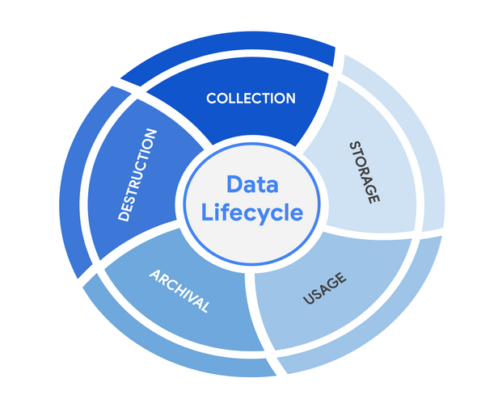

Protecting information at each stage of this process describes the need to keep it accessible and recoverable should something go wrong.

## Data governance

Businesses handle massive amounts of data every day. New information is constantly being collected from internal and external sources. A structured approach to managing all of this data is the best way to keep it private and secure.

Data governance is a set of processes that define how an organization manages information. Governance often includes policies that specify how to keep data private, accurate, available, and secure throughout its lifecycle.

Effective data governance is a collaborative activity that relies on people. Data governance policies commonly categorize individuals into a specific role:

* **Data owner:** the person that decides who can access, edit, use, or destroy their information.
* **Data custodian**: anyone or anything that's responsible for the safe handling, transport, and storage of information.
* **Data steward**: the person or group that maintains and implements data governance policies set by an organization.

Businesses store, move, and transform data using a wide range of IT systems. Data governance policies often assign accountability to data owners, custodians, and stewards.

**Note:** As a data custodian, you will primarily be  responsible for maintaining security and privacy rules for your organization.

## Protecting data at every stage

Most security plans include a specific policy that outlines how information will be managed across an organization. This is known as a data governance policy. These documents clearly define procedures that should be followed to participate in keeping data safe. They place limits on who or what can access data. Security professionals are important participants in data governance. As a data custodian, you will be responsible for ensuring that data isn’t damaged, stolen, or misused.

## Legally protected information

Data is more than just a bunch of 1s and 0s being processed by a computer. Data can represent someone's personal thoughts, actions, and choices. It can represent a purchase, a sensitive medical decision, and everything in between. For this reason, data owners should be the ones deciding whether or not to share their data. As a security professional, protecting a person's data privacy decisions must always be respected.

Securing data can be challenging. In large part, that's because data owners generate more data than they can manage. As a result, data custodians and stewards sometimes lack direct, explicit instructions on how they should handle specific types of data. Governments and other regulatory agencies have bridged this gap by creating rules that specify the types of information that organizations must protect by default:

* **PII** is any information used to infer an individual's identity. Personally identifiable information, or PII, refers to information that can be used to contact or locate someone.
* **PHI** stands for protected health information.  In the U.S., it is regulated by the Health Insurance Portability and Accountability Act (HIPAA), which defines PHI as “information that relates to the past, present, or future physical or mental health or condition of an individual.” In the EU, PHI has a similar definition but it is regulated by the General Data Protection Regulation (GDPR).
* **SPII** is a specific type of PII that falls under stricter handling guidelines. The S stands for sensitive, meaning this is a type of personally identifiable information that should only be accessed on a need-to-know basis, such as a bank account number or login credentials.

Overall, it's important to protect all types of personal information from unauthorized use and disclosure.

## Key takeaways

Keeping information private has never been so important. Many organizations have data governance policies that outline how they plan to protect sensitive information. As a data custodian, you will play a key role in keeping information accessible and safe throughout its lifecycle. There are various types of information and controls that you’ll encounter in the field. As you continue through this course, you’ll learn more about major security controls that keep data private.

# Information privacy: Regulations and compliance

Security and privacy have a close relationship. As you may recall, people have the right to control how their personal data is collected and used. Organizations also have a responsibility to protect the information they are collecting from being compromised or misused. As a security professional, you will be highly involved in these efforts.

Previously, you learned how regulations and compliance reduce security risk. To review, refer to [the reading about how security controls, frameworks, and compliance regulations](https://www.coursera.org/learn/foundations-of-cybersecurity/supplement/xu4pr/controls-frameworks-and-compliance)

are used together to manage security and minimize risk. In this reading, you will learn how information privacy regulations affect data handling practices. You'll also learn about some of the most influential security regulations in the world.

## Information security vs. information privacy

Security and privacy are two terms that often get used interchangeably outside of this field. Although the two concepts are connected, they represent specific functions:

* **Information privacy** refers to the protection of unauthorized access and distribution of data.
* **Information security** (InfoSec) refers to the practice of keeping data in all states away from unauthorized users.

The key difference: Privacy is about providing people with control over their personal information and how it's shared. Security is about protecting people’s choices and keeping their information safe from potential threats.

For example, a retail company might want to collect specific kinds of personal information about its customers for marketing purposes, like their age, gender, and location. How this private information will be used should be disclosed to customers before it's collected. In addition, customers should be given an option to opt-out if they decide not to share their data.

Once the company obtains consent to collect personal information, it might implement specific security controls in place to protect that private data from unauthorized access, use, or disclosure. The company should also have security controls in place to respect the privacy of all stakeholders and anyone who chose to opt-out.

**Note:** Privacy and security are both essential for maintaining customer trust and brand reputation.

## Why privacy matters in security

Data privacy and protection are topics that started gaining a lot of attention in the late 1990s. At that time, tech companies suddenly went from processing people’s data to storing and using it for business purposes. For example, if a user searched for a product online, companies began storing and sharing access to information about that user’s search history with other companies. Businesses were then able to deliver personalized shopping experiences to the user for free.

Eventually this practice led to a global conversation about whether these organizations had the right to collect and share someone’s private data. Additionally, the issue of data security became a greater concern; the more organizations collected data, the more vulnerable it was to being abused, misused, or stolen.

Many organizations became more concerned about the issues of data privacy. Businesses became more transparent about how they were collecting, storing, and using information. They also began implementing more security measures to protect people's data privacy. However, without clear rules in place, protections were inconsistently applied.

**Note:** The more data is collected, stored, and used, the more vulnerable it is to breaches and threats.

## Notable privacy regulations

Businesses are required to abide by certain laws to operate. As you might recall, **regulations** are rules set by a government or another authority to control the way something is done. Privacy regulations in particular exist to protect a user from having their information collected, used, or shared without their consent. Regulations may also describe the security measures that need to be in place to keep private information away from threats.

Three of the most influential industry regulations that every security professional should know about are:

* General Data Protection Regulation (GDPR)
* Payment Card Industry Data Security Standard (PCI DSS)
* Health Insurance Portability and Accountability Act (HIPAA)

### **GDPR**

GDPR is a set of rules and regulations developed by the European Union (EU) that puts data owners in total control of their personal information. Under GDPR, types of personal information include a person's name, address, phone number, financial information, and medical information.

The GDPR applies to any business that handles the data of EU citizens or residents, regardless of where that business operates. For example, a US based company that handles the data of EU visitors to their website is subject to the GDPRs provisions.

### **PCI DSS**

PCI DSS is a set of security standards formed by major organizations in the financial industry. This regulation aims to secure credit and debit card transactions against data theft and fraud.

### **HIPAA**

HIPAA is a U.S. law that requires the protection of sensitive patient health information. HIPAA prohibits the disclosure of a person's medical information without their knowledge and consent.

**Note:** These regulations influence data handling at many organizations around the world even though they were developed by specific nations.

Several other security and privacy compliance laws exist. Which ones your organization needs to follow will depend on the industry and the area of authority. Regardless of the circumstances, regulatory compliance is important to every business.

## Security assessments and audits

Businesses should comply with important regulations in their industry. Doing so validates that they have met a minimum level of security while also demonstrating their dedication to maintaining data privacy.

Meeting compliance standards is usually a continual, two-part process of security audits and assessments:

* A **security audit** is a review of an organization's security controls, policies, and procedures against a set of expectations.
* A **security assessment** is a check to determine how resilient current security implementations are against threats.

For example, if a regulation states that multi-factor authentication (MFA) must be enabled for all administrator accounts, an audit might be conducted to check those user accounts for compliance. After the audit, the internal team might perform a security assessment that determines many users are using weak passwords. Based on their assessment, the team could decide to enable MFA on all user accounts to improve their overall security posture.

**Note:** Compliance with legal regulations, such as GDPR, can be determined during audits.

As a security analyst, you are likely to be involved with security audits and assessments in the field. Businesses usually perform security audits less frequently, approximately once per year. Security audits may be performed both internally and externally by different third-party groups.

In contrast, security assessments are usually performed more frequently, about every three-to-six months. Security assessments are typically performed by internal employees, often as preparation for a security audit. Both evaluations are incredibly important ways to ensure that your systems are effectively protecting everyone's privacy.

## Key takeaways

A growing number of businesses are making it a priority to protect and govern the use of sensitive data to maintain customer trust. Security professionals should think about data and the need for privacy in these terms. Organizations commonly use security assessments and audits to evaluate gaps in their security plans. While it is possible to overlook or delay addressing the results of an assessment, doing so can have serious business consequences, such as fines or data breaches.

# Symmetric and asymmetric encryption

Previously, you learned these terms:

* **Encryption**: the process of converting data from a readable format to an encoded format
* **Public key infrastructure** (PKI):  an encryption framework that secures the exchange of online information
* **Cipher**: an algorithm that encrypts information

All digital information deserves to be kept private, safe, and secure. Encryption is one key to doing that! It is useful for transforming information into a form that unintended recipients cannot understand. In this reading, you’ll compare symmetric and asymmetric encryption and learn about some well-known algorithms for each.

## Types of encryption

There are two main types of encryption:

* **Symmetric encryption** is the use of a single secret key to exchange information. Because it uses one key for encryption and decryption, the sender and receiver must know the secret key to lock or unlock the cipher.
* **Asymmetric encryption** is the use of a public and private key pair for encryption and decryption of data. It uses two separate keys: a public key and a private key. The public key is used to encrypt data, and the private key decrypts it. The private key is only given to users with authorized access.

## The importance of key length

Ciphers are vulnerable to **brute force attacks**, which use a trial and error process to discover private information. This tactic is the digital equivalent of trying every number in a combination lock trying to find the right one. In modern encryption, longer key lengths are considered to be more secure. Longer key lengths mean more possibilities that an attacker needs to try to unlock a cipher.

One drawback to having long encryption keys is slower processing times. Although short key lengths are generally less secure, they’re much faster to compute. Providing fast data communication online while keeping information safe is a delicate balancing act.

## Approved algorithms

Many web applications use a combination of symmetric and asymmetric encryption. This is how they balance user experience with safeguarding information. As an analyst, you should be aware of the most widely-used algorithms.

### **Symmetric algorithms**

* Triple DES (3DES) is known as a block cipher because of the way it converts plaintext into ciphertext in “blocks.” Its origins trace back to the Data Encryption Standard (DES), which was developed in the early 1970s. DES was one of the earliest symmetric encryption algorithms that generated 64-bit keys. A **bit** is the smallest unit of data measurement on a computer. As you might imagine, Triple DES generates keys that are 192 bits, or three times as long. Despite the longer keys, many organizations are moving away from using Triple DES due to limitations on the amount of data that can be encrypted. However, Triple DES is likely to remain in use for backwards compatibility purposes.
* Advanced Encryption Standard (AES)is one of the most secure symmetric algorithms today. AES generates keys that are 128, 192, or 256 bits. Cryptographic keys of this size are considered to be safe from brute force attacks. It’s estimated that brute forcing an AES 128-bit key could take a modern computer billions of years!

### **Asymmetric algorithms**

* Rivest Shamir Adleman (RSA)is named after its three creators who developed it while at the Massachusetts Institute of Technology (MIT). RSA is one of the first asymmetric encryption algorithms that produces a public and private key pair. Asymmetric algorithms like RSA produce even longer key lengths. In part, this is due to the fact that these functions are creating two keys. RSA key sizes are 1,024, 2,048, or 4,096 bits. RSA is mainly used to protect highly sensitive data.
* Digital Signature Algorithm (DSA)is a standard asymmetric algorithm that was introduced by NIST in the early 1990s. DSA also generates key lengths of 2,048 bits. This algorithm is widely used today as a complement to RSA in public key infrastructure.

### **Generating keys**

These algorithms must be implemented when an organization chooses one to protect their data. One way this is done is using OpenSSL, which is an open-source command line tool that can be used to generate public and private keys. OpenSSL is commonly used by computers to verify digital certificates that are exchanged as part of public key infrastructure.

**Note:** OpenSSL is just one option. There are various others available that can generate keys with any of these common algorithms.

In early 2014, OpenSSL disclosed a vulnerability, known as the [Heartbleed bug](https://en.wikipedia.org/wiki/Heartbleed)

, that exposed sensitive data in the memory of websites and applications. Although unpatched versions of OpenSSL are still available, the Heartbleed bug was patched later that year (2014). Many businesses today use the secure versions of OpenSSL to generate public and private keys, demonstrating the importance of using up-to-date software.

## Obscurity is not security

In the world of cryptography, a cipher must be proven to be unbreakable before claiming that it is secure. According to [Kerchoff’s principle](https://en.wikipedia.org/wiki/Kerckhoffs%27s_principle)

, cryptography should be designed in such a way that all the details of an algorithm—except for the private key—should be knowable without sacrificing its security. For example, you can access all the details about how AES encryption works online and yet it is still unbreakable.

Occasionally, organizations implement their own, custom encryption algorithms. There have been instances where those secret cryptographic systems have been quickly cracked after being made public.

**Pro tip:** A cryptographic system should not be considered secure if it requires secrecy around how it works.

### Encryption is everywhere

Companies use both symmetric and asymmetric encryption. They often work as a team, balancing security with user experience.

For example, websites tend to use asymmetric encryption to secure small blocks of data that are important. Usernames and passwords are often secured with asymmetric encryption while processing login requests. Once a user gains access, the rest of their web session often switches to using symmetric encryption for its speed.

Using data encryption like this is increasingly required by law. Regulations like the Federal Information Processing Standards (FIPS 140-3) and the General Data Protection Regulation (GDPR) outline how data should be collected, used, and handled. Achieving compliance with either regulation is critical to demonstrating to business partners and governments that customer data is handled responsibly.

## Key takeaways

Knowing the basics of encryption is important for all security professionals. Symmetric encryption relies on a single secret key to protect data. On the other hand, asymmetric uses a public and private key pair. Their encryption algorithms create different key sizes. Both types of encryption are used to meet compliance regulations and protect data online.

# The evolution of hash functions

Hash functions are important controls that are part of every company's security strategy. Hashing is widely used for authentication and **non-repudiation**, the concept that the authenticity of information can’t be denied.

Previously, you learned that **hash functions** are algorithms that produce a code that can't be decrypted.Hash functions convert information into a unique value that can then be used to determine its integrity. In this reading, you’ll learn about the origins of hash functions and how they’ve changed over time.

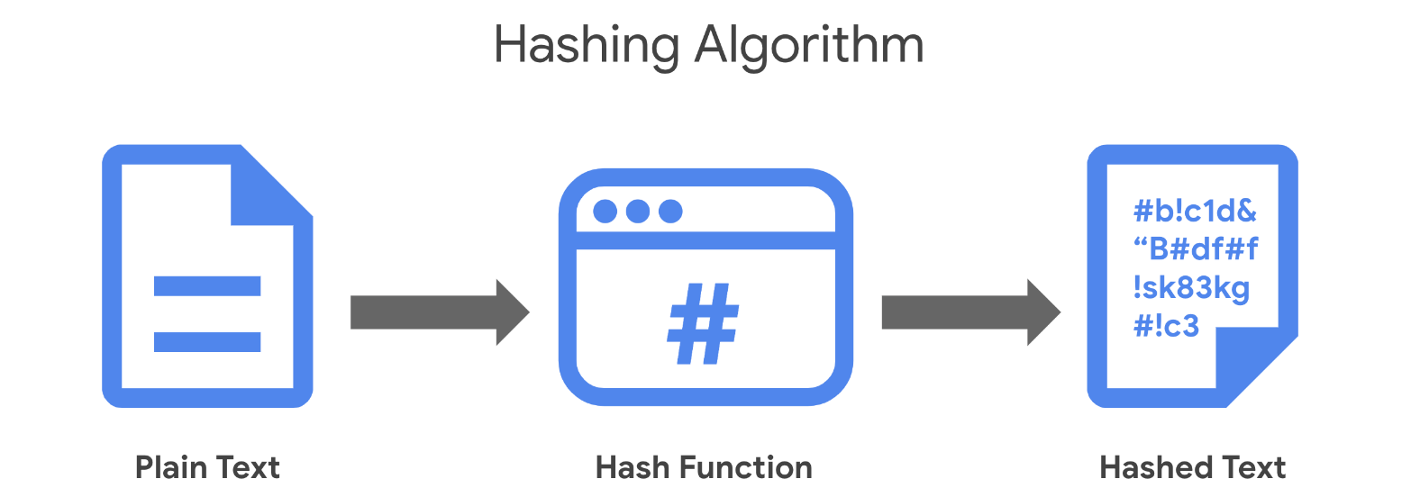

## Origins of hashing

Hash functions have been around since the early days of computing. They were originally created as a way to quickly search for data. Since the beginning, these algorithms have been designed to represent data of any size as small, fixed-size values, or digests. Using a hash table, which is a data structure that's used to store and reference hash values, these small values became a more secure and efficient way for computers to reference data.

One of the earliest hash functions is Message Digest 5, more commonly known as MD5. Professor Ronald Rivest of the Massachusetts Institute of Technology (MIT) developed MD5 in the early 1990s as a way to verify that a file sent over a network matched its source file.

Whether it’s used to convert a single email or the source code of an application, MD5 works by converting data into a 128-bit value. You might recall that a **bit** is the smallest unit of data measurement on a computer. Bits can either be a 0 or 1. In a computer, bits represent user input in a way that computers can interpret. In a hash table, this appears as a string of 32 characters. Altering anything in the source file generates an entirely new hash value.

Generally, the longer the hash value, the more secure it is. It wasn’t long after MD5's creation that security practitioners discovered 128-bit digests resulted in a major vulnerability.

Here is an example of how plaintext gets turned into hash values:

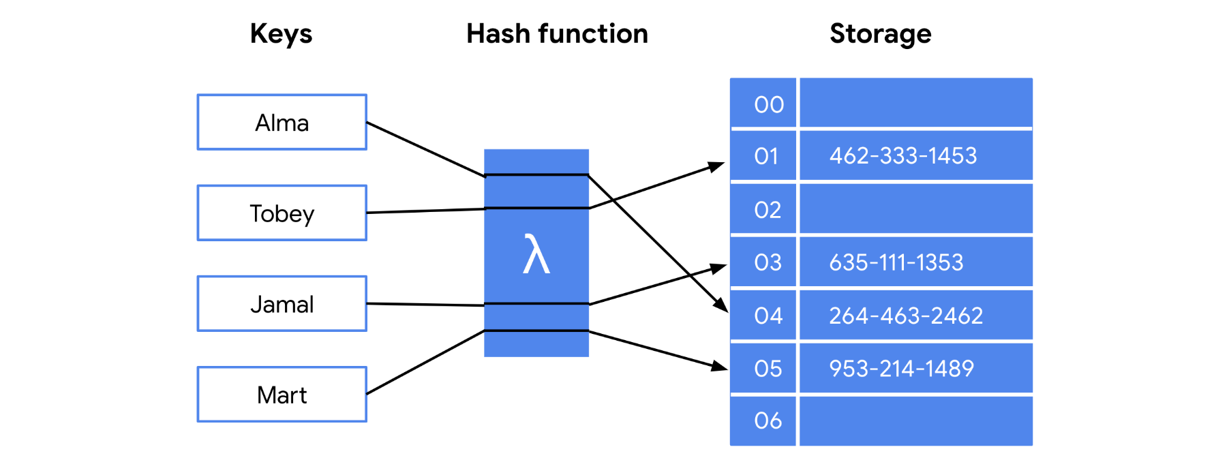

### **Hash collisions**

One of the flaws in MD5 happens to be a characteristic of all hash functions. Hash algorithms map any input, regardless of its length, into a fixed-size value of letters and numbers. What’s the problem with that? Although there are an infinite amount of possible inputs, there’s only a finite set of available outputs!

MD5 values are limited to 32 characters in length. Due to the limited output size, the algorithm is considered to be vulnerable to **hash collision**, an instance when different inputs produce the same hash value. Because hashes are used for authentication, a hash collision is similar to copying someone’s identity. Attackers can carry out collision attacks to fraudulently impersonate authentic data.

## Next-generation hashing

To avoid the risk of hash collisions, functions that generated longer values were needed. MD5's shortcomings gave way to a new group of functions known as the Secure Hashing Algorithms, or SHAs.

The National Institute of Standards and Technology (NIST) approves each of these algorithms. Numbers besides each SHA function indicate the size of its hash value in bits. Except for SHA-1, which produces a 160-bit digest, these algorithms are considered to be collision-resistant. However, that doesn’t make them invulnerable to other exploits.

**Five functions make up the SHA family of algorithms:**

* SHA-1
* SHA-224
* SHA-256
* SHA-384
* SHA-512

## Secure password storage

Passwords are typically stored in a database where they are mapped to a username. The server receives a request for authentication that contains the credentials supplied by the user. It then looks up the username in the database and compares it with the password that was provided and verifies that it matches before granting them access.

This is a safe system unless an attacker gains access to the user database. If passwords are stored in plaintext, then an attacker can steal that information and use it to access company resources. Hashing adds an additional layer of security. Because hash values can't be reversed, an attacker would not be able to steal someone's login credentials if they managed to gain access to the database.

### **Rainbow tables**

A **rainbow table** is a file of pre-generated hash values and their associated plaintext. They’re like dictionaries of weak passwords. Attackers capable of obtaining an organization’s password database can use a rainbow table to compare them against all possible values.

## Adding some “salt”

Functions with larger digests are less vulnerable to collision and rainbow table attacks. But as you’re learning, no security control is perfect.

**Salting** is an additional safeguard that's used to strengthen hash functions. A salt is a random string of characters that's added to data before it's hashed. The additional characters produce a more unique hash value, making salted data resilient to rainbow table attacks.

For example, a database containing passwords might have several hashed entries for the password "password." If those passwords were all salted, each entry would be completely different. That means an attacker using a rainbow table would be unable to find matching values for "password" in the database.

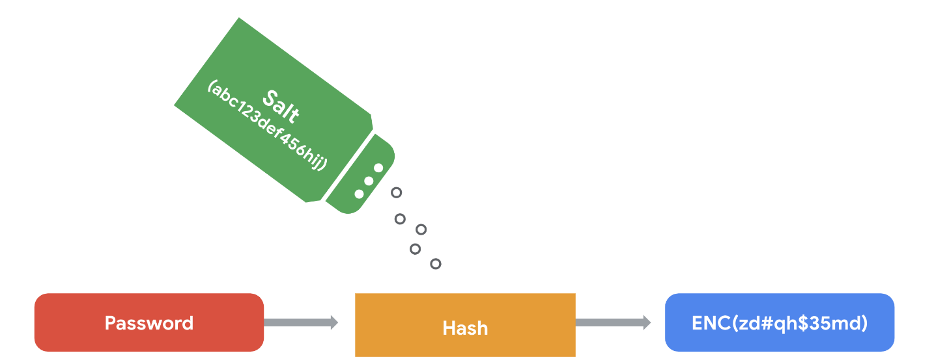

For this reason, salting has become increasingly common when storing passwords and other types of sensitive data. The length and uniqueness of a salt is important. Similar to hash values, the longer and more complex a salt is, the harder it is to crack.

## Key takeaways

Security professionals often use hashing as a tool to validate the integrity of program files, documents, and other types of data. Another way it’s used is to reduce the chances of a data breach. As you’ve learned, not all hashing functions provide the same level of protection. Rainbow table attacks are more likely to work against algorithms that generate shorter keys, like MD5. Many small- and medium-sized businesses still rely on MD5 to secure sensitive data. Knowing about alternative algorithms and salting better prepares you to make impactful security recommendations.

# **The rise of SSO and MFA**

Most companies help keep their data safely locked up behind authentication systems. Usernames and passwords are the keys that unlock information for most organizations. But are those credentials enough? Information security often focuses on managing a user's access of, and authorization to, information.

Previously, you learned about the three factors of authentication: knowledge, ownership, and characteristic. Single sign-on (SSO) and multi-factor authentication (MFA) are two technologies that have become popular for implementing these authentication factors. In this reading, you’ll learn how these technologies work and why companies are adopting them.

## A better approach to authentication

**Single sign-on** (SSO) is a technology that combines several different logins into one. More companies are turning to SSO as a solution to their authentication needs for three reasons:

1. **SSO improves the user experience** by eliminating the number of usernames and passwords people have to remember.
2. **Companies can lower costs** by streamlining how they manage connected services.
3. **SSO improves overall security** by reducing the number of access points attackers can target.

This technology became available in the mid-1990s as a way to combat password fatigue, which refers to people’s tendency to reuse passwords across services. Remembering many different passwords can be a challenge, but using the same password repeatedly is a major security risk. SSO solves this dilemma by shifting the burden of authentication away from the user.

## How SSO works

SSO works by automating how trust is established between a user and a service provider. Rather than placing the responsibility on an employee or customer, SSO solutions use trusted third-parties to prove that a user is who they claim to be. This is done through the exchange of encrypted access tokens between the identity provider and the service provider.

Similar to other kinds of digital information, these access tokens are exchanged using specific protocols. SSO implementations commonly rely on two different authentication protocols: LDAP and SAML. LDAP, which stands for Lightweight Directory Access Protocol, is mostly used to transmit information on-premises; SAML, which stands for Security Assertion Markup Language, is mostly used to transmit information off-premises, like in the cloud.

**Note:** LDAP and SAML protocols are often used together.

Here's an example of how SSO can connect a user to multiple applications with one access token:

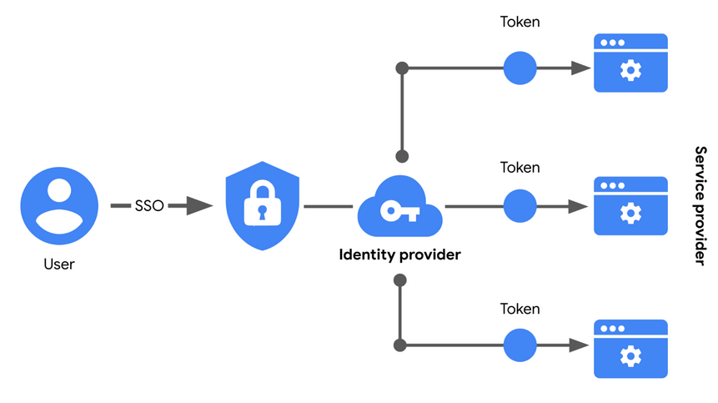

## Limitations of SSO

Usernames and passwords alone are not always the most secure way of protecting sensitive information. SSO provides useful benefits, but there’s still the risk associated with using one form of authentication. For example, a lost or stolen password could expose information across multiple services. Thankfully, there’s a solution to this problem.

## MFA to the rescue

**Multi-factor authentication** (MFA) requires a user to verify their identity in two or more ways to access a system or network. In a sense, MFA is similar to using an ATM to withdraw money from your bank account. First, you insert a debit card into the machine as one form of identification. Then, you enter your PIN number as a second form of identification. Combined, both steps, or factors, are used to verify your identity before authorizing you to access the account.

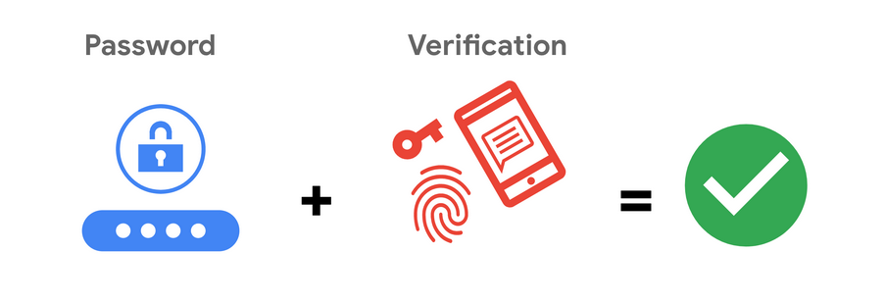

# Identity and access management

Security is more than simply combining processes and technologies to protect assets. Instead, security is about ensuring that these processes and technologies are creating a secure environment that supports a defense strategy. A key to doing this is implementing two fundamental security principles that limit access to organizational resources:

* The **principle of least privilege** in which a user is only granted the minimum level of access and authorization required to complete a task or function.
* **Separation of duties**, which is the principle that users should not be given levels of authorization that would allow them to misuse a system.

Both principles typically support each other. For example, according to least privilege, a person who needs permission to approve purchases from the IT department shouldn't have the permission to approve purchases from every department. Likewise, according to separation of duties, the person who can approve purchases from the IT department should be different from the person who can input new purchases.

In other words, least privilege limits the access that an individual receives, while separation of duties divides responsibilities among multiple people to prevent any one person from having too much control.

**Note:** Separation of duties is sometimes referred to as segregation of duties.

Previously, you learned about the authentication, authorization, and accounting (AAA) framework. Many businesses used this model to implement these two security principles and manage user access. In this reading, you’ll learn about the other major framework for managing user access,identity and access management(IAM). You will learn about the similarities between AAA and IAM and how they're commonly implemented.

## Identity and access management (IAM)

As organizations become more reliant on technology, regulatory agencies have put more pressure on them to demonstrate that they’re doing everything they can to prevent threats. **Identity and access management** (IAM) is a collection of processes and technologies that helps organizations manage digital identities in their environment. Both AAA and IAM systems are designed to authenticate users, determine their access privileges, and track their activities within a system.

Either model used by your organization is more than a single, clearly defined system. They each consist of a collection of security controls that ensure the right user is granted access to the right resources at the right time and for the right reasons. Each of those four factors is determined by your organization's policies and processes.

**Note:** A user can either be a person, a device, or software.

## Authenticating users

To ensure the right user is attempting to access a resource requires some form of proof that the user is who they claim to be. In a [video on authentication controls](https://www.coursera.org/learn/assets-threats-and-vulnerabilities/item/r6XuB)

, you learned that there are a few factors that can be used to authenticate a user:

* **Knowledge**, or something the user knows
* **Ownership**, or something the user possesses
* **Characteristic**, or something the user is

Authentication is mainly verified with login credentials. **Single sign-on** (SSO), a technology that combines several different logins into one, and **multi-factor authentication** (MFA), a security measure that requires a user to verify their identity in two or more ways to access a system or network, are other tools that organizations use to authenticate individuals and systems.

**Pro tip:** Another way to remember this authentication model is: something you know, something you have, and something you are.

### **User provisioning**

Back-end systems need to be able to verify whether the information provided by a user is accurate. To accomplish this, users must be properly provisioned. **User provisioning** is the process of creating and maintaining a user's digital identity. For example, a college might create a new user account when a new instructor is hired. The new account will be configured to provide access to instructor-only resources while they are teaching. Security analysts are routinely involved with provisioning users and their access privileges.

**Pro tip:** Another role analysts have in IAM is to deprovision users. This is an important practice that removes a user's access rights when they should no longer have them.

### **Granting authorization**

If the right user has been authenticated, the network should ensure the right resources are made available. There are three common frameworks that organizations use to handle this step of IAM:

* Mandatory access control (MAC)
* Discretionary access control (DAC)
* Role-based access control (RBAC)

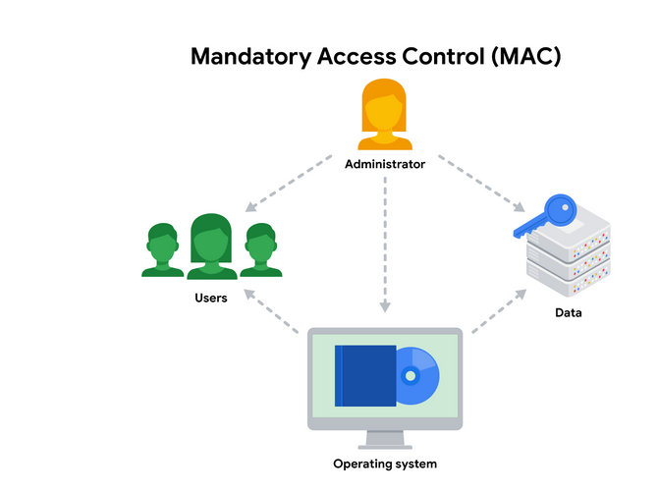

### **Mandatory Access Control (MAC)**

MAC is the strictest of the three frameworks. Authorization in this model is based on a strict need-to-know basis. Access to information must be granted manually by a central authority or system administrator. For example, MAC is commonly applied in law enforcement, military, and other government agencies where users must request access through a chain of command. MAC is also known as non-discretionary control because access isn’t given at the discretion of the data owner.

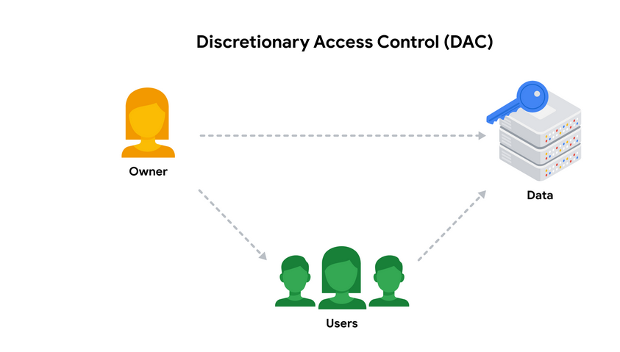

### **Discretionary Access Control (DAC)**

DAC is typically applied when a data owner decides appropriate levels of access. One example of DAC is when the owner of a Google Drive folder shares editor, viewer, or commentor access with someone else.

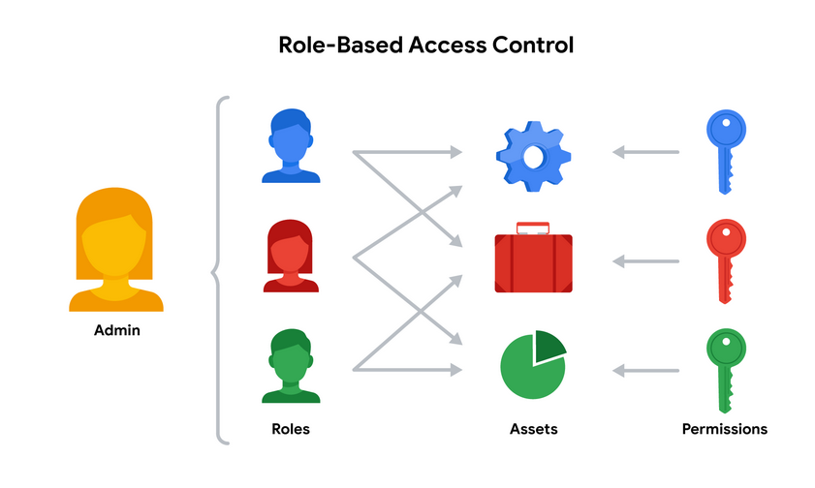

### **Role-Based Access Control (RBAC)**

RBAC is used when authorization is determined by a user's role within an organization. For example, a user in the marketing department may have access to user analytics but not network administration.

## Access control technologies

Users often experience authentication and authorization as a single, seamless experience. In large part, that’s due to access control technologies that are configured to work together. These tools offer the speed and automation needed by administrators to monitor and modify access rights. They also decrease errors and potential risks.

An organization's IT department sometimes develops and maintains customized access control technologies on their own. A typical IAM or AAA system consists of a user directory, a set of tools for managing data in that directory, an authorization system, and an auditing system. Some organizations create custom systems to tailor them to their security needs. However, building an in-house solution comes at a steep cost of time and other resources.

Instead, many organizations opt to license third-party solutions that offer a suite of tools that enable them to quickly secure their information systems. Keep in mind, security is about more than combining a bunch of tools. It’s always important to configure these technologies so they can help to provide a secure environment.

## Key takeaways

Controlling access requires a collection of systems and tools. IAM and AAA are common frameworks for implementing least privilege and separation of duties. As a security analyst, you might be responsible for user provisioning and collaborating with other IAM or AAA teams. Having familiarity with these models is valuable for helping organizations achieve their security objectives. They each ensure that the right user is granted access to the right resources at the right time and for the right reasons.

## ****Terms and definitions from Course 5, Module 2****

**Access controls:** Security controls that manage access, authorization, and accountability of information

**Algorithm:** A set of rules used to solve a problem

**Application programming interface (API) token:** A small block of encrypted code that contains information about a user

**Asymmetric encryption:** The use of a public and private key pair for encryption and decryption of data

**Basic auth:** The technology used to establish a user’s request to access a server

**Bit:** The smallest unit of data measurement on a computer

**Brute force attack:** The trial and error process of discovering private information

**Cipher:** An algorithm that encrypts information

**Cryptographic key:** A mechanism that decrypts ciphertext

**Cryptography:** The process of transforming information into a form that unintended readers can’t understand

**Data custodian:** Anyone or anything that’s responsible for the safe handling, transport, and storage of information

**Data owner:** The person that decides who can access, edit, use, or destroy their information

**Digital certificate:** A file that verifies the identity of a public key holder

**Encryption:** The process of converting data from a readable format to an encoded format

**Hash collision:** An instance when different inputs produce the same hash value

**Hash function:** An algorithm that produces a code that can’t be decrypted

**Hash table:** A data structure that's used to store and reference hash values

**Identity and access management (IAM):** A collection of processes and technologies that helps organizations manage digital identities in their environment

**Information privacy:** The protection of unauthorized access and distribution of data

**Multi-factor authentication (MFA):** A security measure that requires a user to verify their identity in two or more ways to access a system or network

**Non-repudiation:** The concept that the authenticity of information can’t be denied

**OAuth:** An open-standard authorization protocol that shares designated access between applications

**Payment Card Industry Data Security Standards (PCI DSS):** A set of security standards formed by major organizations in the financial industry

**Personally identifiable information (PII):** Any information used to infer an individual's identity

**Principle of least privilege:** The concept of granting only the minimal access and authorization required to complete a task or function

**Protected health information (PHI):** Information that relates to the past, present, or future physical or mental health or condition of an individual

**Public key infrastructure (PKI):** An encryption framework that secures the exchange of online information

**Rainbow table:** A file of pre-generated hash values and their associated plaintext

**Salting:** An additional safeguard that’s used to strengthen hash functions

**Security assessment:** A check to determine how resilient current security implementations are against threats

**Security audit:** A review of an organization's security controls, policies, and procedures against a set of expectations

**Security controls:** Safeguards designed to reduce specific security risks

**Separation of duties:** The principle that users should not be given levels of authorization that would allow them to misuse a system

**Session:** A sequence of network HTTP basic auth requests and responses associated with the same user

**Session cookie:** A token that websites use to validate a session and determine how long that session should last

**Session hijacking:** An event when attackers obtain a legitimate user’s session ID

**Session ID:** A unique token that identifies a user and their device while accessing a system

**Single Sign-On (SSO):** A technology that combines several different logins into one

**Symmetric encryption:** The use of a single secret key to exchange information

**User provisioning:** The process of creating and maintaining a user's digital identity

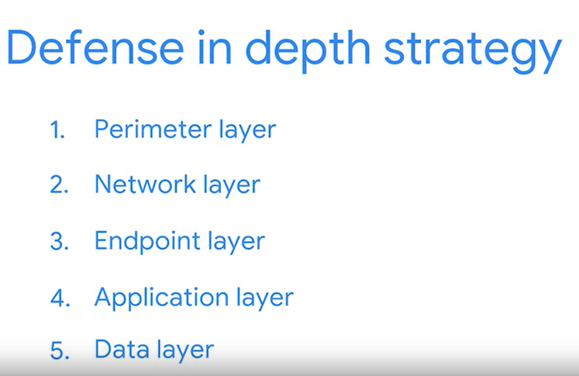

## The OWASP Top 10

One of OWASP’s most valuable resources is the OWASP Top 10. The organization has published this list since 2003 as a way to spread awareness of the web’s most targeted vulnerabilities. The Top 10 mainly applies to new or custom made software. Many of the world's largest organizations reference the OWASP Top 10 during application development to help ensure their programs address common security mistakes.

**Pro tip:** OWASP’s Top 10 is updated every few years as technologies evolve. Rankings are based on how often the vulnerabilities are discovered and the level of risk they present.

**Note:** Auditors also use the OWASP Top 10 as one point of reference when checking for regulatory compliance.

## Common vulnerabilities

Businesses often make critical security decisions based on the vulnerabilities listed in the OWASP Top 10. This resource influences how businesses design new software that will be on their network, unlike the CVE® list, which helps them identify improvements to existing programs. These are the most regularly listed vulnerabilities that appear in their rankings to know about:

### **Broken access control**

Access controls limit what users can do in a web application. For example, a blog might allow visitors to post comments on a recent article but restricts them from deleting the article entirely. Failures in these mechanisms can lead to unauthorized information disclosure, modification, or destruction. They can also give someone unauthorized access to other business applications.

### **Cryptographic failures**

Information is one of the most important assets businesses need to protect. Privacy laws such as General Data Protection Regulation (GDPR) require sensitive data to be protected by effective encryption methods. Vulnerabilities can occur when businesses fail to encrypt things like personally identifiable information (PII). For example, if a web application uses a weak hashing algorithm, like MD5, it’s more at risk of suffering a data breach.

### **Injection**

Injection occurs when malicious code is inserted into a vulnerable application. Although the app appears to work normally, it does things that it wasn’t intended to do. Injection attacks can give threat actors a backdoor into an organization’s information system. A common target is a website’s login form. When these forms are vulnerable to injection, attackers can insert malicious code that gives them access to modify or steal user credentials.

### **Insecure design**

Applications should be designed in such a way that makes them resilient to attack. When they aren’t, they’re much more vulnerable to threats like injection attacks or malware infections. Insecure design refers to a wide range of missing or poorly implemented security controls that should have been programmed into an application when it was being developed.

### **Security misconfiguration**

Misconfigurations occur when security settings aren’t properly set or maintained. Companies use a variety of different interconnected systems. Mistakes often happen when those systems aren’t properly set up or audited. A common example is when businesses deploy equipment, like a network server, using default settings. This can lead businesses to use settings that fail to address the organization's security objectives.

### **Vulnerable and outdated components**

Vulnerable and outdated components is a category that mainly relates to application development. Instead of coding everything from scratch, most developers use open-source libraries to complete their projects faster and easier. This publicly available software is maintained by communities of programmers on a volunteer basis. Applications that use vulnerable components that have not been maintained are at greater risk of being exploited by threat actors.

### **Identification and authentication failures**

Identification is the keyword in this vulnerability category. When applications fail to recognize who should have access and what they’re authorized to do, it can lead to serious problems. For example, a home Wi-Fi router normally uses a simple login form to keep unwanted guests off the network. If this defense fails, an attacker can invade the homeowner’s privacy.

### **Software and data integrity failures**

Software and data integrity failures are instances when updates or patches are inadequately reviewed before implementation. Attackers might exploit these weaknesses to deliver malicious software. When that occurs, there can be serious downstream effects. Third parties are likely to become infected if a single system is compromised, an event known as a supply chain attack.

A famous example of a supply chain attack is the [SolarWinds cyber attack (2020)](https://www.gao.gov/blog/solarwinds-cyberattack-demands-significant-federal-and-private-sector-response-infographic)

where hackers injected malicious code into software updates that the company unknowingly released to their customers.

### **Security logging and monitoring failures**

In security, it’s important to be able to log and trace back events. Having a record of events like user login attempts is critical to finding and fixing problems. Sufficient monitoring and incident response is equally important.

### **Server-side request forgery**

Companies have public and private information stored on web servers. When you use a hyperlink or click a button on a website, a request is sent to a server that should validate who you are, fetch the appropriate data, and then return it to you.

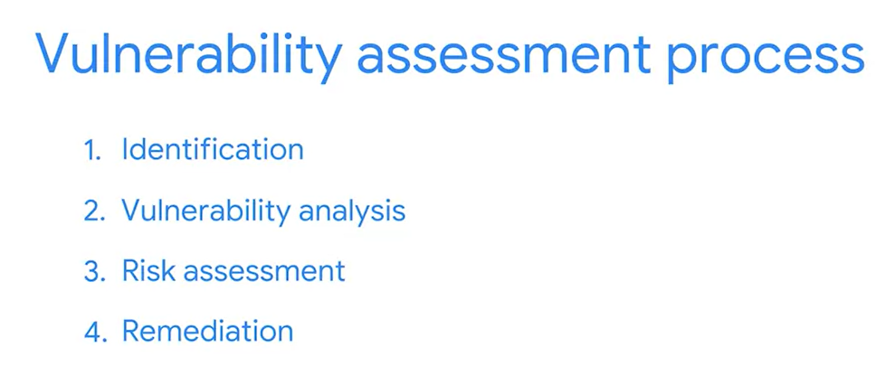

# Approaches to vulnerability scanning

Previously, you learned about a **vulnerability assessment**, which is the internal review process of an organization's security systems. An organization performs vulnerability assessments to identify weaknesses and prevent attacks. Vulnerability scanning tools are commonly used to simulate threats by finding vulnerabilities in an attack surface. They also help security teams take proactive steps towards implementing their remediation strategy.

Vulnerability scanners are important tools that you'll likely use in the field. In this reading, you’ll explore how vulnerability scanners work and the types of scans they can perform.

## What is a vulnerability scanner?

A **vulnerability scanner** is software that automatically compares known vulnerabilities and exposures against the technologies on the network. In general, these tools scan systems to find misconfigurations or programming flaws.

Scanning tools are used to analyze each of the five attack surfaces that you learned about in [the video about the defense in depth strategy](https://www.coursera.org/learn/assets-threats-and-vulnerabilities/lecture/IdvXj/defense-in-depth-strategy)

:

1. **Perimeter layer**,like authentication systems that validate user access
2. **Network layer**,which is made up of technologies like network firewalls and others
3. **Endpoint layer**,which describes devices on a network, like laptops, desktops, or servers
4. **Application layer**,which involves the software that users interact with
5. **Data layer**, which includes any information that’s stored, in transit, or in use

When a scan of any layer begins, the scanning tool compares the findings against databases of security threats. At the end of the scan, the tool flags any vulnerabilities that it finds and adds them to its reference database. Each scan adds more information to the database, helping the tool be more accurate in its analysis.

**Note:** Vulnerability databases are also routinely updated by the company that designed the scanning software.

## Performing scans

Vulnerability scanners are meant to be non-intrusive. Meaning, they don’t break or take advantage of a system like an attacker would. Instead, they simply scan a surface and alert you to any potentially unlocked doors in your systems.

**Note:** While vulnerability scanners are non-intrusive, there are instances when a scan can inadvertently cause issues, like crash a system.

There are a few different ways that these tools are used to scan a surface. Each approach corresponds to the pathway a threat actor might take. Next, you can explore each type of scan to get a clearer picture of this.

**External vs. internal**

External and internal scans simulate an attacker's approach.

External scans test the perimeter layer outside of the internal network. They analyze outward facing systems, like websites and firewalls. These kinds of scans can uncover vulnerable things like vulnerable network ports or servers.

Internal scans start from the opposite end by examining an organization's internal systems. For example, this type of scan might analyze application software for weaknesses in how it handles user input.

### **Authenticated vs. unauthenticated**

Authenticated and unauthenticatedscans simulate whether or not a user has access to a system.

Authenticated scans might test a system by logging in with a real user account or even with an admin account. These service accounts are used to check for vulnerabilities, like broken access controls.

Unauthenticated scans simulate external threat actors that do not have access to your business resources. For example, a scan might analyze file shares within the organization that are used to house internal-only documents. Unauthenticated users should receive "access denied" results if they tried opening these files. However, a vulnerability would be identified if you were able to access a file.

### **Limited vs. comprehensive**

Limited and comprehensive scans focus on particular devices that are accessed by internal and external users.

Limited scans analyze particular devices on a network, like searching for misconfigurations on a firewall.

Comprehensive scans analyze all devices connected to a network. This includes operating systems, user databases, and more.

**Pro tip:** Discovery scanning should be done prior to limited or comprehensive scans. Discovery scanning is used to get an idea of the computers, devices, and open ports that are on a network.

## Key takeaways

Finding vulnerabilities requires thinking of all possibilities. Vulnerability scans vary depending on the surfaces that an organization is evaluating. Usually, seasoned security professionals lead the effort of configuring and performing these types of scans to create a profile of a company’s security posture. However, analysts also play an important role in the process. The results of a vulnerability scan often lead to renewed compliance efforts, procedural changes, and system patching. Understanding the objectives of common types of vulnerability scans will help you participate in these proactive security exercises whenever possible.

**Tip:** To explore vulnerability scanner software commonly used in the cybersecurity industry, in your preferred browser enter search terms similar to “popular vulnerability scanner software” and/or “open source vulnerability scanner software used in cybersecurity”.

## Scanning for trouble

You might recall that a **vulnerability scanner** is software that automatically compares existing common vulnerabilities and exposures against the technologies on the network. Vulnerability scanners are frequently used in the field. Security teams employ a variety of scanning techniques to uncover weaknesses in their defenses. Reactive simulations often rely on the results of a scan to weigh the risks and determine ways to remediate a problem.

For example, a team conducting a reactive simulation might perform an external vulnerability scan of their network. The entire exercise might follow the steps you learned in a video about vulnerability assessments:

* **Identification:** A vulnerable server is flagged because it's running an outdated operating system (OS).
* **Vulnerability analysis:** Research is done on the outdated OS and its vulnerabilities.
* **Risk assessment:** After doing your due diligence, the severity of each vulnerability is scored and the impact of not fixing it is evaluated.
* **Remediation**: Finally, the information that you’ve gathered can be used to address the issue.

During an activity like this, you’ll often produce a report of your findings. These can be brought to the attention of service providers or your supervisors. Clearly communicating the results of these exercises to others is an important skill to develop as a security professional.

## Finding innovative solutions

Many security controls that you’ve learned about were created as a reactive response to risks. That’s because criminals are continually looking for ways to bypass existing defenses. Effectively applying an attacker mindset will require you to stay knowledgeable of security trends and emerging technologies.

**Pro tip:** Resources like [NISTs National Vulnerability Database (NVD)](https://nvd.nist.gov/)

can help you remain current on common vulnerabilities.

## Key takeaways

Vulnerability assessments are an important part of security risk planning. As an analyst, you’ll likely participate in proactive and reactive simulations of these activities. Preparing yourself by researching common vulnerabilities only goes so far. It’s equally important that you stay informed about new technologies to be able to think with an innovative mindset.

# **Types of threat actors**

Anticipating attacks is an important skill you’ll need to be an effective security professional. Developing this skill requires you to have an open and flexible mindset about where attacks can come from. Previously, you learned about **attack surfaces**, which are all the potential vulnerabilities that a threat actor could exploit.

Networks, servers, devices, and staff are examples of attack surfaces that can be exploited. Security teams of all sizes regularly find themselves defending these surfaces due to the expanding digital landscape. The key to defending any of them is to limit access to them.

In this reading, you’ll learn more about threat actors and the types of risks they pose. You’ll also explore the most common features of an attack surface that threat actors can exploit.

## Threat actors

A **threat actor** is any person or group who presents a security risk. This broad definition refers to people inside and outside an organization. It also includes individuals who intentionally pose a threat, and those that accidentally put assets at risk. That’s a wide range of people!

Threat actors are normally divided into five categories based on their motivations:

* **Competitors** refers to rival companies who pose a threat because they might benefit from leaked information.
* **State actors** are government intelligence agencies.
* **Criminal syndicates** refer to organized groups of people who make money from criminal activity.
* **Insider threats** can be any individual who has or had authorized access to an organization’s resources. This includes employees who accidentally compromise assets or individuals who purposefully put them at risk for their own benefit.
* **Shadow IT** refers to individuals who use technologies that lack IT governance. A common example is when an employee uses their personal email to send work-related communications.

## Access points

Each threat actor has a unique motivation for targeting an organization's assets. Keeping them out takes more than knowing their intentions and capabilities. It’s also important to recognize the types of attack vectors they’ll use.

For the most part, threat actors gain access through one of these attack vector categories:

* **Direct access**, referring to instances when they have physical access to a system
* **Removable media**, which includes portable hardware, like USB flash drives
* **Social media platforms** that are used for communication and content sharing
* **Email**,includingboth personal and business accounts
* **Wireless networks** on premises
* **Cloud services** usually provided by third-party organizations
* **Supply chains** like third-party vendors that can present a backdoor into systems

Any of these attack vectors can provide access to a system. Recognizing a threat actor’s intentions can help you determine which access points they might target and what ultimate goals they could have. For example, remote workers are more likely to present a threat via email than a direct access threat.

# Glossary terms from module 3

## ****Terms and definitions from Course 5, M****odule ****3****

**Advanced persistent threat (APT):** An instance when a threat actor maintains unauthorized access to a system for an extended period of time

**Attack surface:** All the potential vulnerabilities that a threat actor could exploit

**Attack tree:** A diagram that maps threats to assets

**Attack vector:** The pathways attackers use to penetrate security defenses

**Bug bounty:** Programs that encourage freelance hackers to find and report vulnerabilities

**Common Vulnerabilities and Exposures (CVE®) list:** An openly accessible dictionary of known vulnerabilities and exposures

**Common Vulnerability Scoring System (CVSS):** A measurement system that scores the severity of a vulnerability

**CVE Numbering Authority (CNA):** An organization that volunteers to analyze and distribute information on eligible CVEs

**Defense in depth:** A layered approach to vulnerability management that reduces risk

**Exploit:** A way of taking advantage of a vulnerability

**Exposure:** A mistake that can be exploited by a threat

**Hacker:** Any person who uses computers to gain access to computer systems, networks, or data

**MITRE:** A collection of non-profit research and development centers

**Security hardening:** The process of strengthening a system to reduce its vulnerability and attack surface

**Threat actor:** Any person or group who presents a security risk

**Vulnerability:** A weakness that can be exploited by a threat

**Vulnerability assessment:** The internal review process of a company’s security systems

**Vulnerability management:** The process of finding and patching vulnerabilities

**Vulnerability scanner:** Software that automatically compares existing common vulnerabilities and exposures against the technologies on the network

**Zero-day:** An exploit that was previously unknown

# An introduction to malware

Previously, you learned that **malware** is software designed to harm devices or networks. Since its first appearance on personal computers decades ago, malware has developed into a variety of strains. Being able to identify different types of malware and understand the ways in which they are spread will help you stay alert and be informed as a security professional.

## Virus

A **virus** is malicious code written to interfere with computer operations and cause damage to data and software. This type of malware must be installed by the target user before it can spread itself and cause damage. One of the many ways that viruses are spread is through phishing campaigns where malicious links are hidden within links or attachments.

## Worm

A **worm** is malware that can duplicate and spread itself across systems on its own. Similar to a virus, a worm must be installed by the target user and can also be spread with tactics like malicious email. Given a worm's ability to spread on its own, attackers sometimes target devices, drives, or files that have shared access over a network.

A well known example is the Blaster worm, also known as Lovesan, Lovsan, or MSBlast. In the early 2000s, this worm spread itself on computers running Windows XP and Windows 2000 operating systems. It would force devices into a continuous loop of shutting down and restarting. Although it did not damage the infected devices, it was able to spread itself to hundreds of thousands of users around the world. Many variants of the Blaster worm have been deployed since the original and can infect modern computers.

**Note:** Worms were very popular attacks in the mid 2000s but are less frequently used in recent years.

## Trojan

A trojan, also called a **Trojan horse**, is malware that looks like a legitimate file or program. This characteristic relates to how trojans are spread. Similar to viruses, attackers deliver this type of malware hidden in file and application downloads. Attackers rely on tricking unsuspecting users into believing they’re downloading a harmless file, when they’re actually infecting their own device with malware that can be used to spy on them, grant access to other devices, and more.

## Adware

Advertising-supported software, or **adware**, is a type of legitimate software that is sometimes used to display digital advertisements in applications. Software developers often use adware as a way to lower their production costs or to make their products free to the public—also known as freeware or shareware. In these instances, developers monetize their product through ad revenue rather than at the expense of their users.

Malicious adware falls into a sub-category of malware known as a **potentially unwanted application (PUA)**. A PUA is a type of unwanted software that is bundled in with legitimate programs which might display ads, cause device slowdown, or install other software. Attackers sometimes hide this type of malware in freeware with insecure design to monetize ads for themselves instead of the developer. This works even when the user has declined to receive ads.

## Spyware

**Spyware** is malware that's used to gather and sell information without consent. It's also considered a PUA. Spyware is commonly hidden in bundleware, additional software that is sometimes packaged with other applications. PUAs like spyware have become a serious challenge in the open-source software development ecosystem. That’s because developers tend to overlook how their software could be misused or abused by others.

## Scareware

Another type of PUA is **scareware**. This type of malware employs tactics to frighten users into infecting their own device. Scareware tricks users by displaying fake warnings that appear to come from legitimate companies. Email and pop-ups are just a couple of ways scareware is spread. Both can be used to deliver phony warnings with false claims about the user's files or data being at risk.

## Fileless malware

**Fileless malware** does not need to be installed by the user because it uses legitimate programs that are already installed to infect a computer. This type of infection resides in memory where the malware never touches the hard drive. This is unlike the other types of malware, which are stored within a file on disk. Instead, these stealthy infections get into the operating system or hide within trusted applications.

**Pro tip:** Fileless malware is detected by performing memory analysis, which requires experience with operating systems.

## Rootkits

A **rootkit** is malware that provides remote, administrative access to a computer. Most attackers use rootkits to open a backdoor to systems, allowing them to install other forms of malware or to conduct network security attacks.

This kind of malware is often spread by a combination of two components: a dropper and a loader. A **dropper** is a type of malware that comes packed with malicious code which is delivered and installed onto a target system. For example, a dropper is often disguised as a legitimate file, such as a document, an image, or an executable to deceive its target into opening, or dropping it, onto their device. If the user opens the dropper program, its malicious code is executed and it hides itself on the target system.

Multi-staged malware attacks, where multiple packets of malicious code are deployed, commonly use a variation called a loader. A **loader** is a type of malware that downloads strains of malicious code from an external source and installs them onto a target system. Attackers might use loaders for different purposes, such as to set up another type of malware---a botnet.

## Botnet

A **botnet**, short for “robot network,” is a collection of computers infected by malware that are under the control of a single threat actor, known as the “bot-herder.” Viruses, worms, and trojans are often used to spread the initial infection and turn the devices into a bot for the bot-herder. The attacker then uses file sharing, email, or social media application protocols to create new bots and grow the botnet. When a target unknowingly opens the malicious file, the computer, or bot, reports the information back to the bot-herder, who can execute commands on the infected computer.

## Ransomware

Ransomware describes a malicious attack where threat actors encrypt an organization's data and demand payment to restore access. According to the Cybersecurity and Infrastructure Security Agency (CISA), ransomware crimes are on the rise and becoming increasingly sophisticated. Ransomware infections can cause significant damage to an organization and its customers. An example is the [WannaCry](https://en.wikipedia.org/wiki/WannaCry_ransomware_attack)

attack that encrypts a victim's computer until a ransom payment of cryptocurrency is paid.

## Key takeaways

The variety of malware is astounding. The number of ways that it’s spread is even more staggering. Malware is a complex threat that can require its own specialization in cybersecurity. One place to learn more about malware analysis is [INFOSEC's introductory course on malware analysis](https://www.infosecinstitute.com/skills/courses/malware-analysis-introduction/)

. Even without specializing in malware analysis, recognizing the types of malware and how they’re spread is an important part of defending against these attacks as a security analyst.

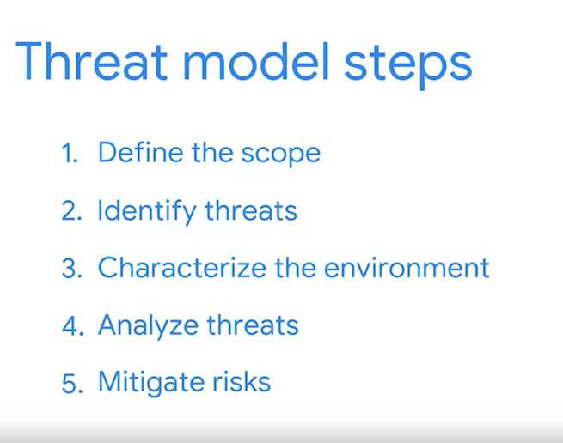

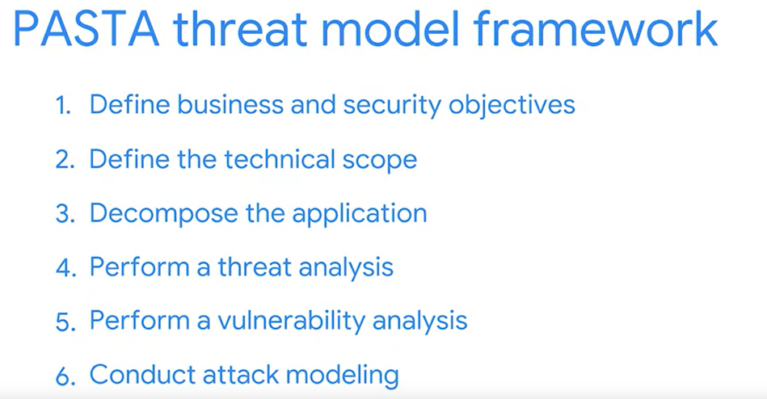

# Traits of an effective threat model

**Threat modeling** is the process of identifying assets, their vulnerabilities, and how each is exposed to threats. It is a strategic approach that combines various security activities, such as vulnerability management, threat analysis, and incident response. Security teams commonly perform these exercises to ensure their systems are adequately protected. Another use of threat modeling is to proactively find ways of reducing risks to any system or business process.

Traditionally, threat modeling is associated with the field of application development. In this reading, you will learn about common threat modeling frameworks that are used to design software that can withstand attacks. You'll also learn about the growing need for application security and ways that you can participate.

## Why application security matters

Applications have become an essential part of many organizations' success. For example, web-based applications allow customers from anywhere in the world to connect with businesses, their partners, and other customers.

Mobile applications have also changed the way people access the digital world. Smartphones are often the main way that data is exchanged between users and a business. The volume of data being processed by applications makes securing them a key to reducing risk for everyone who’s connected.

For example, say an application uses Java-based logging libraries with the Log4Shell vulnerability ([CVE-2021-44228](https://nvd.nist.gov/vuln/detail/CVE-2021-44228)

). If it's not patched, this vulnerability can allow remote code execution that an attacker can use to gain full access to your system from anywhere in the world. If exploited, a critical vulnerability like this can impact millions of devices.

## Defending the application layer

Defending the application layer requires proper testing to uncover weaknesses that can lead to risk. Threat modeling is one of the primary ways to ensure that an application meets security requirements. A DevSecOps team, which stands for development, security, and operations, usually performs these analyses.

A typical threat modeling process is performed in a cycle:

* Define the scope
* Identify threats
* Characterize the environment
* Analyze threats
* Mitigate risks
* Evaluate findings

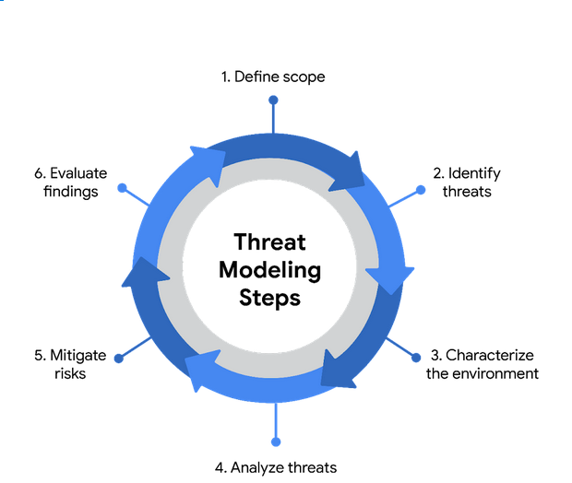

Ideally, threat modeling should be performed before, during, and after an application is developed. However, conducting a thorough software analysis takes time and resources. Everything from the application's architecture to its business purposes should be evaluated. As a result, a number of threat-modeling frameworks have been developed over the years to make the process smoother.

**Note:** Threat modeling should be incorporated at every stage of the software development lifecycle, or SDLC.

## Common frameworks

When performing threat modeling, there are multiple methods that can be used, such as:

* STRIDE
* PASTA
* Trike
* VAST

Organizations might use any one of these to gather intelligence and make decisions to improve their security posture. Ultimately, the “right” model depends on the situation and the types of risks an application might face.

### **STRIDE**

STRIDE is a threat-modeling framework developed by Microsoft. It’s commonly used to identify vulnerabilities in six specific attack vectors. The acronym represents each of these vectors: spoofing, tampering, repudiation, information disclosure, denial of service, and elevation of privilege.

### **PASTA**

The **Process of Attack Simulation and Threat Analysis** (PASTA) is a risk-centric threat modeling process developed by two OWASP leaders and supported by a cybersecurity firm called VerSprite. Its main focus is to discover evidence of viable threats and represent this information as a model. PASTA's evidence-based design can be applied when threat modeling an application or the environment that supports that application. Its seven stage process consists of various activities that incorporate relevant security artifacts of the environment, like vulnerability assessment reports.

### **Trike**

Trike is an open source methodology and tool that takes a security-centric approach to threat modeling. It's commonly used to focus on security permissions, application use cases, privilege models, and other elements that support a secure environment.

### **VAST**

The Visual, Agile, and Simple Threat (VAST) Modeling framework is part of an automated threat-modeling platform called ThreatModeler®. Many security teams opt to use VAST as a way of automating and streamlining their threat modeling assessments.

## Participating in threat modeling

Threat modeling is often performed by experienced security professionals, but it’s almost never done alone. This is especially true when it comes to securing applications. Programs are complex systems responsible for handling a lot of data and processing  a variety of commands from users and other systems.

One of the keys to threat modeling is asking the right questions:

* What are we working on?
* What kinds of things can go wrong?
* What are we doing about it?
* Have we addressed everything?
* Did we do a good job?

It takes time and practice to learn how to work with things like data flow diagrams and attack trees. However, anyone can learn to be an effective threat modeler. Regardless of your level of experience, participating in one of these exercises always starts with simply asking the right questions.

## Key takeaways

Many people rely on software applications in their day to day lives. Securing the applications that people use has never been more important. Threat modeling is one of the main ways to determine whether security controls are in place to protect data privacy. Building the skills required to lead a threat modeling activity is a matter of practice. However, even a security analyst with little experience can be a valuable contributor to the process. It all starts with applying an attacker mindset and thinking critically about how data is handled.

# Glossary terms from module 4

## Terms and definitions from Course 5, Module 4

**Angler phishing:** A technique where attackers impersonate customer service representatives on social media

**Advanced persistent threat (APT):** Instances when a threat actor maintains unauthorized access to a system for an extended period of time

**Adware:** A type of legitimate software that is sometimes used to display digital advertisements in applications

**Attack tree:** A diagram that maps threats to assets

**Baiting:** A social engineering tactic that tempts people into compromising their security

**Botnet:** A collection of computers infected by malware that are under the control of a single threat actor, known as the “bot-herder"

**Cross-site scripting (XSS):** An injection attack that inserts code into a vulnerable website or web application

**Cryptojacking:** A form of malware that installs software to illegally mine cryptocurrencies

**DOM-based XSS attack:** An instance when malicious script exists in the webpage a browser loads

**Dropper:** A type of malware that comes packed with malicious code which is delivered and installed onto a target system

**Fileless malware:** Malware that does not need to be installed by the user because it uses legitimate programs that are already installed to infect a computer

**Hacker:** Any person or group who uses computers to gain unauthorized access to data

**Identity and access management (IAM):** A collection of processes and technologies that helps organizations manage digital identities in their environment

**Injection attack:** Malicious code inserted into a vulnerable application

**Input validation:** Programming that validates inputs from users and other programs

**Intrusion detection system (IDS):** An application that monitors system activity and alerts on possible intrusions

**Loader:** A type of malware that downloads strains of malicious code from an external source and installs them onto a target system

**Malware:** Software designed to harm devices or networks

**Process of Attack Simulation and Threat Analysis (PASTA):** A popular threat modeling framework that’s used across many industries

**Phishing:** The use of digital communications to trick people into revealing sensitive data or deploying malicious software

**Phishing kit:** A collection of software tools needed to launch a phishing campaign

**Prepared statement:** A coding technique that executes SQL statements before passing them onto the database

**Potentially unwanted application (PUA):** A type of unwanted software that is bundled in with legitimate programs which might display ads, cause device slowdown, or install other software

**Quid pro quo:** A type of baiting used to trick someone into believing that they’ll be rewarded in return for sharing access, information, or money

**Ransomware:** Type of malicious attack where attackers encrypt an organization’s data and demand payment to restore access

**Reflected XSS attack:** An instance when malicious script is sent to a server and activated during the server’s response

**Rootkit:** Malware that provides remote, administrative access to a computer

**Scareware:** Malware that employs tactics to frighten users into infecting their device

**Smishing**: The use of text messages to trick users to obtain sensitive information or to impersonate a known source

**Social engineering:** A manipulation technique that exploits human error to gain private information, access, or valuables

**Spear phishing:** A malicious email attack targeting a specific user or group of users, appearing to originate from a trusted source

**Spyware:** Malware that’s used to gather and sell information without consent

**SQL (Structured Query Language):** A programming language used to create, interact with, and request information from a database

**SQL injection:** An attack that executes unexpected queries on a database

**Stored XSS attack:** An instance when malicious script is injected directly on the server

**Tailgating:** A social engineering tactic in which unauthorized people follow an authorized person into a restricted area

**Threat:** Any circumstance or event that can negatively impact assets

**Threat actor:** Any person or group who presents a security risk

**Threat modeling:** The process of identifying assets, their vulnerabilities, and how each is exposed to threats

**Trojan horse:** Malware that looks like a legitimate file or program

**Vishing:** The exploitation of electronic voice communication to obtain sensitive information or to impersonate a known source

**Watering hole attack**: A type of attack when a threat actor compromises a website frequently visited by a specific group of users

**Whaling:** A category of spear phishing attempts that are aimed at high-ranking executives in an organization

**Web-based exploits:** Malicious code or behavior that’s used to take advantage of coding flaws in a web application

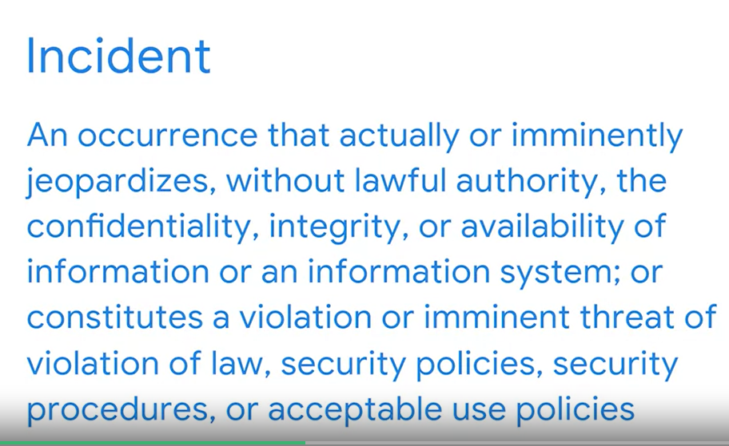

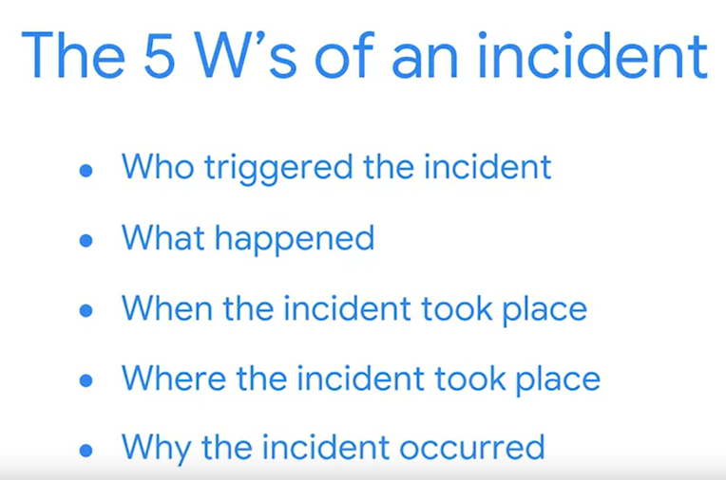

# Roles in response

So far, you've been introduced to the **National Institute of Standards and Technology (NIST) Incident Response Lifecycle**, which is a framework for incident response consisting of four phases:

* Preparation
* Detection and Analysis
* Containment, Eradication, and Recovery
* Post-incident activity

As a security professional, you'll work on a team to monitor, detect, and respond to incidents. Previously, you learned about a **computer security incident response team (CSIRT)** and a **security operations center (SOC)**. This reading explains the different functions, roles, and responsibilities that make up CSIRTs and SOCs.

Understanding the composition of incident response teams will help you navigate an organization’s hierarchy, openly collaborate and communicate with others, and work cohesively to respond to incidents. You may even discover specific roles that you’re interested in pursuing as you begin your security career!

## Command, control, and communication

A **computer security incident response team (CSIRT)** is a specialized group of security professionals that are trained in incident management and response. During incident response, teams can encounter a variety of different challenges. For incident response to be effective and efficient, there must be clear command**,** control, and communication of the situation to achieve the desired goal.

* **Command** refers to having the appropriate leadership and direction to oversee the response.
* **Control** refers to the ability to manage technical aspects during incident response, like coordinating resources and assigning tasks.
* **Communication** refers to the ability to keep stakeholders informed.

Establishing a CSIRT organizational structure with clear and distinctive roles aids in achieving an effective and efficient response.

## Roles in CSIRTs

CSIRTs are organization dependent, so they can vary in their structure and operation. Structurally, they can exist as a separate, dedicated team or as a task force that meets when necessary. CSIRTs involve both nonsecurity and security professionals. Nonsecurity professionals are often consulted to offer their expertise on the incident. These professionals can be from external departments, such as human resources, public relations, management, IT, legal, and others. Security professionals involved in a CSIRT typically include three key security related roles:

1. **Security analyst**
2. **Technical lead**
3. **Incident coordinator**

### **Security analyst**

The job of the **security** **analyst** is to continuously monitor an environment for any security threats. This includes:

* Analyzing and triaging alerts
* Performing root-cause investigations
* Escalating or resolving alerts

If a critical threat is identified, then analysts escalate it to the appropriate team lead, such as the technical lead.

### **Technical lead**

The job of the technical lead is to manage all of the technical aspects of the incident response process, such as applying software patches or updates. They do this by first determining the root cause of the incident. Then, they create and implement the strategies for containing, eradicating, and recovering from the incident. Technical leads often collaborate with other teams to ensure their incident response priorities align with business priorities, such as reducing disruptions for customers or returning to normal operations.

### **Incident coordinator**

Responding to an incident also requires cross-collaboration with nonsecurity professionals. CSIRTs will often consult with and leverage the expertise of members from external departments. The job of the incident coordinator is to coordinate with the relevant departments during a security incident. By doing so, the lines of communication are open and clear, and all personnel are made aware of the incident status. Incident coordinators can also be found in other teams, like the SOC.

### **Other roles**

Depending on the organization, many other roles can be found in a CSIRT, including a dedicated communications lead, a legal lead, a planning lead, and more.

**Note**: Teams, roles, responsibilities, and organizational structures can differ for each company. For example, some different job titles for incident coordinator include incident commander and incident manager.

## Security operations center

A **security operations center (SOC)** is an organizational unit dedicated to monitoring networks, systems, and devices for security threats or attacks. Structurally, a SOC (usually pronounced "sock") often exists as its own separate unit or within a CSIRT. You may be familiar with the term blue team, which refers to the security professionals who are responsible for defending against all security threats and attacks at an organization. A SOC is involved in various types of blue team activities, such as network monitoring, analysis, and response to incidents.

## SOC organization

A SOC is composed of SOC analysts, SOC leads, and SOC managers. Each role has its own respective responsibilities. SOC analysts are grouped into three different tiers.

### **Tier 1 SOC analyst**

The first tier is composed of the least experienced SOC analysts who are known as level 1s (L1s). They are responsible for:

* Monitoring, reviewing, and prioritizing alerts based on criticality or severity
* Creating and closing alerts using ticketing systems
* Escalating alert tickets to Tier 2 or Tier 3

### **Tier 2 SOC analyst**

The second tier comprises the more experienced SOC analysts, or level 2s (L2s). They are responsible for:

* Receiving escalated tickets from L1 and conducting deeper investigations
* Configuring and refining security tools
* Reporting to the SOC Lead

### **Tier 3 SOC lead**

The third tier of a SOC is composed of the SOC leads, or level 3s (L3s). These highly experienced professionals are responsible for:

* Managing the operations of their team
* Exploring methods of detection by performing advanced detection techniques, such as malware and forensics analysis
* Reporting to the SOC manager

### **SOC manager**

The SOC manager is at the top of the pyramid and is responsible for:

* Hiring, training, and evaluating the SOC team members
* Creating performance metrics and managing the performance of the SOC team
* Developing reports related to incidents, compliance, and auditing
* Communicating findings to stakeholders such as executive management

### **Other roles**

SOCs can also contain other specialized roles such as:

* **Forensic investigators**: Forensic investigators are commonly L2s and L3s who collect, preserve, and analyze digital evidence related to security incidents to determine what happened.
* **Threat hunters**: Threat hunters are typically L3s who work to detect, analyze, and defend against new and advanced cybersecurity threats using threat intelligence.

**Note**: Just like CSIRTs, the organizational structure of a SOC can differ depending on the organization.

## Key takeaways

As a security analyst, you will collaborate with your team members and people outside of your immediate team. Recognizing the organizational structure of an incident response team, such as a CSIRT or SOC, will help you understand how incidents move through their lifecycle and the responsibilities of different security roles throughout the process. Knowing the role that you and other professionals have during an incident response event will help you respond to challenging security situations by leveraging different perspectives and thinking of creative solutions.

# Overview of detection tools

Previously, you explored **intrusion detection system** (**IDS**) and **intrusion prevention system** (**IPS**) technologies. In this reading, you’ll compare and contrast these tools and learn about **endpoint detection and response** (**EDR**). As a security analyst, you'll likely work with these different tools, so it's important to understand their functions.

## Why you need detection tools

Detection tools work similarly to home security systems. Whereas home security systems monitor and protect homes against intrusion, cybersecurity detection tools help organizations protect their networks and systems against unwanted and unauthorized access. For organizations to protect their systems from security threats or attacks, they must be made aware when there is any indication of an intrusion. Detection tools make security professionals aware of the activity happening on a network or a system. The tools do this by continuously monitoring networks and systems for any suspicious activity. Once something unusual or suspicious is detected, the tool triggers an alert that notifies the security professional to investigate and stop the possible intrusion.

## Detection tools

As a security analyst, you'll likely encounter **IDS**, **IPS**, and **EDR** detection tools at some point, but it's important to understand the differences between them. Here is a comparison chart for quick reference:

| **Capability** | **IDS** | **IPS** | **EDR** |
| --- | --- | --- | --- |
| Detects malicious activity | ✓ | ✓ | ✓ |
| Prevents intrusions | N/A | ✓ | ✓ |
| Logs activity | ✓ | ✓ | ✓ |
| Generates alerts | ✓ | ✓ | ✓ |
| Performs behavioral analysis | N/A | N/A | ✓ |

## Overview of IDS tools

An **intrusion detection system** (**IDS**) is an application that monitors system activity and alerts on possible intrusions. An IDS provides continuous monitoring of network events to help protect against security threats or attacks. The goal of an IDS is to detect potential malicious activity and generate an alert once such activity is detected. An IDS does not stop or prevent the activity. Instead, security professionals will investigate the alert and act to stop it, if necessary.

For example, an IDS can send out an alert when it identifies a suspicious user login, such as an unknown IP address logging into an application or a device at an unusual time. But, an IDS will not stop or prevent any further actions, like blocking the suspicious user login.

Examples of IDS tools include Zeek, Suricata, Snort®, and Sagan.

### **Detection categories**

As a security analyst, you will investigate alerts that an IDS generates. There are four types of detection categories you should be familiar with:

1. **A true positive** is an alert that correctly detects the presence of an attack.
2. **A true negative** is a state where there is no detection of malicious activity. This is when no malicious activity exists and no alert is triggered.
3. **A false positive** is an alert that incorrectly detects the presence of a threat. This is when an IDS identifies an activity as malicious, but it isn't. False positives are an inconvenience for security teams because they spend time and resources investigating an illegitimate alert.
4. **A false negative** is a state where the presence of a threat is not detected. This is when malicious activity happens but an IDS fails to detect it. False negatives are dangerous because security teams are left unaware of legitimate attacks that they can be vulnerable to.

## Overview of IPS tools

An **intrusion prevention system** (**IPS**) is an application that monitors system activity for intrusive activity and takes action to stop the activity. An IPS works similarly to an IDS. But, IPS monitors system activity to detect and alert on intrusions, and it also takes action to prevent the activity and minimize its effects. For example, an IPS can send an alert and modify an access control list on a router to block specific traffic on a server.

**Note:** Many IDS tools can also operate as an IPS. Tools like Suricata, Snort, and Sagan have both IDS and IPS capabilities.

## Overview of EDR tools

**Endpoint detection and response** (**EDR**) is an application that monitors an endpoint for malicious activity. EDR tools are installed on endpoints. Remember that an **endpoint** is any device connected on a network. Examples include end-user devices, like computers, phones, tablets, and more.

EDR tools monitor, record, and analyze endpoint system activity to identify, alert, and respond to suspicious activity. Unlike IDS or IPS tools, EDRs collect endpoint activity data and perform behavioral analysis to identify threat patterns happening on an endpoint. Behavioral analysis uses the power of machine learning and artificial intelligence to analyze system behavior to identify malicious or unusual activity. EDR tools also use automation to stop attacks without the manual intervention of security professionals. For example, if an EDR detects an unusual process starting up on a user’s workstation that normally is not used, it can automatically block the process from running.

Tools like Open EDR®, Bitdefender™ Endpoint Detection and Response, and FortiEDR™ are examples of EDR tools.

**Note**: Security information and event management (SIEM) tools also have detection capabilities, which you'll explore later.

## Key takeaways

Organizations deploy detection tools to gain awareness into the activity happening in their environments. IDS, IPS, and EDR are different types of detection tools. The value of detection tools is in their ability to detect, log, alert, and stop potential malicious activity.

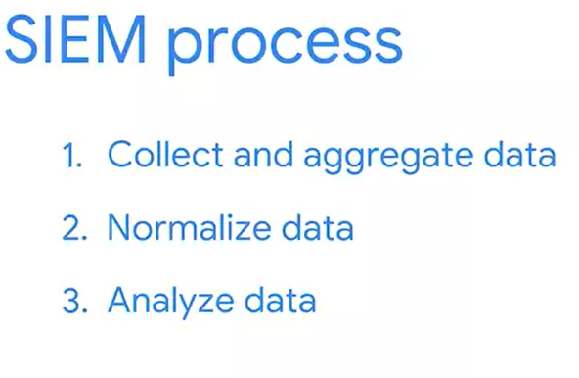

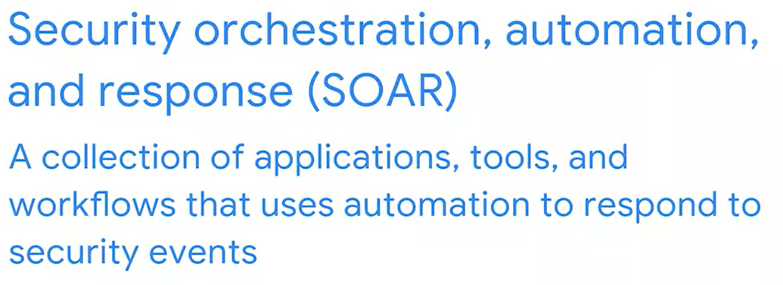

## SIEM tools

There are many SIEM tools. The following are some SIEM tools commonly used in the cybersecurity industry:

* AlienVault® OSSIM™
* Chronicle
* Elastic
* Exabeam
* IBM QRadar® Security Intelligence Platform
* LogRhythm
* Splunk

## ****Terms and definitions from Course 6, Module 1****

**Computer security incident response teams (CSIRT):** A specialized group of security professionals that are trained in incident management and response

**Documentation:** Any form of recorded content that is used for a specific purpose

**Endpoint detection and response (EDR):** An application that monitors an endpoint for malicious activity

**Event:** An observable occurrence on a network, system, or device

**False negative**: A state where the presence of a threat is not detected

**False positive:** An alert that incorrectly detects the presence of a threat

**Incident:** An occurrence that actually or imminently jeopardizes, without lawful authority, the confidentiality, integrity, or availability of information or an information system; or constitutes a violation or imminent threat of violation of law, security policies, security procedures, or acceptable use policies

**Incident handler’s journal:** A form of documentation used in incident response

**Incident response plan:** A document that outlines the procedures to take in each step of incident response

**Intrusion detection system (IDS):** An application that monitors system activity and alerts on possible intrusions

**Intrusion prevention system (IPS):** An application that monitors system activity for intrusive activity and takes action to stop the activity

**National Institute of Standards and Technology (NIST) Incident Response Lifecycle:** A framework for incident response consisting of four phases: Preparation; Detection and Analysis; Containment, Eradication, and Recovery; and Post-incident activity

**Playbook:** A manual that provides details about any operational action

**Security information and event management (SIEM):** An application that collects and analyzes log data to monitor critical activities in an organization

**Security operations center (SOC):** An organizational unit dedicated to monitoring networks, systems, and devices for security threats or attacks

**Security orchestration, automation, and response (SOAR):** A collection of applications, tools, and workflows that uses automation to respond to security events

**True negative:** A state where there is no detection of malicious activity

**True positive** An alert that correctly detects the presence of an attack

# Maintain awareness with network monitoring

Network communication can be noisy! Events like sending an email, streaming a video, or visiting a website all produce network communications in the form of network traffic and network data. As a reminder, **network traffic** is the amount of data that moves across a network. It can also include the type of data that is transferred, such as HTTP. **Network** **data** is the data that's transmitted between devices on a network.

Network monitoring is essential in maintaining situational awareness of any activity on a network. By collecting and analyzing network traffic, organizations can detect suspicious network activity. But before networks can be monitored, you must know exactly what to monitor. In this reading, you'll learn more about the importance of network monitoring, ways to monitor your network, and network monitoring tools.

## Know your network

As you’ve learned, networks connect devices, and devices then communicate and exchange data using network protocols. Network communications provide information about connections such as source and destination IP addresses, amount of data transferred, date and time, and more. This information can be valuable for security professionals when developing a **baseline** of normal or expected behavior.

A baseline is a reference point that’s used for comparison. You've probably encountered or used baselines at some point. For example, a grocery amount for a personal budget is an example of a baseline that can be used to help identify any patterns or changes in spending habits. In security, baselines help establish a standard of expected or normal behavior for systems, devices, and networks. Essentially, by knowing the baseline of normal network behavior, you'll be better able to identify abnormal network behavior.

## Monitor your network

Once you’ve determined a baseline, you can monitor a network to identify any deviations from that baseline. Monitoring involves examining network components to detect unusual activities, such as large and unusual data transfers. Here are examples of network components that can be monitored to detect malicious activity:

### **Flow analysis**

Flow refers to the movement of network communications and includes information related to packets, protocols, and ports. Packets can travel to ports, which receive and transmit communications. Ports are often, but not always, associated with network protocols. For example, port 443 is commonly used by HTTPS which is a protocol that provides website traffic encryption.

However, malicious actors can use protocols and ports that are not commonly associated to maintain communications between the compromised system and their own machine. These communications are what’s known as **command and control (C2)**,which are the techniques used by malicious actors to maintain communications with compromised systems.

For example, malicious actors can use HTTPS protocol over port 8088 as opposed to its commonly associated port 443 to communicate with compromised systems. Organizations must know which ports should be open and approved for connections, and watch out for any mismatches between ports and their associated protocols.

### **Packet payload information**

Network packets contain components related to the transmission of the packet. This includes details like source and destination IP address, and the packet payload information, which is the actual data that’s transmitted. Often, this data is encrypted and requires decryption for it to be readable. Organizations can monitor the payload information of packets to uncover unusual activity, such as sensitive data transmitting outside of the network, which could indicate a possible data exfiltration attack.

### **Temporal patterns**

Network packets contain information relating to time. This information is useful in understanding time patterns. For example, a company operating in North America experiences bulk traffic flows between 9 a.m. to 5 p.m., which is the baseline of normal network activity. If large volumes of traffic are suddenly outside of the normal hours of network activity, then this is considered off baseline and should be investigated.

Through network monitoring, organizations can promptly detect network intrusions and work to prevent them from happening by securing network components.

## Protect your network

In this program, you’ve learned about **security operations centers** (**SOC**) and their role in monitoring systems against security threats and attacks. Organizations may deploy a **network operations center** (**NOC**), which is an organizational unit that monitors the performance of a network and responds to any network disruption, such as a network outage. While a SOC is focused on maintaining the security of an organization through detection and response, a NOC is responsible for maintaining network performance, availability, and uptime.

Security analysts monitor networks to identify any signs of potential security incidents known as **indicators of compromise** (**IoC**) and  protect networks from threats or attacks. To do this, they must understand the environment that network communications travel through so that they can identify deviations in network traffic.

### **Network monitoring tools**

Network monitoring can be automated or performed manually. Some common network monitoring tools can include:

* **Intrusion detection systems** (**IDS**) monitor system activity and alert on possible intrusions. An IDS will detect and alert on the deviations you’ve configured it to detect. Most commonly, IDS tools will monitor the content of packet payload to detect patterns associated with threats such as malware or phishing attempts.
* **Network protocol analyzers**, also known as packet sniffers, are tools designed to capture and analyze data traffic within a network. They can be used to analyze network communications manually in detail. Examples include tools such as tcpdump and Wireshark, which can be used by security professionals to record network communications through packet captures. Packet captures can then be investigated to identify potentially malicious activity.

## Key takeaways

Monitoring and protecting networks from intrusions and attacks are key responsibilities of security professionals. You can’t protect what you don’t know. As a security analyst, you’ll need to know the components of a network and the communications that happen on it, so you can better protect it. Baselines provide a way to understand network traffic by uncovering common patterns which help in identifying any deviations from the expected traffic patterns. Tools like intrusion detection systems and network protocol analyzers support efforts in monitoring network activities.

Data exfil defence measures:

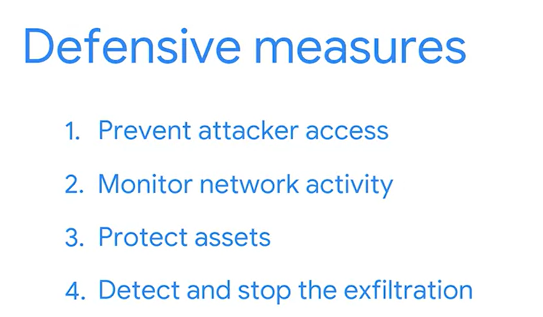

## Internet Protocol (IP)

Packets form the foundation of data exchange over a network, which means that detection begins at the packet level. The **Internet Protocol (IP)** includes a set of standards used for routing and addressing data packets as they travel between devices on a network. IP operates as the foundation for all communications over the internet.

IP ensures that packets reach their destinations. There are two versions of IP that you will find in use today: IPv4 and IPv6. Both versions use different headers to structure packet information.

### **IPv4**

IPv4 is the most commonly used version of IP. There are thirteen fields in the header:

* **Version**: This field indicates the IP version. For an IPv4 header, IPv4 is used.
* **Internet Header Length (IHL)**: This field specifies the length of the IPv4 header including any Options.
* **Type of Service (ToS)**: This field provides information about packet priority for delivery.
* **Total Length**: This field specifies the total length of the entire IP packet including the header and the data.
* **Identification**: Packets that are too large to send are fragmented into smaller pieces. This field specifies a unique identifier for fragments of an original IP packet so that they can be reassembled once they reach their destination.
* **Flags**: This field provides information about packet fragmentation including whether the original packet has been fragmented and if there are more fragments in transit.
* **Fragment Offset**: This field is used to identify the correct sequence of fragments.
* **Time to Live (TTL)**: This field limits how long a packet can be circulated in a network, preventing packets from being forwarded by routers indefinitely.
* **Protocol**: This field specifies the protocol used for the data portion of the packet.
* **Header Checksum**: This field specifies a checksum value which is used for error-checking the header.
* **Source Address**: This field specifies the source address of the sender.
* **Destination Address**: This field specifies the destination address of the receiver.
* **Options**: This field is optional and can be used to apply security options to a packet.

### **IPv6**

IPv6 adoption has been increasing because of its large address space. There are eight fields in the header:

* **Version**: This field indicates the IP version. For an IPv6 header, IPv6 is used.
* **Traffic Class**: This field is similar to the IPv4 Type of Service field. The Traffic Class field provides information about the packet's priority or class to help with packet delivery.
* **Flow Label**: This field identifies the packets of a flow. A flow is the sequence of packets sent from a specific source.
* **Payload Length**: This field specifies the length of the data portion of the packet.
* **Next Header**: This field indicates the type of header that follows the IPv6 header such as TCP.
* **Hop Limit**: This field is similar to the IPv4 Time to Live field. The Hop Limit limits how long a packet can travel in a network before being discarded.
* **Source Address**: This field specifies the source address of the sender.
* **Destination Address**: This field specifies the destination address of the receiver.

## Wireshark

**Wireshark** is an open-source network protocol analyzer. It uses a graphical user interface (GUI), which makes it easier to visualize network communications for packet analysis purposes. Wireshark has many features to explore that are beyond the scope of this course. You'll focus on how to use basic filtering to isolate network packets so that you can find what you need.

### Display filters

Wireshark's display filters let you apply filters to packet capture files. This is helpful when you are inspecting packet captures with large volumes of information. Display filters will help you find specific information that's most relevant to your investigation. You can filter packets based on information such as protocols, IP addresses, ports, and virtually any other property found in a packet. Here, you'll focus on display filtering syntax and filtering for protocols, IP addresses, and ports.

### Comparison operators

You can use different comparison operators to locate specific header fields and values. Comparison operators can be expressed using either abbreviations or symbols. For example, this filter using the == equal symbol in this filter ip.src == 8.8.8.8 is identical to using the eq abbreviation in this filter ip.src eq 8.8.8.8.

This table summarizes the different types of comparison operators you can use for display filtering.

| **Operator type** | **Symbol** | **Abbreviation** |
| --- | --- | --- |
| Equal | == | eq |
| Not equal | != | ne |
| Greater than | > | gt |
| Less than | < | lt |
| Greater than or equal to | >= | ge |
| Less than or equal to | <= | le |

**Pro tip:** You can combine comparison operators with Boolean logical operators like and and or to create complex display filters. Parentheses can also be used to group expressions and to prioritize search terms.

### Contains operator

The contains operator is used to filter packets that contain an exact match of a string of text. Here is an example of a filter that displays all HTTP streams that match the keyword "moved".

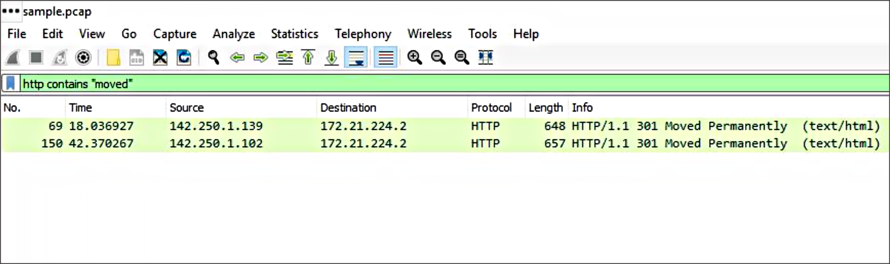

### Matches operator

The matches operator is used to filter packets based on the regular expression (regex) that's specified. Regular expression is a sequence of characters that forms a pattern. You'll explore more about regular expressions later in this program.

## Filter toolbar

You can apply filters to a packet capture using Wireshark's filter toolbar. In this example, dns is the applied filter, which means Wireshark will only display packets containing the DNS protocol.

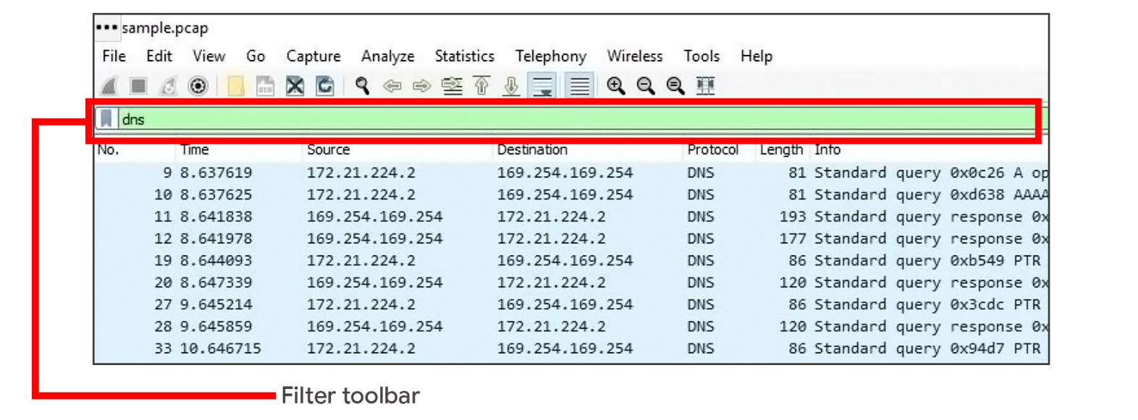

**Pro tip**: Wireshark uses different colors to represent protocols. You can customize colors and create your own filters.

### **Filter for protocols**

Protocol filtering is one of the simplest ways you can use display filters. You can simply enter the name of the protocol to filter. For example, to filter for DNS packets simply type dns in the filter toolbar. Here is a list of some protocols you can filter for:

* dns
* http
* ftp
* ssh
* arp
* telnet
* icmp

### **Filter for an IP address**

You can use display filters to locate packets with a specific IP address.

For example, if you would like to filter packets that contain a specific IP address use ip.addr, followed by a space, the equal == comparison operator, and the IP address. Here is an example of a display filter that filters for the IP address 172.21.224.2:

ip.addr == 172.21.224.2

To filter for packets originating from a specific source IP address, you can use the ip.src filter. Here is an example that looks for the 10.10.10.10 source IP address:

ip.src == 10.10.10.10

To filter for packets delivered to a specific destination IP address, you can use the ip.dst filter. Here is an example that searches for the 4.4.4.4 destination IP address:

ip.dst == 4.4.4.4

### **Filter for a MAC address**

You can also filter packets according to the **Media Access Control (MAC) address**. As a refresher, a MAC address is a unique alphanumeric identifier that is assigned to each physical device on a network.

Here's an example:

eth.addr == 00:70:f4:23:18:c4

### **Filter for ports**

Port filtering is used to filter packets based on port numbers. This is helpful when you want to isolate specific types of traffic. DNS traffic uses TCP or UDP port 53 so this will list traffic related to DNS queries and responses only.

For example, if you would like to filter for a UDP port:

udp.port == 53

Likewise, you can filter for TCP ports as well:

tcp.port == 25

## Follow streams

Wireshark provides a feature that lets you filter for packets specific to a protocol and view streams. A stream or conversation is the exchange of data between devices using a protocol. Wireshark reassembles the data that was transferred in the stream in a way that's simple to read.

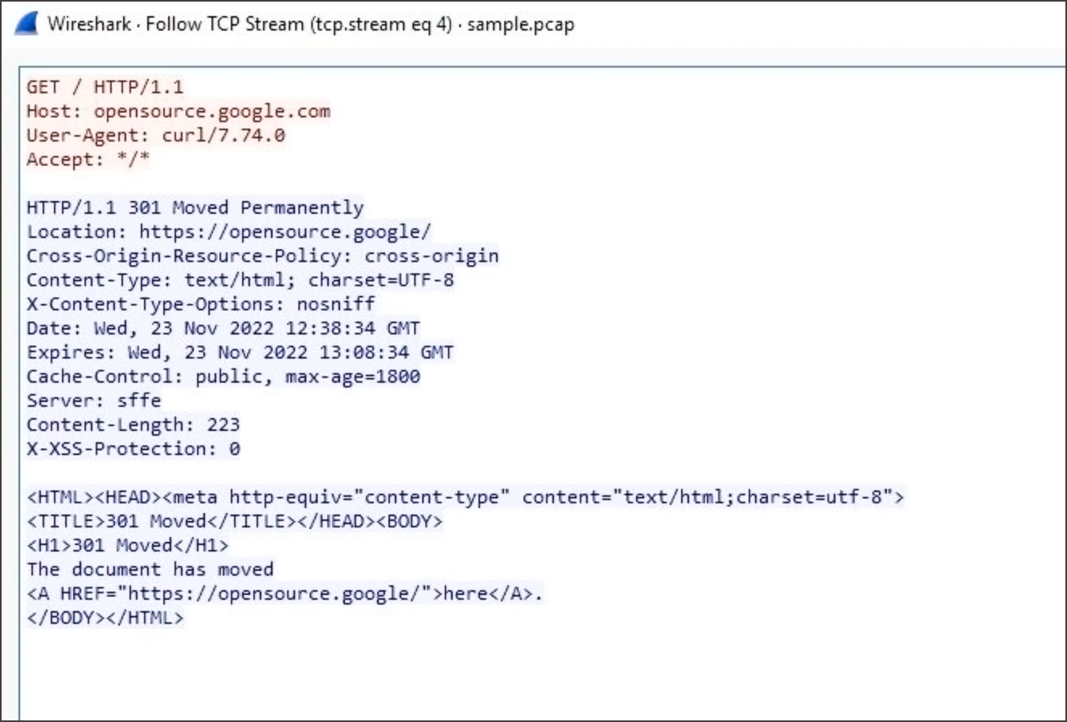

Following a protocol stream is useful when trying to understand the details of a conversation. For example, you can examine the details of an HTTP conversation to view the content of the exchanged request and response messages.

## Key takeaways

In this reading, you explored basic display filters with Wireshark. Packet analysis is an essential skill that you will continue to develop over time in your cybersecurity journey. Put your skills to practice in the upcoming activity and explore investigating the details of a packet capture file using Wireshark!

# Overview of tcpdump

As a security analyst, you’ll use network protocol analyzers to help defend against any network intrusions. Previously, you learned the following terms related to network monitoring and analysis:

* A **network protocol analyzer (packet sniffer)** is a tool designed to capture and analyze data traffic within a network.
* **Packet sniffing** is the practice of capturing and inspecting data packets across a network.

In this reading, you'll learn more about tcpdump, a network protocol analyzer that can be used to capture and view network communications.

## What is tcpdump?

**Tcpdump** is a command-line network protocol analyzer. Recall that a **command-line interface (CLI)** is a text-based user interface that uses commands to interact with the computer.

Tcpdump is used to capture network traffic. This traffic can be saved to a **packet capture (p-cap)**, which is a file containing data packets intercepted from an interface or network. The p-cap file can be accessed, analyzed, or shared at a later time. Analysts use tcpdump for a variety of reasons, from troubleshooting network issues to identifying malicious activity. Tcpdump comes pre-installed in many Linux distributions and can also be installed on other Unix-based operating systems such as macOS®.

**Note**: It's common for network traffic to be encrypted, which means data is encoded and unreadable. Inspecting the network packets might require decrypting the data using the appropriate private keys.

## Capturing packets with tcpdump

Previously in this program, you learned that a Linux **root user (or superuser)** has elevated privileges to modify the system. You also learned that the **sudo** command temporarily grants elevated permissions to specific users in Linux. Like many other packet sniffing tools, you’ll need to have administrator-level privileges to capture network traffic using tcpdump. This means you will need to either be logged in as the root user or have the ability to use the sudo command. Here is a breakdown of the tcpdump syntax for capturing packets:

sudo tcpdump [-i interface] [option(s)] [expression(s)]

* The sudo tcpdump command begins running tcpdump using elevated permissions as sudo.
* The -i parameter specifies the network interface to capture network traffic. You must specify a network interface to capture from to begin capturing packets. For example, if you specify -i any you’ll sniff traffic from all network interfaces on the system.
* The option(s) are optional and provide you with the ability to alter the execution of the command. The expression(s) are a way to further filter network traffic packets so that you can isolate network traffic. You’ll learn more about option(s) and expression(s) in the next section.

**Note**: Before you can begin capturing network traffic, you must identify which network interface you'll want to use to capture packets from. You can use the -D flag to list the network interfaces available on a system.

## Options

With tcpdump, you can apply options, also known as flags, to the end of commands to filter network traffic. Short options are abbreviated and represented by a hyphen and a single character like -i. Long options are spelled out using a double hyphen like --interface. Tcpdump has over fifty options that you can explore using [the manual page](https://www.tcpdump.org/manpages/tcpdump.1.html)

. Here, you’ll examine a couple of essential tcpdump options including how to write and read packet capture files.

**Note**: Options are case sensitive. For example, a lowercase -w is a separate option with a different use than the option with an uppercase -W.

**Note**: tcpdump options that are written using short options can be written with or without a space between the option and its value. For example, sudo tcpdump -i any -c 3 and sudo tcpdump -iany -c3 are equivalent commands.

### **-w**

Using the -w flag, you can write or save the sniffed network packets to a packet capture file instead of just printing it out in the terminal. This is very useful because you can refer to this saved file for later analysis. In this command, tcpdump is capturing network traffic from all network interfaces and saving it to a packet capture file named packetcapture.pcap:

### sudo tcpdump -i any -w packetcapture.pcap

### **-r**

Using the -r flag, you can read a packet capture file by specifying the file name as a parameter. Here is an example of a tcpdump command that reads a file called packetcapture.pcap:

### sudo tcpdump -r packetcapture.pcap

### **-v**

As you’ve learned, packets contain a lot of information. By default, tcpdump will not print out all of a packet's information. This option, which stands for verbose, lets you control how much packet information you want tcpdump to print out.

There are three levels of verbosity you can use depending on how much packet information you want tcpdump to print out. The levels are -v, -vv, and -vvv. The level of verbosity increases with each added v. The verbose option can be helpful if you’re looking for packet information like the details of a packet’s IP header fields. Here’s an example of a tcpdump command that reads the packetcapture.pcap file with verbosity:

### sudo tcpdump -r packetcapture.pcap -v

### **-c**

The -c option stands for count. This option lets you control how many packets tcpdump will capture. For example, specifying -c 1 will only print out one single packet, whereas -c 10 prints out 10 packets. This example is telling tcpdump to only capture the first three packets it sniffs from any network interface:

### sudo tcpdump -i any -c 3

### **-n**

By default, tcpdump will perform name resolution. This means that tcpdump automatically converts IP addresses to names. It will also resolve ports to commonly associated services that use these ports. This can be problematic because tcpdump isn’t always accurate in name resolution. For example, tcpdump can capture traffic from port 80 and automatically translates port 80 to HTTP in the output. However, this is misleading because port 80 isn’t always going to be using HTTP; it could be using a different protocol.

Additionally, name resolution uses what’s known as a reverse DNS lookup. A reverse DNS lookup is a query that looks for the domain name associated with an IP address. If you perform a reverse DNS lookup on an attacker’s system, they might be alerted that you are investigating them through their DNS records.

Using the -n flag disables this automatic mapping of numbers to names and is considered to be best practice when sniffing or analyzing traffic. Using -n will not resolve hostnames, whereas -nn will not resolve both hostnames or ports. Here’s an example of a tcpdump command that reads the packetcapture.pcap file with verbosity and disables name resolution:

### sudo tcpdump -r packetcapture.pcap -v -n

**Pro tip:** You can combine options together. For example, -v and -n can be combined as -vn. But, if an option accepts a parameter right after it like -c 1 or -r capture.pcap then you can’t combine other options to it.

## Expressions

Using filter expressions in tcpdump commands is also optional, but knowing how and when to use filter expressions can be helpful during packet analysis. There are many ways to use filter expressions.

If you want to specifically search for network traffic by protocol, you can use filter expressions to isolate network packets. For example, you can filter to find only IPv6 traffic using the filter expression ip6.

You can also use boolean operators like and, or, or not to further filter network traffic for specific IP addresses, ports, and more. The example below reads the packetcapture.pcap file and combines two expressions ip and port 80 using the and boolean operator:

sudo tcpdump -r packetcapture.pcap -n 'ip and port 80'

**Pro tip:** You can use single or double quotes to ensure that tcpdump executes all of the expressions. You can also use parentheses to group and prioritize different expressions. Grouping expressions is helpful for complex or lengthy commands. For example, the command ip and (port 80 or port 443) tells tcpdump to prioritize executing the filters enclosed in the parentheses before filtering for IPv4.

## Interpreting output

Once you run a command to capture packets, tcpdump will print the output of the command as the sniffed packets. In the output, tcpdump prints one line of text for each packet with each line beginning with a timestamp. Here’s an example of a command and output for a single TCP packet:

sudo tcpdump -i any -v -c 1

This command tells tcpdump to capture packets on -i any network interface. The option -v prints out the packet with detailed information and the option -c 1 prints out only one packet. Here is the output of this command:

1. **Timestamp**: The output begins with the timestamp, which starts with hours, minutes, seconds, and fractions of a second.
2. **Source IP:** The packet’s origin is provided by its source IP address.
3. **Source port:** This port number is where the packet originated.
4. **Destination IP:** The destination IP address is where the packet is being transmitted to.
5. **Destination port:** This port number is where the packet is being transmitted to.

The remaining output contains details of the TCP connection including flags and sequence number. The options information is additional packet information that the  -v option has provided.

## Key takeaways

In security, you’ll likely encounter using network protocol analyzer tools like tcpdump. It’s important to be equipped with the knowledge of capturing, filtering, and interpreting network packets on the command line.

# Glossary terms from module 2

## Terms and definitions from Course 6, Module 2

**Command and control (C2):** The techniques used by malicious actors to maintain communications with compromised systems

**Command-line interface (CLI):** A text-based user interface that uses commands to interact with the computer

**Data exfiltration:** Unauthorized transmission of data from a system

**Data packet:** A basic unit of information that travels from one device to another within a network

**Indicators of compromise (IoC):** Observable evidence that suggests signs of a potential security incident

**Internet Protocol (IP):** A set of standards used for routing and addressing data packets as they travel between devices on a network

**Intrusion detection systems (IDS):** An application that monitors system activity and alerts on possible intrusions

**Media Access Control (MAC) Address:** A unique alphanumeric identifier that is assigned to each physical device on a network

**National Institute of Standards and Technology (NIST) Incident Response Lifecycle:** A framework for incident response consisting of four phases: Preparation; Detection and Analysis; Containment, Eradication and Recovery; and Post-incident activity

**Network data:** The data that’s transmitted between devices on a network

**Network protocol analyzer (packet sniffer):** A tool designed to capture and analyze data traffic within a network

**Network traffic:** The amount of data that moves across a network

**Network Interface Card (NIC):** Hardware that connects computers to a network

**Packet capture (p-cap):** A file containing data packets intercepted from an interface or network

**Packet sniffing:** The practice of capturing and inspecting data packets across a network

**Playbook:** A manual that provides details about any operational action

**Root user (or superuser)**:A user with elevated privileges to modify the system

**Sudo:** A command that temporarily grants elevated permissions to specific users

**tcpdump:** A command-line network protocol analyzer

**Wireshark:** An open-source network protocol analyzer

# Cybersecurity incident detection methods

Security analysts use detection tools to help them discover threats, but there are additional methods of detection that can be used as well.

Previously, you learned about how detection tools can identify attacks like data exfiltration. In this reading, you’ll be introduced to different detection methods that organizations can employ to discover threats.

## Methods of detection

During the **Detection and Analysis Phase** of the incident response lifecycle, security teams are notified of a possible incident and work to investigate and verify the incident by collecting and analyzing data. As a reminder, **detection** refers to the prompt discovery of security events and **analysis** involves the investigation and validation of alerts.

As you’ve learned, an intrusion detection system (IDS) can detect possible intrusions and send out alerts to security analysts to investigate the suspicious activity. Security analysts can also use security information and event management (SIEM) tools to detect, collect, and analyze security data.

You’ve also learned that there are challenges with detection. Even the best security teams can fail to detect real threats for a variety of reasons. For example, detection tools can only detect what security teams configure them to monitor. If they aren’t properly configured, they can fail to detect suspicious activity, leaving systems vulnerable to attack. It’s important for security teams to use additional methods of detection to increase their coverage and accuracy.

### **Threat hunting**

Threats evolve and attackers advance their tactics and techniques. Automated, technology-driven detection can be limited in keeping up to date with the evolving threat landscape. Human-driven detection like threat hunting combines the power of technology with a human element to discover hidden threats left undetected by detection tools.

**Threat hunting** is the proactive search for threats on a network. Security professionals use threat hunting to uncover malicious activity that was not identified by detection tools and as a way to do further analysis on detections. Threat hunting is also used to detect threats before they cause damage. For example, fileless malware is difficult for detection tools to identify. It’s a form of malware that uses sophisticated evasion techniques such as hiding in memory instead of using files or applications, allowing it to bypass traditional methods of detection like signature analysis. With threat hunting, the combination of active human analysis and technology is used to identify threats like fileless malware.

**Note**: Threat hunting specialists are known as threat hunters. Threat hunters perform research on emerging threats and attacks and then determine the probability of an organization being vulnerable to a particular attack. Threat hunters use a combination of threat intelligence, indicators of compromise, indicators of attack, and machine learning to search for threats in an organization.

### **Threat intelligence**

Organizations can improve their detection capabilities by staying updated on the evolving threat landscape and understanding the relationship between their environment and malicious actors. One way to understand threats is by using **threat intelligence**, which is evidence-based threat information that provides context about existing or emerging threats.

Threat intelligence can come from private or public sources like:

* **Industry reports**: These often include details about attacker's tactics, techniques, and procedures (TTP).
* **Government advisories:** Similar to industry reports, government advisories include details about attackers' TTP.
* **Threat data feeds**: Threat data feeds provide a stream of threat-related data that can be used to help protect against sophisticated attackers like **advanced persistent threats (APTs)**. APTs are instances when a threat actor maintains unauthorized access to a system for an extended period of time. The data is usually a list of indicators like IP addresses, domains, and file hashes.

It can be difficult for organizations to efficiently manage large volumes of threat intelligence. Organizations can leverage a threat intelligence platform (TIP) which is an application that collects, centralizes, and analyzes threat intelligence from different sources. TIPs provide a centralized platform for organizations to identify and prioritize relevant threats and improve their security posture.

**Note**: Threat intelligence data feeds are best used to add context to detections. They should not drive detections completely and should be assessed before applied to an organization.

### **Cyber deception**

Cyber deception involves techniques that deliberately deceive malicious actors with the goal of increasing detection and improving defensive strategies.

**Honeypots** are an example of an active cyber defense mechanism that uses deception technology. Honeypots are systems or resources that are created as decoys vulnerable to attacks with the purpose of attracting potential intruders. For example, having a fake file labeled Client Credit Card Information - 2022 can be used to capture the activity of malicious actors by tricking them into accessing the file because it appears to be legitimate. Once a malicious actor tries to access this file, security teams are alerted.

## Key takeaways

Various detection methods can be implemented to identify and locate security events in an environment. It’s essential for organizations to use a variety of detection methods, tools, and technologies to adapt to the ever evolving threat landscape and better protect assets.

# Indicators of compromise

In this reading, you’ll be introduced to the concept of the Pyramid of Pain and you'll explore examples of the different types of indicators of compromise. Understanding and applying this concept helps organizations improve their defense and reduces the damage an incident can cause.

## Indicators of compromise

**Indicators of compromise** (**IoCs**) are observable evidence that suggests signs of a potential security incident. IoCs chart specific pieces of evidence that are associated with an attack, like a file name associated with a type of malware. You can think of an IoC as evidence that points to something that's already happened, like noticing that a valuable has been stolen from inside of a car.

**Indicators of attack** (**IoA**) are the series of observed events that indicate a real-time incident.  IoAs focus on identifying the behavioral evidence of an attacker, including their methods and intentions.

Essentially, IoCs help to identify the who and what of an attack after it's taken place, while IoAs focus on finding the why and how of an ongoing or unknown attack. For example, observing a process that makes a network connection is an example of an IoA. The filename of the process and the IP address that the process contacted are examples of the related IoCs.

**Note**: Indicators of compromise are not always a confirmation that a security incident has happened. IoCs may be the result of human error, system malfunctions, and other reasons not related to security.

## Pyramid of Pain

Not all indicators of compromise are equal in the value they provide to security teams. It’s important for security professionals to understand the different types of indicators of compromise so that they can quickly and effectively detect and respond to them. This is why security researcher David J. Bianco created the concept of the [Pyramid of Pain](http://detect-respond.blogspot.com/2013/03/the-pyramid-of-pain.html)

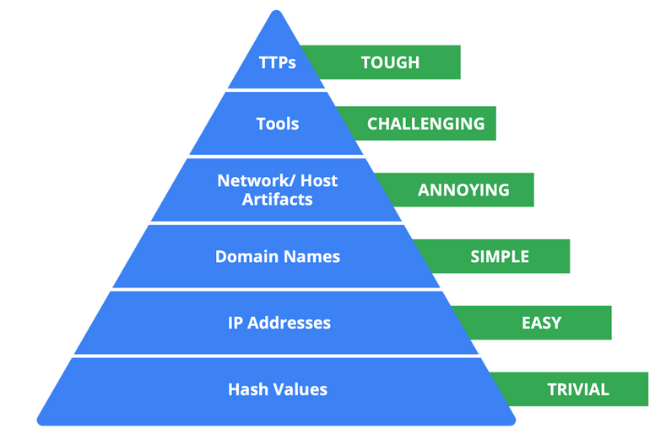

, with the goal of improving how indicators of compromise are used in incident detection.

The Pyramid of Pain captures the relationship between indicators of compromise and the level of difficulty that malicious actors experience when indicators of compromise are blocked by security teams. It lists the different types of indicators of compromise that security professionals use to identify malicious activity.

Each type of indicator of compromise is separated into levels of difficulty. These levels represent the “pain” levels that an attacker faces when security teams block the activity associated with the indicator of compromise. For example, blocking an IP address associated with a malicious actor is labeled as easy because malicious actors can easily use different IP addresses to work around this and continue with their malicious efforts. If security teams are able to block the IoCs located at the top of the pyramid, the more difficult it becomes for attackers to continue their attacks. Here’s a breakdown of the different types of indicators of compromise found in the Pyramid of Pain.

1. **Hash values**: Hashes that correspond to known malicious files. These are often used to provide unique references to specific samples of malware or to files involved in an intrusion.
2. **IP addresses**: An internet protocol address like 192.168.1.1
3. **Domain names**: A web address such as www.google.com
4. **Network artifacts**: Observable evidence created by malicious actors on a network. For example, information found in network protocols such as User-Agent strings.
5. **Host artifacts:** Observable evidence created by malicious actors on a host. A host is any device that’s connected on a network. For example, the name of a file created by malware.
6. **Tools**: Software that’s used by a malicious actor to achieve their goal. For example, attackers can use password cracking tools like John the Ripper to perform password attacks to gain access into an account.
7. **Tactics, techniques, and procedures (TTPs)**: This is the behavior of a malicious actor. Tactics refer to the high-level overview of the behavior. Techniques provide detailed descriptions of the behavior relating to the tactic. Procedures are highly detailed descriptions of the technique. TTPs are the hardest to detect.

## Key takeaways

Indicators of compromise and indicators of attack are valuable sources of information for security professionals when it comes to detecting incidents. The Pyramid of Pain is a concept that can be used to understand the different types of indicators of compromise and the value they have in detecting and stopping malicious activity.

# Best practices for effective documentation

**Documentation** is any form of recorded content that is used for a specific purpose, and it is essential in the field of security. Security teams use documentation to support investigations, complete tasks, and communicate findings. This reading explores the benefits of documentation and provides you with a list of common practices to help you create effective documentation in your security career.

## Documentation benefits

You’ve already learned about many types of security documentation, including playbooks, final reports, and more. As you’ve also learned, effective documentation has three benefits:

1. Transparency
2. Standardization
3. Clarity

### **Transparency**

In security, transparency is critical for demonstrating compliance with regulations and internal processes, meeting insurance requirements, and for legal proceedings. **Chain of custody** is the process of documenting evidence possession and control during an incident lifecycle. Chain of custody is an example of how documentation produces transparency and an audit trail.

### **Standardization**

Standardization through repeatable processes and procedures supports continuous improvement efforts, helps with knowledge transfer, and facilitates the onboarding of new team members. **Standards** are references that inform how to set policies.

You have learned how NIST provides various security frameworks that are used to improve security measures. Likewise, organizations set up their own standards to meet their business needs. An example of documentation that establishes standardization is an **incident response plan**, which is a document that outlines the procedures to take in each step of incident response. Incident response plans standardize an organization’s response process by outlining procedures in advance of an incident. By documenting an organization’s incident response plan, you create a standard that people follow, maintaining consistency with repeatable processes and procedures.

### **Clarity**

Ideally, all documentation provides clarity to its audience. Clear documentation helps people quickly access the information they need so they can take necessary action. Security analysts are required to document the reasoning behind any action they take so that it’s clear to their team why an alert was escalated or closed.

## Best practices

As a security professional, you’ll need to apply documentation best practices in your career. Here are some general guidelines to remember:

### **Know your audience**

Before you start creating documentation, consider your audience and their needs. For instance, an incident summary written for a security operations center (SOC) manager will be written differently than one that's drafted for a chief executive officer (CEO). The SOC manager can understand technical security language but a CEO might not. Tailor your document to meet your audience’s needs.

### **Be concise**

You might be tasked with creating long documentation, such as a report. But when documentation is too long, people can be discouraged from using it. To ensure that your documentation is useful, establish the purpose immediately. This helps people quickly identify the objective of the document. For example, executive summaries outline the major facts of an incident at the beginning of a final report. This summary should be brief so that it can be easily skimmed to identify the key findings.

### **Update regularly**

In security, new vulnerabilities are discovered and exploited constantly. Documentation must be regularly reviewed and updated to keep up with the evolving threat landscape. For example, after an incident has been resolved, a comprehensive review of the incident can identify gaps in processes and procedures that require changes and updates. By regularly updating documentation, security teams stay well informed and incident response plans stay updated.

## Key takeaways

Effective documentation produces benefits for everyone in an organization. Knowing how to create documentation is an essential skill to have as a security analyst. As you continue in your journey to become a security professional, be sure to consider these practices for creating effective documentation.

# The triage process

Previously, you learned that triaging is used to assess alerts and assign priority to incidents. In this reading, you'll explore the triage process and its benefits. As a security analyst, you'll be responsible for analyzing security alerts. Having the skills to effectively triage is important because it allows you to address and resolve security alerts efficiently.

## Triage process

Incidents can have the potential to cause significant damage to an organization. Security teams must respond quickly and efficiently to prevent or limit the impact of an incident before it becomes too late. **Triage** is the prioritizing of incidents according to their level of importance or urgency. The triage process helps security teams evaluate and prioritize security alerts and allocate resources effectively so that the most critical issues are addressed first.

The triage process consists of three steps:

1. Receive and assess
2. Assign priority
3. Collect and analyze

### **Receive and assess**

During this first step of the triage process, a security analyst receives an alert from an alerting system like an **intrusion detection system** (IDS). You might recall that an IDS is an application that monitors system activity and alerts on possible intrusions. The analyst then reviews the alert to verify its validity and ensure they have a complete understanding of the alert.

This involves gathering as much information as possible about the alert, including details about the activity that triggered the alert, the systems and assets involved, and more. Here are some questions to consider when verifying the validity of an alert:

* **Is the alert a false positive?** Security analysts must determine whether the alert is a genuine security concern or a **false positive**, or an alert that incorrectly detects the presence of a threat.
* **Was this alert triggered in the past?** If so, how was it resolved? The history of an alert can help determine whether the alert is a new or recurring issue.
* **Is the alert triggered by a known vulnerability?** If an alert is triggered by a known vulnerability, security analysts can leverage existing knowledge to determine an appropriate response and minimize the impact of the vulnerability.
* **What is the severity of the alert?** The severity of an alert can help determine the priority of the response so that critical issues are quickly escalated.

### **Assign priority**

Once the alert has been properly assessed and verified as a genuine security issue, it needs to be prioritized accordingly. Incidents differ in their impact, size, and scope, which affects the response efforts. To manage time and resources, security teams must prioritize how they respond to various incidents because not all incidents are equal. Here are some factors to consider when determining the priority of an incident:

* **Functional impact:** Security incidents that target information technology systems impact the service that these systems provide to its users. For example, a ransomware incident can severely impact the confidentiality, availability, and integrity of systems. Data can be encrypted or deleted, making it completely inaccessible to users. Consider how an incident impacts the existing business functionality of the affected system.
* **Information impact:** Incidents can affect the confidentiality, integrity, and availability of an organization’s data and information. In a data exfiltration attack, malicious actors can steal sensitive data. This data can belong to third party users or organizations. Consider the effects that information compromise can have beyond the organization.
* **Recoverability:** How an organization recovers from an incident depends on the size and scope of the incident and the amount of resources available. In some cases, recovery might not be possible, like when a malicious actor successfully steals proprietary data and shares it publicly. Spending time, effort, and resources on an incident with no recoverability can be wasteful. It’s important to consider whether recovery is possible and consider whether it’s worth the time and cost.

**Note**: Security alerts often come with an assigned priority or severity level that classifies the urgency of the alert based on a level of prioritization.

### **Collect and analyze**

The final step of the triage process involves the security analyst performing a comprehensive analysis of the incident. Analysis involves gathering evidence from different sources, conducting external research, and documenting the investigative process. The goal of this step is to gather enough information to make an informed decision to address it. Depending on the severity of the incident, escalation to a level two analyst or a manager might be required. Level two analysts and managers might have more knowledge on using advanced techniques to address the incident.

## Benefits of triage

By prioritizing incidents based on their potential impact, you can reduce the scope of impact to the organization by ensuring a timely response. Here are some benefits that triage has for security teams:

* **Resource management:** Triaging alerts allows security teams to focus their resources on threats that require urgent attention. This helps team members avoid dedicating time and resources to lower priority tasks and might also reduce response time.
* **Standardized approach:** Triage provides a standardized approach to incident handling. Process documentation, like playbooks, help to move alerts through an iterative process to ensure that alerts are properly assessed and validated. This ensures that only valid alerts are moved up to investigate.

## Key takeaways

Triage allows security teams to prioritize incidents according to their level of importance or urgency. The triage process is important in ensuring that an organization meets their incident response goals. As a security professional, you will likely utilize triage to effectively respond to and resolve security incidents.

# Business continuity considerations

Previously, you learned about how security teams develop incident response plans to help ensure that there is a prepared and consistent process to quickly respond to security incidents. In this reading, you'll explore the importance that business continuity planning has in recovering from incidents.

## Business continuity planning

Security teams must be prepared to minimize the impact that security incidents can have on their normal business operations. When an incident occurs, organizations might experience significant disruptions to the functionality of their systems and services. Prolonged disruption to systems and services can have serious effects, causing legal, financial, and reputational damages. Organizations can use business continuity planning so that they can remain operational during any major disruptions.

Similar to an incident response plan, a **business** **continuity plan (BCP)** is a document that outlines the procedures to sustain business operations during and after a significant disruption. A BCP helps organizations ensure that critical business functions can resume or can be quickly restored when an incident occurs.

Entry level security analysts aren't typically responsible for the development and testing of a BCP. However, it's important that you understand how BCPs provide organizations with a structured way to respond and recover from security incidents.

**Note**: Business continuity plans are not the same as disaster recovery plans. Disaster recovery plans are used to recover information systems in response to a major disaster. These disasters can range from hardware failure to the destruction of facilities from a natural disaster, like a flood.

### **Consider the impacts of ransomware to business continuity**

Impacts of a security incident such as ransomware can be devastating for business operations. Ransomware attacks targeting critical infrastructure such as healthcare can have the potential to cause significant disruption. Depending on the severity of a ransomware attack, the accessibility, availability, and delivery of essential healthcare services can be impacted. For example, ransomware can encrypt data, resulting in disabled access to medical records, which prevents healthcare providers from accessing patient records. At a larger scale, security incidents that target the assets, systems, and networks of critical infrastructure can also undermine national security, economic security, and the health and safety of the public. For this reason, BCPs help to minimize interruptions to operations so that essential services can be accessed.

### **Recovery strategies**

When an outage occurs due to a security incident, organizations must have some sort of a functional recovery plan set to resolve the issue and get systems fully operational. BCPs can include strategies for recovery that focus on returning to normal operations. Site resilience is one example of a recovery strategy.

### **Site resilience**

**Resilience** is the ability to prepare for, respond to, and recover from disruptions. Organizations can design their systems to be resilient so that they can continue delivering services despite facing disruptions. An example is site resilience, which is used to ensure the availability of networks, data centers, or other infrastructure when a disruption happens. There are three types of recovery sites used for site resilience:

* **Hot sites**: A fully operational facility that is a duplicate of an organization's primary environment. Hot sites can be activated immediately when an organization's primary site experiences failure or disruption.
* **Warm sites**:A facility that contains a fully updated and configured version of the hot site. Unlike hot sites, warm sites are not fully operational and available for immediate use but can quickly be made operational when a failure or disruption occurs.
* **Cold sites**:A backup facility equipped with some of the necessary infrastructure required to operate an organization's site. When a disruption or failure occurs, cold sites might not be ready for immediate use and might need additional work to be operational.

## Key takeaways

Security incidents have the potential to seriously disrupt business operations. Having the right plans in place is essential so that organizations can continue to function. Business continuity plans help organizations understand the impact that serious security incidents can have on their operations and work to mitigate these impacts so that regular operations can resume.

## Post-incident activity

The Post-incident activity phase of the NIST Incident Response Lifecycle is the process of reviewing an incident to identify areas for improvement during incident handling.

## Lessons learned

After an organization has successfully contained, eradicated, and recovered from an incident, the incident comes to a close. However, this doesn’t mean that the work of security professionals is complete. Incidents provide organizations and their security teams with an opportunity to learn from what happened and prioritize ways to improve the incident handling process.

This is typically done through a **lessons learned meeting**, also known as a post-mortem. A lessons learned meeting includes all involved parties after a major incident. Depending on the scope of an incident, multiple meetings can be scheduled to gather sufficient data. The purpose of this meeting is to evaluate the incident in its entirety, assess the response actions, and identify any areas of improvement. It provides an opportunity for an organization and its people to learn and improve, not to assign blame. This meeting should be scheduled no later than two weeks after an incident has been successfully remediated.

Not all incidents require their own lessons learned meeting; the size and severity of an incident will dictate whether the meeting is necessary. However, major incidents, such as ransomware attacks, should be reviewed in a dedicated lessons learned meeting. This meeting consists of all parties who participated in any aspect of the incident response process. Here are some examples of questions that are addressed in this meeting:

* What happened?
* What time did it happen?
* Who discovered it?
* How did it get contained?
* What were the actions taken for recovery?
* What could have been done differently?

Besides having the opportunity to learn from the incident, there are additional benefits to conducting a lessons learned meeting. For large organizations, lessons learned meetings offer a platform for team members across departments to share information and recommendations for future prevention.

**Pro tip**: Before a team hosts a lessons learned meeting, organizers should make sure all attendees come prepared. The meeting hosts typically develop and distribute a meeting agenda beforehand, which contains the topics of discussion and ensures that attendees are informed and prepared. Additionally, meeting roles should be assigned in advance, including a moderator to lead and facilitate discussion and a scribe to take meeting notes.

### **Recommendations**

Lessons learned meetings provide opportunities for growth and improvement. For example, security teams can identify errors in response actions, gaps in processes and procedures, or ineffective security controls. A lessons learned meeting should result in a list of prioritized actions or actionable recommendations meant to improve an organization’s incident handling processes and overall security posture. This ensures that organizations are implementing the lessons they’ve learned after an incident so that they are not vulnerable to experiencing the same incident in the future. Examples of changes that can be implemented include updating and improving playbook instructions or implementing new security tools and technologies.

## Final report

Throughout this course, you explored the importance that documentation has in recording details during the incident response lifecycle. At a minimum, incident response documentation should describe the incident by covering the 5 W's of incident investigation: who, what, where, why, and when. The details that are captured during incident response are important for developing additional documents during the end of the lifecycle.

One of the most essential forms of documentation that gets created during the end of an incident is the **final report**.The final report provides a comprehensive review of an incident. Final reports are not standardized, and their formats can vary across organizations. Additionally, multiple final reports can be created depending on the audience it’s written for. Here are some examples of common elements found in a final report:

* **Executive summary**: A high-level summary of the report including the key findings and essential facts related to the incident
* **Timeline**:  A detailed chronological timeline of the incident that includes timestamps dating the sequence of events that led to the incident
* **Investigation**: A compilation of the actions taken during the detection and analysis of the incident. For example, analysis of a network artifact such as a packet capture reveals information about what activities happen on a network.
* **Recommendations**: A list of suggested actions for future prevention

**Pro tip**: When writing the final report, consider the audience that you’re writing the report for. Oftentimes, business executives and other non-security professionals who don’t have the expertise to understand technical details will read post-incident final reports. Considering the audience when writing a final report will help you effectively communicate the most important details.

## Key takeaways

Post-incident actions represent the end of the incident response lifecycle. This phase provides the opportunity for security teams to meet, evaluate the response actions, make recommendations for improvement, and develop the final report.

# Glossary terms from module 3

## ****Terms and definitions from Course 6, Module 3****

**Analysis:** The investigation and validation of alerts

**Broken chain of custody:** Inconsistencies in the collection and logging of evidence in the chain of custody

**Business continuity plan (BCP):** A document that outlines the procedures to sustain business operations during and after a significant disruption

**Chain of custody:** The process of documenting evidence possession and control during an incident lifecycle

**Containment:** The act of limiting and preventing additional damage caused by an incident

**Crowdsourcing:** The practice of gathering information using public input and collaboration

**Detection:** The prompt discovery of security events

**Documentation**: Any form of recorded content that is used for a specific purpose

**Eradication:** The complete removal of the incident elements from all affected systems

**Final report:** Documentation that provides a comprehensive review of an incident

**Honeypot:** A system or resource created as a decoy vulnerable to attacks with the purpose of attracting potential intruders

**Incident response plan:** A document that outlines the procedures to take in each step of incident response

**Indicators of attack (IoA):** The series of observed events that indicate a real-time incident

**Indicators of compromise (IoC):** Observable evidence that suggests signs of a potential security incident

**Intrusion detection system (IDS):** An application that monitors system activity and alerts on possible intrusions

**Lessons learned meeting:** A meeting that includes all involved parties after a major incident

**Open-source intelligence (OSINT):** The collection and analysis of information from publicly available sources to generate usable intelligence

**Playbook:** A manual that provides details about any operational action

**Post-incident activity:** The process of reviewing an incident to identify areas for improvement during incident handling

**Recovery:** The process of returning affected systems back to normal operations

**Resilience**: The ability to prepare for, respond to, and recover from disruptions

**Standards:** References that inform how to set policies

**Threat hunting:** The proactive search for threats on a network

**Threat intelligence:** Evidence-based threat information that provides context about existing or emerging threats

**Triage**: The prioritizing of incidents according to their level of importance or urgency

**VirusTotal:** A service that allows anyone to analyze suspicious files, domains, URLs, and IP addresses for malicious content

# Best practices for log collection and management

In this reading, you’ll examine some best practices related to log management, storage, and protection. Understanding the best practices related to log collection and management will help improve log searches and better support your efforts in identifying and resolving security incidents.

## Logs

Data sources such as devices generate data in the form of events. A **log** is a record of events that occur within an organization's systems. Logs contain log entries and each entry details information corresponding to a single event that happened on a device or system. Originally, logs served the sole purpose of troubleshooting common technology issues. For example, error logs provide information about why an unexpected error occurred and help to identify the root cause of the error so that it can be fixed. Today, virtually all computing devices produce some form of logs that provide valuable insights beyond troubleshooting.

Security teams access logs from logging receivers like SIEM tools which consolidate logs to provide a central repository for log data. Security professionals use logs to perform **log** **analysis**, which is the process of examining logs to identify events of interest. Logs help uncover the details surrounding the 5 W's of incident investigation: who triggered the incident, what happened, when the incident took place, where the incident took place, and why the incident occurred.

### **Types of logs**

Depending on the data source, different log types can be produced. Here’s a list of some common log types that organizations should record:

* **Network**: Network logs are generated by network devices like firewalls, routers, or switches.
* **System**: System logs are generated by operating systems like Chrome OS™, Windows, Linux, or macOS®.
* **Application**: Application logs are generated by software applications and contain information relating to the events occurring within the application such as a smartphone app.
* **Security**: Security logs are generated by various devices or systems such as antivirus software and intrusion detection systems. Security logs contain security-related information such as file deletion.
* **Authentication**: Authentication logs are generated whenever authentication occurs such as a successful login attempt into a computer.

### **Log details**

Generally, logs contain a date, time, location, action, and author of the action. Here is an example of an authentication log:

Login Event [05:45:15] User1 Authenticated successfully

Logs contain information and can be adjusted to contain even more information. Verboselogging records additional, detailed information beyond the default log recording. Here is an example of the same log above but logged as verbose.

Login Event [2022/11/16 05:45:15.892673] auth_performer.cc:470 User1 Authenticated successfully from device1 (192.168.1.2)

## Log management

Because all devices produce logs, it can quickly become overwhelming for organizations to keep track of all the logs that are generated. To get the most value from your logs, you need to choose exactly what to log, how to access it easily, and keep it secure using log management. **Log management** is the process of collecting, storing, analyzing, and disposing of log data.

### **What to log**

The most important aspect of log management is choosing what to log. Organizations are different, and their logging requirements can differ too. It's important to consider which log sources are most likely to contain the most useful information depending on your event of interest. This might be configuring log sources to reduce the amount of data they record, such as excluding excessive verbosity. Some information, including but not limited to phone numbers, email addresses, and names, form personally identifiable information (PII), which requires special handling and in some jurisdictions might not be possible to be logged.

### **The issue with overlogging**

From a security perspective, it can be tempting to log everything. This is the most common mistake organizations make. Just because it can be logged, doesn't mean it needs to be logged. Storing excessive amounts of logs can have many disadvantages with some SIEM tools. For example, overlogging can increase storage and maintenance costs. Additionally, overlogging can increase the load on systems, which can cause performance issues and affect usability, making it difficult to search for and identify important events.

### **Log retention**

Organizations might operate in industries with regulatory requirements. For example, some regulations require organizations to retain logs for set periods of time and organizations can implement log retention practices in their log management policy.

Organizations that operate in the following industries might need to modify their log management policy to meet regulatory requirements:

* Public sector industries, like the Federal Information Security Modernization Act (FISMA)
* Healthcare industries, like the Health Insurance Portability and Accountability Act of 1996 (HIPAA)
* Financial services industries, such as the Payment Card Industry Data Security Standard (PCI DSS), the Gramm-Leach-Bliley Act (GLBA), and the Sarbanes-Oxley Act of 2002 (SOX)

### **Log protection**

Along with management and retention, the protection of logs is vital in maintaining log integrity. It’s not unusual for malicious actors to modify logs in attempts to mislead security teams and to even hide their activity.

Storing logs in a centralized log server is a way to maintain log integrity. When logs are generated, they get sent to a dedicated server instead of getting stored on a local machine. This makes it more difficult for attackers to access logs because there is a barrier between the attacker and the log location.

## Key takeaways

It's important to understand how to properly collect, store, and protect logs because they are integral to incident investigations. Having a detailed plan for log management helps improve the usefulness of logs and resource efficiency.

# Overview of log file formats

You’ve learned about how logs record events that happen on a network, or system. In security, logs provide key details about activities that occurred across an organization, like who signed into an application at a specific point in time. As a security analyst, you’ll use **log analysis**, which is the process of examining logs to identify events of interest. It’s important to know how to read and interpret different log formats so that you can uncover the key details surrounding an event and identify unusual or malicious activity. In this reading, you’ll review the following log formats:

* JSON
* Syslog
* XML
* CSV
* CEF

## JavaScript Object Notation (JSON)

JavaScript Object Notation (JSON) is a file format that is used to store and transmit data. JSON is known for being lightweight and easy to read and write. It is used for transmitting data in web technologies and is also commonly used in cloud environments. JSON syntax is derived from JavaScript syntax. If you are familiar with JavaScript, you might recognize that JSON contains components from JavaScript including:

* Key-value pairs
* Commas
* Double quotes
* Curly brackets
* Square brackets

### **Key-value pairs**

A **key-value** **pair** is a set of data that represents two linked items: a key and its corresponding value. A key-value pair consists of a key followed by a colon, and then followed by a value. An example of a key-value pair is  "Alert": "Malware".

**Note**: For readability, it is recommended that key-value pairs contain a space before or after the colon that separates the key and value.

### **Commas**

Commas are used to separate data. For example: "Alert": "Malware", "Alert code": 1090, "severity": 10.

### **Double quotes**

Double quotes are used to enclose text data, which is also known as a string, for example:  "Alert": "Malware". Data that contains numbers is notenclosed in quotes, like this: "Alert code": 1090.

### **Curly brackets**

Curly brackets enclose an **object**, which is a data type that stores data in a comma-separated list of key-value pairs. Objects are often used to describe multiple properties for a given key. JSON log entries start and end with a curly bracket. In this example, User is the object that contains multiple properties:

"User": {  "id": "1234",  "name": "user", "role": "engineer" }

### **Square brackets**

Square brackets are used to enclose an **array**, which is a data type that stores data in a comma-separated ordered list. Arrays are useful when you want to store data as an ordered collection, for example: ["Administrators", "Users", "Engineering"].

## Syslog

Syslog is a standard for logging and transmitting data. It can be used to refer to any of its three different capabilities:

1. **Protocol**: The syslog protocol is used to transport logs to a centralized log server for log management. It uses port 514 for plaintext logs and port 6514 for encrypted logs.
2. **Service**: The syslog service acts as a log forwarding service that consolidates logs from multiple sources into a single location. The service works by receiving and then forwarding any syslog log entries to a remote server.
3. **Log format**: The syslog log format is one of the most commonly used log formats that you will be focusing on. It is the native logging format used in  Unix® systems. It consists of three components: a header, structured-data, and a message.

## Syslog log example

Here is an example of a syslog entry that contains all three components: a header, followed by structured-data, and a message:

<236>1 2022-03-21T01:11:11.003Z virtual.machine.com evntslog - ID01 [user@32473 iut="1" eventSource="Application" eventID="9999"] This is a log entry!

### **Header**

The header contains details like the timestamp; the hostname, which is the name of the machine that sends the log; the application name; and the message ID.

* **Timestamp**: The timestamp in this example is 2022-03-21T01:11:11.003Z, where 2022-03-21 is the date in YYYY-MM-DD format. T is used to separate the date and the time. 01:11:11.003 is the 24-hour format of the time and includes the number of milliseconds 003. Z indicates the timezone, which is Coordinated Universal Time (UTC).
* **Hostname**: virtual.machine.com
* **Application**: evntslog
* **Message** **ID**: ID01

### **Structured-data**

The structured-data portion of the log entry contains additional logging information. This information is enclosed in square brackets and structured in key-value pairs. Here, there are three keys with corresponding values: [user@32473 iut="1" eventSource="Application" eventID="9999"].

### **Message**

The message contains a detailed log message about the event. Here, the message is This is a log entry!.

### **Priority (PRI)**

The priority (PRI) field indicates the urgency of the logged event and is contained with angle brackets. In this example, the priority value is <236> . Generally, the lower the priority level, the more urgent the event is.

**Note**: Syslog headers can be combined with JSON, and XML formats. Custom log formats also exist.

## XML (eXtensible Markup Language)

XML (eXtensible Markup Language) is a language and a format used for storing and transmitting data. XML is a native file format used in Windows systems. XML syntax uses the following:

* Tags
* Elements
* Attributes

### **Tags**

XML uses tags to store and identify data. Tags are pairs that must contain a start tag and an end tag. The start tag encloses data with angle brackets, for example <tag>,  whereas the end of a tag encloses data with angle brackets and a forward slash like this: </tag>.

### **Elements**

XML elements include both the data contained inside of a tag and the tags itself. All XML entries must contain at least one root element. Root elements contain other elements that sit underneath them, known as child elements.

Here is an example:

<Event> <EventID>4688</EventID> <Version>5</Version> </Event>

In this example, <Event> is the root element and contains two child elements <EventID> and <Version>. There is data contained in each respective child element.

### **Attributes**

XML elements can also contain attributes. Attributes are used to provide additional information about elements. Attributes are included as the second part of the tag itself and must always be quoted using either single or double quotes.

For example:

<EventData> <Data Name='SubjectUserSid'>S-2-3-11-160321</Data> <Data Name='SubjectUserName'>JSMITH</Data> <Data Name='SubjectDomainName'>ADCOMP</Data> <Data Name='SubjectLogonId'>0x1cf1c12</Data> <Data Name='NewProcessId'>0x1404</Data> </EventData>

In the first line for this example, the tag is <Data> and it uses the attribute  Name='SubjectUserSid' to describe the data enclosed in the tag S-2-3-11-160321.

## CSV (Comma Separated Value)

CSV (Comma Separated Value) uses commas to separate data values. In CSV logs, the position of the data corresponds to its field name, but the field names themselves might not be included in the log. It’s critical to understand what fields the source device (like an IPS, firewall, scanner, etc.) is including in the log.

Here is an example:

2009-11-24T21:27:09.534255,ALERT,192.168.2.7, 1041,x.x.250.50,80,TCP,ALLOWED,1:2001999:9,"ET MALWARE BTGrab.com Spyware Downloading Ads",1

## CEF (Common Event Format)

**Common Event Format (CEF)** is a log format that uses key-value pairs to structure data and identify fields and their corresponding values. The CEF syntax is defined as containing the following fields:

CEF:Version|Device Vendor|Device Product|Device Version|Signature ID|Name|Severity|Extension

Fields are all separated with a pipe character |. However, anything in the Extension part of the CEF log entry must be written in a key-value format. Syslog is a common method used to transport logs like CEF. When Syslog is used a timestamp and hostname will be prepended to the CEF message. Here is an example of a CEF log entry that details malicious activity relating to a worm infection:

Sep 29 08:26:10 host CEF:1|Security|threatmanager|1.0|100|worm successfully stopped|10|src=10.0.0.2 dst=2.1.2.2 spt=1232

Here is a breakdown of the fields:

* **Syslog Timestamp**: Sep 29 08:26:10
* **Syslog Hostname**: host
* **Version**:CEF:1
* **Device Vendor**: Security
* **Device Product**: threatmanager
* **Device Version**:1.0
* **Signature ID**:100
* **Name**:worm successfully stopped
* **Severity**:10
* **Extension**: This field contains data written as key-value pairs. There are two IP addresses, src=10.0.0.2 and dst=2.1.2.2, and a source port number spt=1232. Extensions are not required and are optional to add.

This log entry contains details about a Security application called threatmanager that successfully stopped a worm from spreading from the internal network at 10.0.0.2 to the external network 2.1.2.2 through the port 1232. A high severity level of 10 is reported.

**Note**: Extensions and syslog prefix are optional to add to a CEF log.

## Key takeaways

There is no standard format used in logging, and many different log formats exist. As a security analyst, you will analyze logs that originate from different sources. Knowing how to interpret different log formats will help you determine key information that you can use to support your investigations.

# Detection tools and techniques

In this reading, you’ll examine the different types of intrusion detection system (IDS) technologies and the alerts they produce. You’ll also explore the two common detection techniques used by detection systems. Understanding the capabilities and limitations of IDS technologies and their detection techniques will help you interpret security information to identify, analyze, and respond to security events.

As you’ve learned, an **intrusion detection system (IDS)** is an application that monitors system activity and alerts on possible intrusions. IDS technologies help organizations monitor the activity that happens on their systems and networks to identify indications of malicious activity.  Depending on the location you choose to set up an IDS, it can be either host-based or network-based.

## Host-based intrusion detection system

A **host-based intrusion detection system (HIDS)** is an application that monitors the activity of the host on which it's installed. A HIDS is installed as an agent on a host. A host is also known as an **endpoint**,which is any device connected to a network like a computer or a server.

Typically, HIDS agents are installed on all endpoints and used to monitor and detect security threats. A HIDS monitors internal activity happening on the host to identify any unauthorized or abnormal behavior. If anything unusual is detected, such as the installation of an unauthorized application, the HIDS logs it and sends out an alert.

In addition to monitoring inbound and outbound traffic flows, HIDS can have additional capabilities, such as monitoring file systems, system resource usage, user activity, and more.

This diagram shows a HIDS tool installed on a computer. The dotted circle around the host indicates that it is only monitoring the local activity on the single computer on which it’s installed.

## Network-based intrusion detection system

A **network-based intrusion detection system** **(NIDS)** is an application that collects and monitors network traffic and network data. NIDS software is installed on devices located at specific parts of the network that you want to monitor. The NIDS application inspects network traffic from different devices on the network. If any malicious network traffic is detected, the NIDS logs it and generates an alert.

This diagram shows a NIDS that is installed on a network. The highlighted circle around the server and computers indicates that the NIDS is installed on the server and is monitoring the activity of the computers.

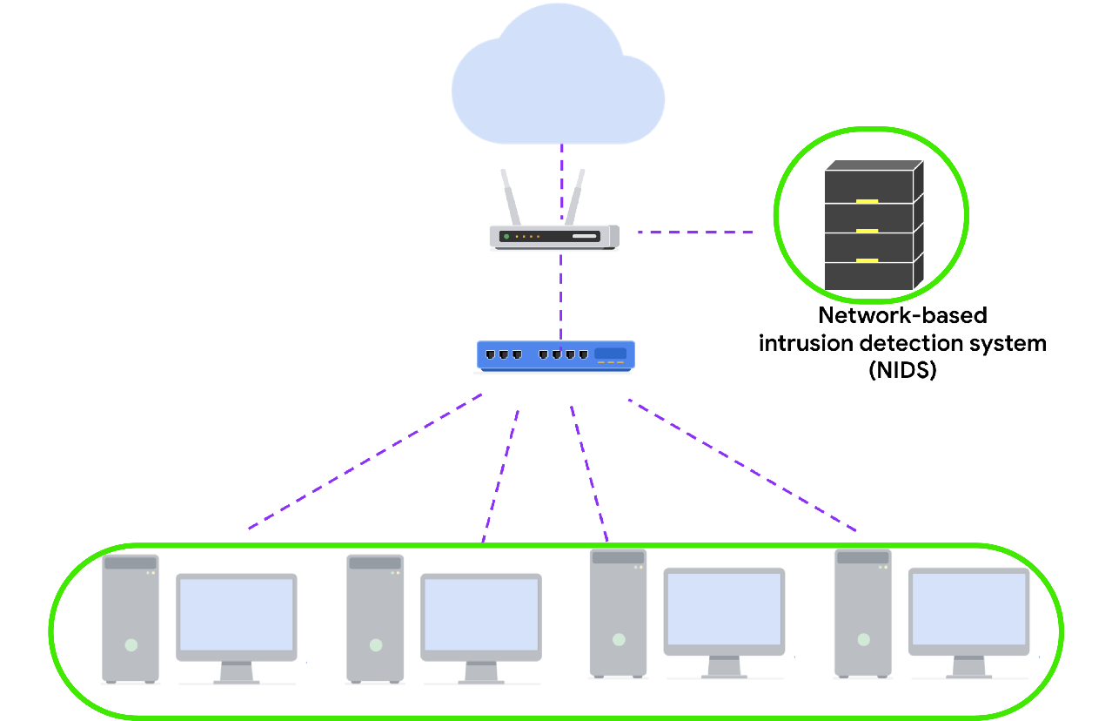

Using a combination of HIDS and NIDS to monitor an environment can provide a multi-layered approach to intrusion detection and response. HIDS and NIDS tools provide a different perspective on the activity occurring on a network and the individual hosts that are connected to it. This helps provide a comprehensive view of the activity happening in an environment.

## Detection techniques

Detection systems can use different techniques to detect threats and attacks. The two types of detection techniques that are commonly used by IDS technologies are signature-based analysis and anomaly-based analysis.

## Signature-based analysis

**Signature analysis**, or signature-based analysis, is a detection method that is used to find events of interest. A **signature** is a pattern that is associated with malicious activity. Signatures can contain specific patterns like a sequence of binary numbers, bytes, or even specific data like an IP address.

Previously, you explored the Pyramid of Pain, which is a concept that prioritizes the different types of **indicators of compromise** (IoCs) associated with an attack or threat, such as IP addresses, tools, tactics, techniques, and more. IoCs and other indicators of attack can be useful for creating targeted signatures to detect and block attacks.

Different types of signatures can be used depending on which type of threat or attack you want to detect. For example, an anti-malware signature contains patterns associated with malware. This can include malicious scripts that are used by the malware. IDS tools will monitor an environment for events that match the patterns defined in this malware signature. If an event matches the signature, the event gets logged and an alert is generated.

### **Advantages**

* **Low rate of false positives:** Signature-based analysis is very efficient at detecting known threats because it is simply comparing activity to signatures. This leads to fewer false positives. Remember that a **false positive** is an alert that incorrectly detects the presence of a threat.

### **Disadvantages**

* **Signatures can be evaded:** Signatures are unique, and attackers can modify their attack behaviors to bypass the signatures. For example, attackers can make slight modifications to malware code to alter its signature and avoid detection.
* **Signatures require updates:** Signature-based analysis relies on a database of signatures to detect threats. Each time a new exploit or attack is discovered, new signatures must be created and added to the signature database.
* **Inability to detect unknown threats:** Signature-based analysis relies on detecting known threats through signatures. Unknown threats can't be detected, such as new malware families or **zero-day** attacks, which are exploits that were previously unknown.

## Anomaly-based analysis

**Anomaly-based analysis** is a detection method that identifies abnormal behavior. There are two phases to anomaly-based analysis: a training phase and a detection phase. In the training phase, a baseline of normal or expected behavior must be established. Baselines are developed by collecting data that corresponds to normal system behavior. In the detection phase, the current system activity is compared against this baseline. Activity that happens outside of the baseline gets logged, and an alert is generated.

### **Advantages**

* **Ability to detect new and evolving threats:** Unlike signature-based analysis, which uses known patterns to detect threats, anomaly-based analysis can detect unknown threats.

### **Disadvantages**

* **High rate of false positives:** Any behavior that deviates from the baseline can be flagged as abnormal, including non-malicious behaviors. This leads to a high rate of false positives.
* **Pre-existing compromise:** The existence of an attacker during the training phase will include malicious behavior in the baseline. This can lead to missing a pre-existing attacker.

## Key takeaways

IDS technologies are an essential security tool that you will encounter in your security journey. To recap, a NIDS monitors an entire network, whereas a HIDS monitors individual endpoints. IDS technologies generate different types of alerts. Lastly, IDS technologies use different detection techniques like signature-based or anomaly-based analysis to identify malicious activity.

# Overview of Suricata

So far, you've learned about detection signatures and you were introduced to Suricata, an intrusion detection system (IDS).

In this reading, you’ll explore more about Suricata. You'll also learn about the value of writing customized signatures and configuration. This is an important skill to build in your cybersecurity career because you might be tasked with deploying and maintaining IDS tools.

## Introduction to Suricata

[**Suricata**](https://suricata.io/)

is an open-source intrusion detection system, intrusion prevention system, and network analysis tool.

### **Suricata features**

There are three main ways Suricata can be used:

* **Intrusion detection system** (**IDS**): As a network-based IDS, Suricata can monitor network traffic and alert on suspicious activities and intrusions. Suricata can also be set up as a host-based IDS to monitor the system and network activities of a single host like a computer.
* **Intrusion prevention system** (**IPS**): Suricata can also function as an intrusion prevention system (IPS) to detect and block malicious activity and traffic. Running Suricata in IPS mode requires additional configuration such as enabling IPS mode.
* **Network security monitoring** (**NSM**):In this mode, Suricata helps keep networks safe by producing and saving relevant network logs. Suricata can analyze live network traffic, existing packet capture files, and create and save full or conditional packet captures. This can be useful for forensics, incident response, and for testing signatures. For example, you can trigger an alert and capture the live network traffic to generate traffic logs, which you can then analyze to refine detection signatures.

## Rules

Rules or signatures are used to identify specific patterns, behavior, and conditions of network traffic that might indicate malicious activity. The terms rule and signature are often used interchangeably in Suricata. Security analysts use **signatures**, or patterns associated with malicious activity, to detect and alert on specific malicious activity. Rules can also be used to provide additional context and visibility into systems and networks, helping to identify potential security threats or vulnerabilities.

Suricata uses **signatures analysis**,which is a detection method used to find events of interest. Signatures consist of three components:

* **Action**: The first component of a signature. It describes the action to take if network or system activity matches the signature. Examples include: alert, pass, drop, or reject.
* **Header**: The header includes network traffic information like source and destination IP addresses, source and destination ports, protocol, and traffic direction.
* **Rule options:** The rule options provide you with different options to customize signatures.

Here's an example of a Suricata signature:

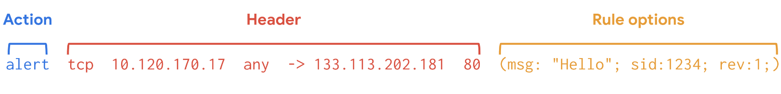

Rule options have a specific ordering and changing their order would change the meaning of the rule.

**Note**: The terms rule and signature are synonymous.

**Note:** Rule order refers to the order in which rules are evaluated by Suricata. Rules are processed in the order in which they are defined in the configuration file. However, Suricata processes rules in a different default order: pass, drop, reject, and alert. Rule order affects the final verdict of a packet especially when conflicting actions such as a drop rule and an alert rule both match on the same packet.

### **Custom rules**

Although Suricata comes with pre-written rules, it is highly recommended that you modify or customize the existing rules to meet your specific security requirements.

There is no one-size-fits-all approach to creating and modifying rules. This is because each organization's IT infrastructure differs. Security teams must extensively test and modify detection signatures according to their needs.

Creating custom rules helps to tailor detection and monitoring. Custom rules help to minimize the amount of false positive alerts that security teams receive. It's important to develop the ability to write effective and customized signatures so that you can fully leverage the power of detection technologies.

## Configuration file

Before detection tools are deployed and can begin monitoring systems and networks, you must properly configure their settings so that they know what to do. A **configuration file** is a file used to configure the settings of an application. Configuration files let you customize exactly how you want your IDS to interact with the rest of your environment.

Suricata's configuration file is suricata.yaml, which uses the YAML file format for syntax and structure.

## Log files

There are two log files that Suricata generates when alerts are triggered:

* **eve.json**: The eve.json file is the standard Suricata log file. This file contains detailed information and metadata about the events and alerts generated by Suricata stored in JSON format. For example, events in this file contain a unique identifier called flow_id  which is used to correlate related logs or alerts to a single network flow, making it easier to analyze network traffic. The eve.json file is used for more detailed analysis and is considered to be a better file format for log parsing and SIEM log ingestion.
* **fast.log**: The fast.log file is used to record minimal alert information including basic IP address and port details about the network traffic. The fast.log file is used for basic logging and alerting and is considered a legacy file format and is not suitable for incident response or threat hunting tasks.

The main difference between the eve.json file and the fast.log file is the level of detail that is recorded in each. The fast.log file records basic information, whereas the eve.json file contains additional verbose information.

## Key takeaways

In this reading, you explored some of Suricata's features, rules syntax, and the importance of configuration. Understanding how to configure detection technologies and write effective rules will provide you with clear insight into the activity happening in an environment so that you can improve detection capability and network visibility. Go ahead and start practicing using Suricata in the upcoming activity!

# Glossary terms from module 4

## ****Terms and definitions from Course 6, Module 4****

**Anomaly-based analysis:** A detection method that identifies abnormal behavior

**Array:** A data type that stores data in a comma-separated ordered list

**Common Event Format (CEF):** A log format that uses key-value pairs to structure data and identify fields and their corresponding values

**Configuration file:** A file used to configure the settings of an application

**Endpoint:** Any device connected on a network

**Endpoint detection and response (EDR):** An application that monitors an endpoint for malicious activity

**False positive:** An alert that incorrectly detects the presence of a threat

**Host-based intrusion detection system (HIDS):** An application that monitors the activity of the host on which it’s installed

**Intrusion detection systems (IDS)**: An application that monitors system activity and alerts on possible intrusions

**Key-value pair:** A set of data that represents two linked items: a key, and its corresponding value

**Log:** A record of events that occur within an organization’s systems

**Log analysis:** The process of examining logs to identify events of interest

**Log management:** The process of collecting, storing, analyzing, and disposing of log data

**Logging:** The recording of events occurring on computer systems and networks

**Network-based intrusion detection system (NIDS):** An application that collects and monitors network traffic and network data

**Object:** A data type that stores data in a comma-separated list of key-value pairs

**Search Processing Language (SPL)**: Splunk’s query language

**Security information and event management (SIEM)**: An application that collects and analyzes log data to monitor critical activities in an organization

**Signature:** A pattern that is associated with malicious activity

**Signature analysis:** A detection method used to find events interest

**Suricata**: An open-source intrusion detection system, intrusion prevention system, and network analysis tool

**Telemetry:** The collection and transmission of data for analysis

**Wildcard**: A special character that can be substituted with any other character

**YARA-L:** A computer language used to create rules for searching through ingested log data

**Zero-day:** An exploit that was previously unknown

# Disaster recovery and business continuity

The role of a security professional is to ensure a company’s data and assets are protected from threats, risks, and vulnerabilities. However, sometimes things don’t go as planned. There are times when security incidents happen. You’ve already learned that security breaches can lead to financial consequences and the loss of credibility with customers or other businesses in the industry.

This reading will discuss the need to create business continuity and disaster recovery plans to minimize the impact of a security incident on an organization’s business operations. Analysts need to consider the sequence of steps to be taken by the security team before business continuity and disaster recovery plans are implemented.

## Identify and protect

Creating business continuity and disaster recovery plans are the final steps of a four-part process that most security teams go through to help ensure the security of an organization.

First, the security team identifies the assets that must be protected in the organization. Next, they determine what potential threats could negatively impact those assets. After the threats have been determined, the security team implements tools and processes to detect potential threats to assets. Lastly, the IT or appropriate business function creates the business continuity and disaster recovery plans. These plans are created in conjunction with one another. The plans help to minimize the impact of a security incident involving one of the organization’s assets.

## Business continuity plan

The impact of successful security attacks on an organization can be significant. Loss of profits and customers are two possible outcomes that organizations never want to happen. A **business continuity plan** is a document that outlines the procedures to sustain business operations during and after a significant disruption. It is created alongside a disaster recovery plan to minimize the damage of a successful security attack. Here are four essential steps for business continuity plans:

* **Conduct a business impact analysis.** The business impact analysis step focuses on the possible effects a disruption of business functions can have on an organization.
* **Identify, document, and implement steps to recover critical business functions and processes.** This step helps the business continuity team create actionable steps toward responding to a security event.
* **Organize a business continuity team.** This step brings various members of the organization together to help execute the business continuity plan, if it is needed. The members of this team are typically from the cybersecurity,  IT, HR, communications, and operations departments.
* **Conduct training for the business continuity team**. The team considers different risk scenarios and prepares for security threats during these training exercises.

## Disaster recovery plan

A **disaster recovery plan** allows an organization’s security team to outline the steps needed to minimize the impact of a security incident, such as a successful ransomware attack that has stopped the manufacturing team from retrieving certain data. It also helps the security team resolve the security threat. A disaster recovery plan is typically created alongside a business continuity plan. Steps to create a disaster recovery plan should include:

* Implementing recovery strategies to restore software
* Implementing recovery strategies to restore hardware functionality
* Identifying applications and data that might be impacted after a security incident has taken place

## Key takeaways

Disaster recovery and business continuity plans are important for an organization’s security posture. It’s essential that the security team has plans in place to keep the organization’s business operations moving forward in case a security incident does occur.

# Recognize roles and responsibilities during escalation

You previously learned about various incident classification types and how those incidents can impact an organization.

This reading will discuss the roles of the various team members who are a part of the incident escalation process. Keep in mind that not all organizations are alike, and some roles and responsibilities may be identified using different terminology and definitions.

## Data owners

A data owner is the person that decides who can access, edit, use, or destroy their information. Data owners have administrative control over specific information hardware or software and are accountable for the classification, protection, access, and use of company data. For example, consider a situation where an employee gains unauthorized access to software they do not need to use for work. This kind of security event would be escalated to the data owner of that software.

## Data controllers

Data controllers determine the procedure and purpose for processing data. This role largely focuses on collecting the personal information of customers. The data controller determines how that data is used. The data controller also ensures that data is used, stored, and processed in accordance with relevant security and privacy regulations. If sensitive customer information was at risk, that event would be escalated to data controllers.

## Data processors

Data processors report directly to the data controller and are responsible for processing the data on behalf of the data controller. The data processor is typically a vendor and is often tasked with installing security measures to help protect the data. Data processing issues are typically escalated to the individual who oversees the third-party organization responsible for data processing.

## Data custodians

Data custodians assign and remove access to software or hardware. Custodians are responsible for implementing security controls for the data they are responsible for, granting and revoking access to that data, creating policies regarding how that data is stored and transmitted, advising on potential threats to that data, and monitoring the data. Data custodians are notified when data security controls need to be strengthened or have been compromised.

## Data protection officers (DPOs)

Data protection officers are responsible for monitoring the internal compliance of an organization’s data protection procedures. These individuals advise the security team on the obligations required by the organization's data protection standards and procedures. They also conduct assessments to determine whether or not the security measures in place are properly protecting the data as necessary. DPOs are notified when set standards or protocols have been violated.

## Key takeaways

Incident escalation requires various members of a security team to act as one. Entry-level analysts should be familiar with the roles and responsibilities of different team members on the security team. As an entry-level analyst, you will typically escalate incidents to your direct supervisor. However, it’s still important to have an understanding of the different team members as you move forward in your security career because it will help you recognize which incidents should be reported to whom.

# Escalation timing

You previously learned about the potential impact even the smallest incident can have on an organization if the incident is not escalated properly. You also discovered just how important your role as an entry-level analyst will be to the effectiveness of an organization’s escalation process.

This reading will go into more detail about the role you’ll play in protecting an organization’s data and assets when it comes to escalating incidents.

## Your decisions matter

Security is a fast-paced environment with bad actors constantly trying to compromise an organization’s systems and data. This means security analysts must be prepared to make daily decisions to help keep a company’s data and systems safe. Entry-level security analysts help the security team escalate potential security incidents to the right team members. A big part of your role as a security analyst will be making decisions about which security events to escalate before they become major security incidents.

## Trust your instincts and ask questions

Confidence is an important attribute for a security analyst to have, especially when it comes to the escalation process. The security team will depend on you to be confident in your decision-making. You should be intentional about learning the organization’s escalation policy. This will help you gain confidence in making the right decisions when it comes to escalating security events. But remember to ask questions when necessary. It shows that you’re committed to constantly learning the right way to do your job.

## All security events are not equal

An important part of escalation is recognizing which assets and data are the most important for your organization. You can determine this information by reading through your onboarding materials, asking your supervisor directly about which assets and data are most important, and reviewing your company’s security policies. When you have that type of understanding, it allows you to recognize when one incident should be given a higher priority over others. You previously learned about the following incident classification types:

* **Malware infections:** Occur when malicious software designed to disrupt a system infiltrates an organization’s computers or network
* **Unauthorized access:** Occurs when an individual gains digital or physical access to a system, data,  or application without permission
* **Improper usage:** Occurs when an employee of an organization violates the organization’s acceptable use policies

Identifying a specific incident type allows you to properly prioritize and quickly escalate those incidents. Remember, an incident which directly impacts assets that are essential to business operations should always take priority over incidents that do not directly impact business operations. For example, an incident where unauthorized access has been gained to a manufacturing application should take priority over an incident where malware has infected a legacy system that does not impact business operations. As you gain experience in the cybersecurity field, you will learn how to quickly assess the priority levels of incident types.

## Quick escalation tips

A big part of your role in cybersecurity will be determining when to escalate a security event. Here are a few tips to help with this:

* Familiarize yourself with the escalation policy of the organization you work for.
* Follow the policy at all times.
* Ask questions.

## Key takeaways

Incident escalation will be an important part of your role within a security team. Entry-level analysts are expected to identify and escalate incidents related to their daily work. Reading and understanding your organization’s escalation policy will be helpful in this responsibility. The escalation policy will describe how and to whom you should escalate incidents. When in doubt, never be afraid to ask a supervisor about the escalation process. This will help you stay knowledgeable about your job and make informed decisions.

# Glossary terms from module 2

## Terms and definitions from Course 8, Module 2

**Data controller:** A person that determines the procedure and purpose for processing data

**Data processor:** A person that is responsible for processing data on behalf of the data controller

**Data protection officer (DPO):** An individual that is responsible for monitoring the compliance of an organization's data protection procedures

**Escalation policy:** A set of actions that outlines who should be notified when an incident alert occurs and how that incident should be handled

**Improper usage:** An incident type that occurs when an employee of an organization violates the organization’s acceptable use policies

**Incident escalation**: The process of identifying a potential security incident, triaging it, and handing it off to a more experienced team member

**Malware infection**: An incident type that occurs when malicious software designed to disrupt a system infiltrates an organization’s computers or network

**Unauthorized access:** An incident type that occurs when an individual gains digital or physical access to a system or an application without permission

# Communicate effectively with stakeholders

You previously learned about security stakeholders and their significance in an organization. In this reading, you’ll learn the importance of clearly communicating to stakeholders to ensure they have a thorough understanding of the information you’re sharing and why it’s meaningful to the organization.

## Get to the point

Security stakeholders have roles and responsibilities that are time sensitive and impact the business. It’s important that any communications they receive, and the actions they need to take, are clear. To get to the point in your communications, ask yourself:

* What do I want this person to know?
* Why is it important for them to know it?
* When do they need to take action?
* How do I explain the situation in a nontechnical manner?

## Follow the protocols

When you first join a security team, you’ll want to learn about the different protocols and procedures in place for communicating with stakeholders and other members of the organization. It’s important to make sure you know what applications and forms of communications are acceptable before you begin communicating with stakeholders, such as in-person meetings, video-conferencing, emails, or company chat applications.

## Communicate with impact

You previously learned about the different stakeholders within an organization and what specific areas they’re focused on. When you first begin your career in the cybersecurity field, you're more likely to interact with lower-level stakeholders, like operations managers or security risk managers, who are interested in the day-to-day operations, such as logging. Senior-level stakeholders might be more interested in the underlying risks, such as the potential financial burden of a security incident—as opposed to the details around logs.

When you communicate with an operations manager, make sure you address relevant information that relates to their daily responsibilities, such as anomalies in data logs that you are escalating. Concentrating on a manager’s daily responsibilities will help you communicate the need-to-know information to that individual.

## Communication methods

Your method of communication will vary, depending on the type of information you’re sharing. Knowing which communication channels are appropriate for different scenarios is a great skill to help you communicate effectively with stakeholders. Here are a few ways you might choose to communicate:

* Instant messaging
* Emailing
* Video calling
* Phone calls
* Sharing a spreadsheet of data
* Sharing a slideshow presentation

If your message is straightforward, an instant message or phone call might be the route to take. If you have to describe a complex situation with multiple layers, an email or in-person meeting might be the better option. If you’re providing a lot of data and numbers, sharing a graph might be the best solution. Each situation helps you determine the best means of communication.

## Key takeaways

Stakeholders are busy people who have very specific interests within the organization. Therefore, it’s important to only communicate information that is specific to their interests and impacts their role in the company.

Be mindful of the kind of information you’re communicating because that will help determine what method of communication you should use.

# Prepare for technical interviews

You previously learned about the interview process, which generally consists of an introductory interview, a second interview with a hiring manager, and a panel interview. In this reading, you’ll focus more on the technical interviews that take place during the interview process. Although technical interviews can vary from one company to another, the concepts covered in this reading will help prepare you for any technical interview.

## What are technical interviews?

After you’ve applied for a job in cybersecurity and receive interest from a recruiter, you might be invited to an introductory interview, a second interview with a hiring manager, and a panel interview. Additionally, you might be asked to participate in a technical interview. The main difference between technical interviews and other interviews is the focus on required knowledge of specific tools.

## Python

Python is a programming language that serves as an important tool in security, and you might be asked about it during a technical interview. It will be important to mention your basic knowledge of Python. You might recall from this program that Python is popular for its ease of use as well as its extensive libraries and integrations. It can be applied to various security tasks that require automation. During your interview, you might be asked to whiteboard a pseudo code in Python. Being able to confidently use Python terminology during an interview can help you stand out as a potential candidate. This will let the interviewer know that you have a solid understanding of what Python is and what it can be used for.

## General techniques

During your technical interview, you might be expected to demonstrate basic knowledge of various general security concepts. For example, you might need to show familiarity with **security frameworks**, which are guidelines used for building plans to help mitigate risk and threats to data and privacy. When discussing security frameworks, it would be helpful to mention your knowledge of specific NIST frameworks, such as the Cybersecurity Framework (CSF). Another technical concept for you to discuss during a technical interview is network security. You might recall that **network security** is the practice of keeping an organization’s network infrastructure secure from unauthorized access. Reviewing the different technical concepts you’ve learned throughout this program is a good way to prepare for a technical interview. It will sharpen your skills and help you leave a good impression on the interviewer.

Additionally, it may be a good idea to write the entire question down on paper before answering. Often, technical interview questions have multiple parts to cover. People sometimes rush to give an answer and show their knowledge but not fully cover everything that the question asks. Writing down the question can help you ensure you have the question right and are able to provide a structured response.

## Possible technical interview questions

Every technical interview will be different, depending on the company and the interviewers. But here are a few possible technical interview questions to help you prepare:

* What is the TCP/IP model?

The TCP/IP model is a framework used to visualize how data is organized and transmitted across a network.

* What is the OSI model?

The OSI model stands for open systems interconnection (OSI) model. It is a standardized concept that describes the seven layers computers use to communicate and send data over the network.

* What are SIEM tools and what are they used for?

SIEM tools are security information and event management tools that are used by security professionals to identify and analyze security threats, risks, and vulnerabilities.

## Key takeaways

Technical interviews are a great opportunity to show your potential employer your technical cybersecurity skills, such as coding, during the interview. Even if you have no prior security experience, you can take this time to share what you’ve learned in the Google Cybersecurity Certificate program and express your excitement to put that learning into action. By preparing for the technical interview process, you’ll be well on your way to building a career in cybersecurity.

# Prepare for interviews

Great news! You’ve submitted your application and received a follow-up email requesting an interview.  The work isn’t over yet, though—you still have a lot of preparation to do. That’s what you’re going to learn about in this reading!

## Prepare for the introductory call

It’s important to showcase your best self in the introductory phone call. In this conversation, you’ll talk with the recruiter or hiring manager about yourself, the kind of work or training you have, and why you want the job. You might also be asked specifically about your salary requirements. For this question, it’s a good idea to prepare in advance and conduct an internet search for “average salary for entry-level security analysts.”

### **Do your research**

Make sure you’ve done your research on the company. When the interviewer asks why you’d be a good fit for the job, they want to learn why you’re interested in cybersecurity and why you want to work at that company specifically.

## Prepare for the second round

Your second-round interview will focus more on what you can offer as an entry-level security analyst. You’ll likely discuss yourself here, too, but you’ll also be going into detail about your knowledge of the profession. You’ll want to cover the same material you prepared for your introductory call, but you’ll also need to fully review your accomplishments in the security industry. Don’t worry if you have no prior professional cybersecurity experience. You can discuss the information you’ve learned in this certificate program.

Depending on where you and your interviewer are located, the second-round interview might be over the phone, via video conference, or in person. In-person interviews often last an hour or so, but if you traveled for your interview or the company likes to bring candidates in for all of the remaining interview stages at once, you might complete your panel interview with a group that day as well.

### **Panel interview**

During the panel interview, you’ll meet with two or more people and discuss yourself and your ability to contribute to the organization. If you’re nervous about this, remind yourself that the team brought you in for the interview for a reason. When you feel confident in your abilities, you’re better able to showcase your knowledge about the security industry and demonstrate your ability to work well with a team.

Be sure to engage with each panelist by giving them your full attention during the interview. Maintaining eye contact can help you express confidence, but for those who cannot do so, actively engaging with each panelist in your own way is just as important.

It’s likely that each panelist will ask you at least one question during the interview. It’s okay to address the whole panel when answering a question, rather than only directing your response to the person who asked the question.

## More resources to help you prepare

There’s an endless supply of job-preparation resources available to you. Here are some great ones to get you started:

* [Interview tips from Google](https://careers.google.com/interview-tips/?src=Online%2FSocial%2FNewYearNewJob&utm_campaign=&utm_medium=Social&utm_source=Online)

• . This resource from the Google Careers team provides best practices and advice on how to prepare and ace your interviews at Google, but of course these tips will work at any company!

• [Interviewing techniques for persons with disabilities](https://askjan.org/publications/consultants-corner/vol01iss13.cfm)

* . This resource from the Job Accommodation Network (JAN) offers helpful advice on navigating the interview process for individuals with disabilities.

## Key takeaways

Preparation for your first interview is very important, so be sure to do your research and practice for the introductory call. Don’t worry if you don’t have prior security experience. Instead, you can rely on the information and skill sets you’ve gained from completing this certificate program

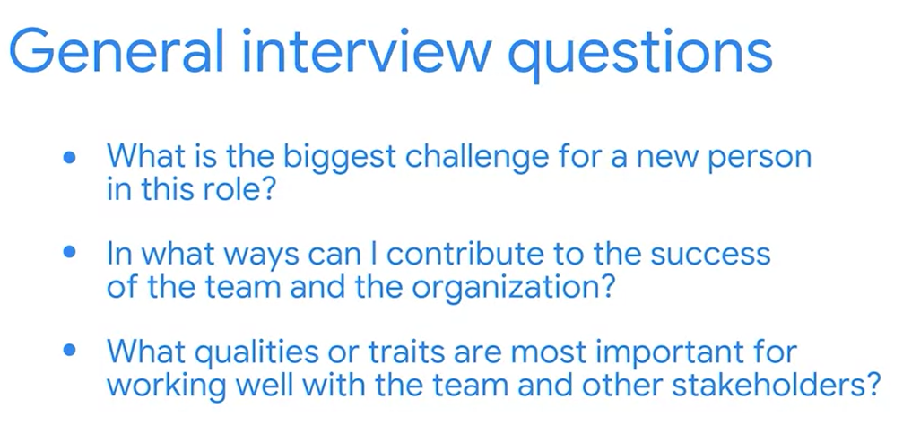

The STAR method is a structured technique used to respond to behavioral interview questions. It stands for Situation, Task, Action, and Result. Here's what each component means:

1. **Situation**: Describe the context or background of a specific event or challenge you faced.
2. **Task**: Explain the specific task or goal you needed to accomplish in that situation.
3. **Action**: Detail the actions you took to address the situation and accomplish the task.
4. **Result**: Summarize the outcomes or results of your actions. It's important to highlight positive results and any lessons learned from the experience.

Using the STAR method helps provide a clear and structured response, allowing interviewers to better understand your thought process, skills, and abilities in handling different situations.

# Learn more about developing an elevator pitch

When interviewing with potential employers, it’s important to communicate who you are, your value as a security professional, and what qualities you’re searching for in a potential job. A simple way to deliver this information succinctly is with an elevator pitch. An **elevator pitch** is a brief summary of your experience, skills, and background that should be communicated in 60 seconds or fewer.

Although an elevator pitch is often specific to an idea or a product, you can also use it to sell yourself as a professional to potential employers. In an interview, a strong elevator pitch can be used to stand out to your interviewer. It can be used to help explain why you’re a good fit for the role or to answer the popular interview question “tell me about yourself.” This reading helps you prepare your elevator pitch to express the value you can provide as an entry-level security analyst or a more experienced cybersecurity professional.

## Provide an introduction

Start by providing an introduction. Introduce yourself and give a brief overview of your professional background. Explain some job roles you’ve had, your years of work experience, and the types of industries you’ve worked in. If this is your first job in security, mention some of your past roles and skills used for those roles that can translate to success in the security field. Some of these skills can include attention to detail, goal-orientedness, and good collaboration skills.

## Describe your career interests and transferable skills

Even if you’re interviewing for your first internship or job in security, it’s important to clarify that this is your desired career. For example, you could say, “I want to apply my excellent skills for collaborating with others, and my attention to detail, to help the security team protect company data and assets.” To determine which transferable skills to highlight in your elevator pitch, consider ones that you have already developed and how they might apply to your goals as a security professional, such as problem-solving, communication, and time management.

## Express your excitement

This is where you share your passion for the field and why you want to work in the industry. If you’re motivated to help an organization defend itself against hackers, mention that. This is also a good time to talk about your goals.

For example, you could say, “I love security because it gives me the opportunity to safeguard valuable information from malicious actors attempting to cause unnecessary harm to people and organizations. Long term, I’d love to develop a security and hacker mindset to play my part in defending against the constantly evolving threat actor tactics and techniques.”

## Communicate your interest in the company

Communicating why you are interested in the company—and not just the role—is a great way to help the interviewer recognize that you are knowledgeable about the company. This helps you to establish a rapport with the interviewer and shows that you’ve done your due diligence before coming to the interview.

For example, if you were interviewing for a position for Google’s security team, you could say, “Being a member of Google’s security team helps protect millions of people’s private and sensitive information. As a long-time Google products user, I’m looking forward to the opportunity to be able to help safeguard those products and ensure customers have the best experience possible.”

## Key takeaways

Creating an elevator pitch that's 60 seconds or fewer is a great tool to use to quickly share who you are. Use an elevator pitch to introduce yourself to career and business connections in the future. You can even use your elevator pitch in other types of situations, like meeting new friends or colleagues.

# Tips for interviewing remotely

A remote interview is an interview conducted virtually using video platform software. This type of interview provides an opportunity to connect with hiring managers and recruiters, even if you are not able to meet with them in person. Remote interviews also present challenges that in-person interviews do not, such as issues related to technology, lighting, and sound.

In this reading, you will learn tips to successfully prepare for a remote interview.

## Test your technology

The first tip is to test the technology you’ll be using for the video. Different companies use different video platform software to host their remote interviews. Typically, the recruiter or hiring manager will reach out to you over the phone or email to share information about which software will be used for the interview.

Once you find out which software the company you’re interviewing with uses, you should download that software, if you don't have it already. Next, it's important to test your computer’s camera and microphone to ensure they work well with the video platform software a day or two before the interview. This allows you to resolve any technical issues you might have.  Be mindful of how to mute and unmute your microphone, just in case there is noise in your environment that you do not want the interviewer to hear. It’s also important to talk with the recruiter or hiring manager about a backup plan if the technology does not cooperate when it's time for the interview.

You’ll also want to test any technologies you need to use to ensure you are ready to interview, such as the closed caption feature on the app. Employers are typically happy to accommodate your needs if you're using assistive technology or need specific accommodations. If your internet service is not fast enough to allow for a video interview, you can request a phone interview instead.

## Practice communicating through video

Communicating through video can be a challenge because there is a slight sound delay. The sound delay can make it difficult to know how long to wait for someone to stop speaking and for you to start. If you don’t have experience communicating through video, consider practicing with friends and family before the remote interview. This will help you learn how pauses affect video communication.

## Create a professional background

Review your video background before the interview. Typically, you should avoid having an unorganized background or any objects that might distract the interviewer. When interviewing remotely, ensure that your area is well lit. You might want to rearrange your desk or furniture to ensure good lighting.

Always try to have light behind your camera so that it will shine on your face. If you can’t position your desk next to a window or don’t have enough light coming from the window, consider using artificial light.

Additionally, you should do your best to limit background noise and use a headset, if possible.

## Dress appropriately

It’s a good idea to research the company you’re interviewing with to determine which type of interview outfit is suitable. You might need to wear formal business attire during your remote interview for a particular role and company, whereas for another position, more casual clothing might be appropriate. Typically, it is better to overdress than to underdress, especially for more traditional businesses.

## Look at the interviewer when speaking

When communicating through video, try to look at the interviewer when speaking instead of at the camera. Looking at the interviewer can give them the feeling that you’re engaged in the conversation and focused on what they’re saying.

## Sign in early

Before the interview, test your technology. This will help you feel confident that everything will work. However, technology and software can be unpredictable. If possible, sign in to your remote interview early to ensure everything is working properly.

Signing in early also indicates to your interviewer that you respect their time and are a punctual person.

## Key takeaways

Follow the tips in this reading to become more confident with the remote interviewing process. Always test your technology before the interview to ensure it works well with the video platform software being used for the interview.

## Terms and definitions from Course 8, Module 5

**Rapport:** A friendly relationship in which the people involved understand each other’s ideas and communicate well with each other

**STAR method:** An interview technique used to answer behavioral and situational questions

**Elevator pitch:** A brief summary of your experience, skills, and background